In-Role Writing Tips

In-role writing is a special opportunity to use all of your persuasive skills and tools.

Adjectives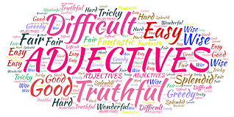

- Words that describe nouns
  - They add more information

Boring: MASH, my favourite television show, is funny.

Colourful: MASH, my favourite television show of all time, is screwball comedy combined with touching moments that make you forgive the bad jokes.

Adverbs 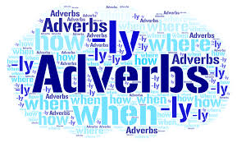

- Words that describe verbs
  - They add more information

Boring: The cat walked to the kitchen to get her dinner.

Colourful: The cat walked daintily to the kitchen to devour her dinner ferociously.

Bias

Put yourself into the shoes of the person you are speaking/writing as.

When you do this you have to take on their biases as well. That means you need to know their attitudes, values, beliefs, likes, dislikes, and all that stuff.

You are still the writer/speaker - you bring some of yourself, such as your interpretations and ideas.

Role = self + other

Make sure you know the circumstances or context in which they lived. Don’t make factual errors when you’re playing the role of someone else.

Take on their perspectives, their views. Think about how they would see things, not how you would see things. Think about their age, gender, position in society, occupation, religion, etc. These factors influence how they see their world.

Don’t be presentist! Don’t judge the past by today’s values.

