CHW3M Comparison of Medieval Lord and Vassal Obligations

How Feudalism Evolved
- Landowners built defensive forts because they could afford to do so (LORDS)
  - Ordinary people were willing to give up their freedom in order to receive protection from these lords (SERFS)
- Feudalism is a system of relationships related to land-owning and land-working

Kinds of People
People in the Middle Ages (mostly rural, few cities) were largely divided between these groups:
  - Those who Fight (knights = independent warriors)
  - Those who Pray (priests)
  - Those who Farm (serfs and peasants)
  - Those who Own land (lords, also the Catholic Church)
In theory, the system of feudalism provided mutual advantages between lord and vassal (someone who is sub-ordinate to the person above). As you see in the diagram, each gets something in return for a service provided.

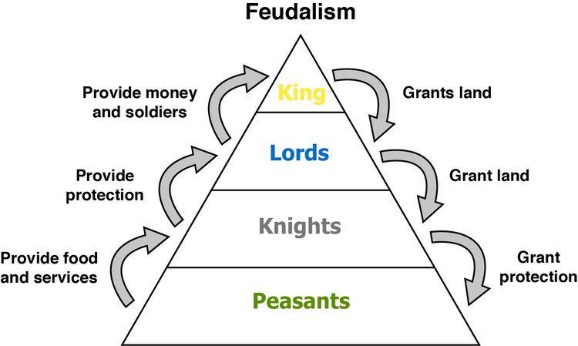

However, let’s see if you think it was so mutual in practice. Make your way through the chart on the next page, noticing that there are two kinds of vassals. Read the green section first, from left to right. You’ll notice that the biggest landowner (maybe a king) grants some land to a vassal under him, but that vassal is still a pretty high-up person in society. Then, read the lower half of the chart from left to right. Here you’ll see that the king’s vassal has in turn granted land to someone else who in turn has actual people working on the land (farming it!). This lowest kind of vassal is a serf, kind of like an agricultural slave, but not quite as unfree as a slave.

MUTUALLY BENEFICIAL RELATIONSHIP?

Lord (king, noble, bishop, knight) Provides to their vassal… | Vassal Provides… (to their lord)
Military protection | Military service or payment in lieu
Justice | Guard castle
 | Ransom money if lord captured
 | Contribution for knighting of lord’s eldest son or marriage of eldest daughter
 | Fee to inherit fief (paid by vassal’s son)
Lord Provides To Their Serf | Serfs Provide (to whomever their lord is)
Land to farm and live on | Work on lord’s land (farming, digging moat, repairing castle and roads)
Fair treatment | Extra work at harvest time
 | Annual tax for home and land
 | Fees (for use of lord’s road, bridges, mill, oven, wine press, streams for fishing)
 | Marriage tax
 | Christmas and Easter payments
 | Death tax (paid by widow)
 | Fines for infractions

The shape below could represent the way land is divided up.

Answer these questions based on the chart above:
- How mutual were the benefits?

- How mutual were the obligations?

- Overall, how fair was the system?

- Is the serf always stuck at the bottom?

Note: if you find feudalism confusing, have a quick read of this article from “Ancient History Encyclopedia”: https://www.ancient.eu/Feudalism/

