CHY4U Unit 2, Activity 1
Enlightenment Activity
Introductory Text by Jim Pedrech

Introduction
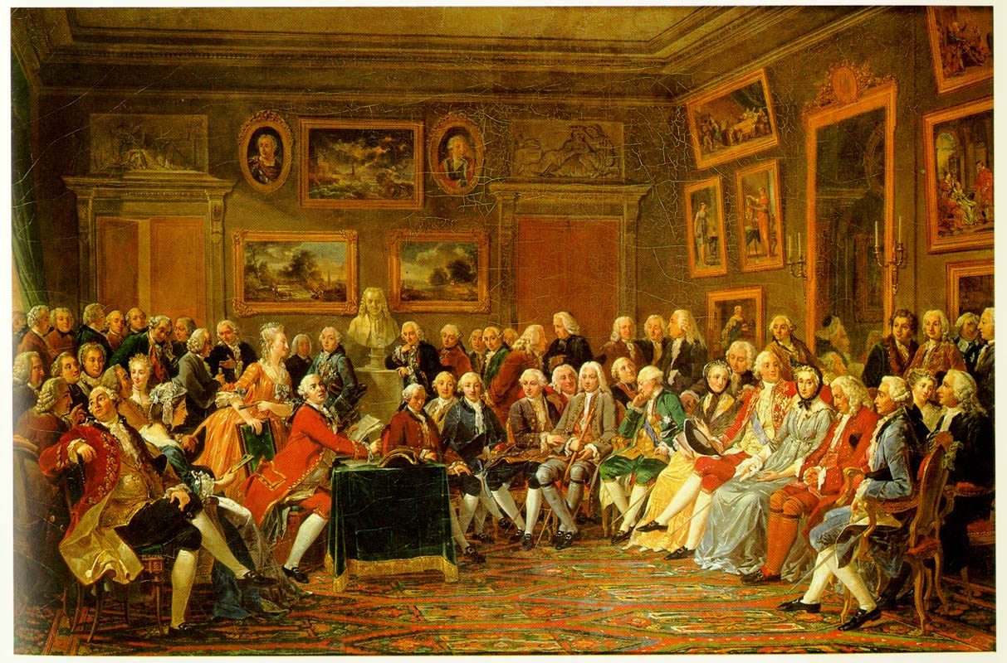
Figure 1 http://www3.gettysburg.edu/~tshannon/hist106web/site6/soiree.jpg>
Réunion de dames, Abraham Bosse, 17th century
Imagine a gathering of the wealthy and powerful at a noble’s house in 17th or 18th century Europe. While this gathering called a Salon, shown in the image above, resembles a party, the entertainment is rather unusual. The host, Madame Geoffrin, has invited well-known thinkers to delight the gathering with their wit and intellectual arguments. These thinkers amuse the attendees, but they also challenge the structures that have made the comfortable lives of the audience members possible. Despite their challenge to the status quo, these thinkers are not punished. Instead, they enjoy celebrity status not only in Paris but throughout Europe; in fact, rulers across the continent are clamouring to have them visit their courts. How did this come to pass? This is the European Age of the Enlightenment, an era defined by the pursuit of reason and justice.

Pursuit, however, is not the same as achievement. In this activity, you will learn about some of the key thinkers of the era, including their views on those issues they sought to address.
CHY4U Unit 2, Activity 1 – Enlightenment – What Was Worth Fighting For?
Text by R. Gluskin
Read the following anecdote about Jean Calas and then identify two or three things enlightened thinkers like Voltaire believed were worth fighting for.
This is the story of Jean Calas, a persecuted Huguenot (French Protestant) who came to the attention of Voltaire.
The Huguenots, French Protestants, had lost their freedom to worship under Louis XIV. Some of the other non-religious restrictions placed on Huguenots included not being able to enter the professions (law, medicine, etc.) and not being able to serve in government positions. Things were so bad that anyone who conducted a Protestant religious service could be convicted and face the death penalty.
Calas’ case took place in the city of Toulouse, which was not known to be particularly tolerant. As recently as 1761 a Huguenot preacher had died there for delivering a sermon.
According to Voltaire, Calas’ “crime” was that he had tried to disguise his son’s suicide as a “natural death.” Note that Catholicism considered suicide to be sinful and punished the sinner; even in death, the person could be punished by dragging the dead, naked body through the streets and then publicly hanging it.
Calas and his family were arrested. The religious officials thought that Calas had murdered his son for allegedly converting to Catholicism.
A trial was held. Calas and his family were found guilty, though the others won their freedom through appeals. Calas’ punishment was gruesome. Officials tortured him in order to get him to confess. The method was brutal: the question ordinaire, a torture tactic in which the victim’s arms and legs were stretched and eventually pulled from their sockets. Since the question ordinaire neither killed nor elicited the desired confession, the torturers went on to the question extraordinaire, a forced feeding of four gallons of water. When this did not work Calas faced the ultimate torture, being broken on the wheel, literally being pulled in all directions, simultaneously. The dead body was then burnt.
For Voltaire, Calas’ story represented the sorry state of French society. As a critic, he went on to write about Calas and establish his true innocence. In 1762 he told his friend Jean LeRond d’Alembert – co-editor of the Encyclopedie: “Shout everywhere, I beg you, for Calas and against fanaticism, for it is l’infame that has caused their misery.”
Source: Derson, Denise. Ed. What Life Was Like During the Age of Reason. Alexandria, Virginia: Timelife Books, 1999.

Enlightenment PSD Activity
Stage 1
- Read the PSDs given to you.
- Annotate the PSDs.
- Identify common themes amongst your group of PSDs.
- Identify significant differences between your group of PSDs.
Stage 2
- Annotate the other PSDs.
- Further identify commonalities and differences amongst all the PSDs to the point where you feel comfortable with answering “what was worth fighting for” in the mind of enlightened thinkers.

Stage 3
- Did westerners have a monopoly on enlightened ideas? Research the answer for Akbar and Suleiman.

PSD Groupings (10 documents, 4 groups)
Political
John Locke, Two Treatises on Government (done together)
Thomas Jefferson, The Declaration of Independence

English
Jonathan Swift, A Modest Proposal
Olaudah Equiano, The Interesting Narrative of the Life of Olaudah Equiano
Mary Wollstonecraft, A Vindication of the Rights of Woman, 1792

French
Jean Jacques Rousseau, The Social Contract
Denis Diderot, Definition of Intolerance
Voltaire, Superstition

Rulers (Enlightened Despots)
Catherine the Great, Proposals for a New Law Code, 1767
Frederick the Great, Essay on the Forms of Government

