GLS Intro to SMART Goals for Remote Learning
Weekly goal sheets are worth a big chunk of marks in GLS – 30%. You were using them well in the classroom. Now it’s time to transition to using them effectively during remote learning.

Weekly and Daily Goals
Always start with the weekly goal. This is what guides you everyday – you are working towards this big goal. Since we no longer have a classroom, it makes sense to have a weekly goal that includes other subjects, not just GLS/Credit Recovery.
For daily goals, you might want to divide each “cell” of the chart into four sections for your four different classes. Use the “split cell” function on the menu bar inside the Layout tab.

Date | Independent Work Goal (be specific and include how long you will plan to work for on each item)
Tues. April 14 | GLS/RCR
 | History
 | Math
 | Science

Turn the page, please
SMART Reminder
Here’s a hint: the letters overlap with each other quite a bit. You don’t need to write five separate sentences. Just make sure that the weekly goal is time-bound (as in, hand in something on Wednesday, have a test on Friday).

Letter | Hints
S (specific) | Not vague (“do a worksheet”)  - What is the name of the worksheet?
M (measurable) | You and the teacher can see if you met your goal by looking at your actions (e.g., answered 5 questions)
A (achievable) | Not too big a goal for a week or a class period. Has to be realistic.
R (results-oriented) | Will lead to you accomplishing something – overlaps with A and M.
T (time-bound)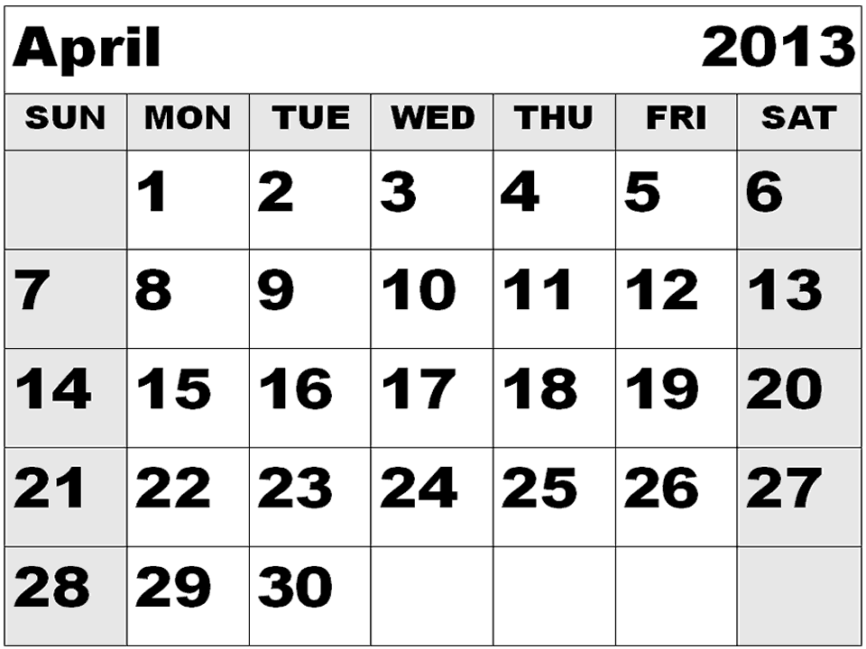 | Has a start date and time and an end date and time (this is built into the daily goals but has to be explicitly [directly] stated on the weekly goal).

Turn the page, please

Evaluating Yourself
You are expected to work independently in credit recovery. Therefore, your daily self- evaluation should reflect how well you do the following:
- Set a weekly SMART goal on Monday (or the first day of the week) in consultation with the teacher. Please email the teacher to figure out your weekly goal.
- Answer the questions at the bottom of the goal sheet on Friday (if provided).
- Set daily goals at the start of each study period.
  - You are encouraged to include goals for your other subjects as well.
- Listen to advice from the teacher: Google Classroom posts, emails, etc.
- When working at home, stay focused and keep your phone off. You can take breaks but they shouldn’t be longer than 5 or 10 minutes (use a timer to force you to come back to work).
- Complete your goals with good quality. Don’t race through and do poor quality work.
- Ask the teacher for assistance or clarification as needed by emailing.
- Complete GLS worksheets on time and with good quality as directed by the teachers in Google Classroom.

If you have any questions, feel free to email Ms. Gluskin or Ms. Muere.

