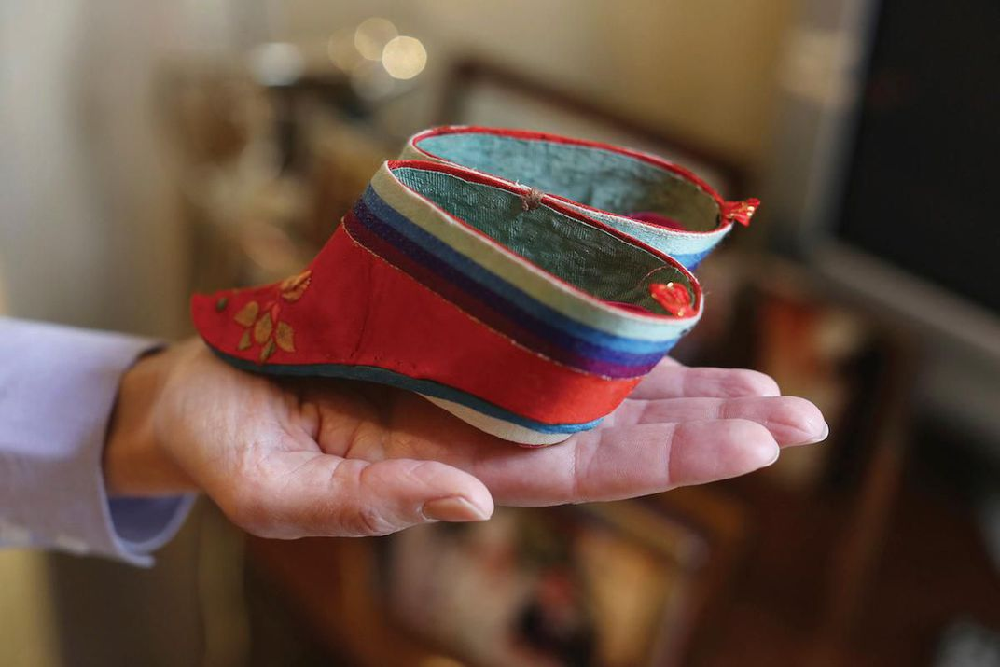
A pair of tiny “Lotus” shoes for women with bound feet held by author Amanda Foreman.
THE ETHICAL DIMENSION
The binding of feet runs contrary to the values of our time, but we must weigh that ethical concern against the need to avoid presentism.
The controversial issue of footbinding in ancient China illustrates the complexity of the Ethical Dimension in history. Though footbinding began earlier, it was in the Song dynasty that aristocratic men began to have their daughters bind their feet to make them smaller and more desirable. In turn, the men believed their daughters would be more likely to make good marriage matches. What had begun as a trend by dancers in the royal palace now spread to the families of the elite. Over time, the feet got smaller as more debilitating practices were used, ultimately resulting in girls and women who could barely walk. Though it is easy to denounce the practice as unethical, contemporary students must stop and analyze their application of presentism. Are 21st century historians and students imposing equal gender values on a patriarchal society? One way of concluding this debate is to argue that pain is pain. A two-year process to bend the foot into this tiny shape was cruel no matter what time period. Certainly society was more patriarchal at the time. However, as some authors have noted, women took up the practice as a form of loyalty to Confucian values in place at the time. Perhaps our society should not be so judgmental; our forms of physical beauty often involve physical changes, too, that may invoke physical pain. On the whole, it seems nearly impossible to come down fully on one-side of the morality versus presentism debate when it comes to the long-held and deeply ingrained practice of footbinding in China.

Denise Dersin, ed., What Life Was Like in the Land of the Dragon: Imperial China, AD 960-1368 (Alexandria, Virginia: Time Life Books, 1998), 23.
Ibid.
Amanda Foreman, “Why Footbinding Persisted in China for a Millennium?” Smithsonian Magazine, February 2015, https://www.smithsonianmag.com/history/why-footbinding-persisted-china-millennium-180953971/

