CHY4U Unit 2 – Did the Western World Have a Monopoly on Enlightenment?
Non-PSD text by R. Gluskin

Now that you have read the western PSDs related to the Enlightenment, the question remains: was the west the only part of the world that was enlightened, if enlightenment is to be taken as tolerant and equitable? Here are a few case studies for you to consider. They are not necessarily from exactly the same time period as the western European Enlightenment, but they are close enough.
Akbar the Great, Moghul ruler of India, 1542-1605
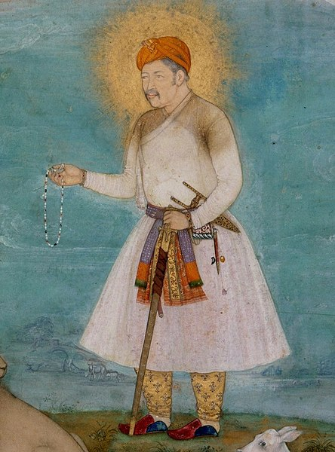
Figure 1 Akbar with Lion and Calf, c. 1630 by Govardhan. https://commons.wikimedia.org/wiki/File:Govardhan._Akbar_With_Lion_and_Calf_ca._1630,_Metmuseum_(cropped).jpg
- The Moghul Dynasty was an Islamic empire. How did Akbar show tolerance toward Hindus and others?

- In what other ways did Akbar demonstrate enlightened characteristics?

- What were the limits of enlightenment during his rule?

Suleiman the Magnificent, Sultan of the Ottoman Empire, 1494 to 1566.
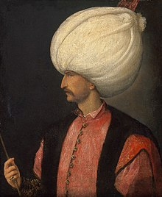
Figure 2 https://en.wikipedia.org/wiki/Suleiman_the_Magnificent

- Though a conqueror of many territories, Suleiman was also known as the lawgiver. What was the nature of his laws?

- His time was known as a ‘golden age’. What made it so golden artistically and culturally?

- Who was Roxelana?

- What were the limits of enlightenment under his rule?

