CHY4U Timeline with Attitude – Sample from Unit 1 – **Catholic Church officials = Perspective**

+3 Catholic Church Elated

Progress

+3 Looking for new souls to convert to Catholicism because of the success of Protestantism, Jesuit missionaries arrived in Japan. They found the Japanese people open to Christianity and ultimately converted up to 100 000 people in a short period. **The Church would be elated about the openness of the population to conversion and their level of success in doing so because it expands the influence of the Catholic Church, especially in the face of Protestant competition. (Source)**

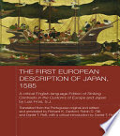 This is a translation of Luis Frois’ *Historia de Japan*. Frois was a Jesuit missionary who wrote about his experiences in Japan. The First European Description of Japan, 1585. Via Google Books.

-3 Martin Luther posted his 95 Theses on the Castle Church door in Wittenberg, Germany, prompting the beginning of the Protestant Reformation and the loss of millions of Catholic souls. His complaints against the Catholic Church related to the practice of selling indulgences, which he labelled sinful, and to the power of the Pope, which he labelled as non-existent. **The Catholic Church would feel dejected by his challenging, non-traditional actions and would, in turn, feel no choice but to excommunicate him. Ultimately, they were trying to prevent the spread of the new religion and wanted to make Luther - the person who said such negative things about their spiritual leader, appear to be a non-believing heretic. (Source)**

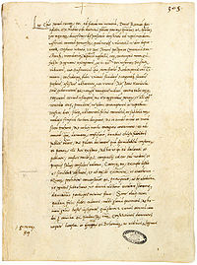 This is a copy of the 1521 Papal Bull that excommunicated Luther for his actions, *Decet Romanum Pontificem*. From Wikipedia, Decet Romanum Pontificem, March 19, 2017, <https://en.wikipedia.org/wiki/Decet_Romanum_Pontificem> (April 7, 2017)

-3 Catholic Church Dejected

Decline

1549

1517