CHY4U Unit 2, Activity 3
Early Inventions of Industrialization
Non-PSD Text by Jim Pedrech

Cotton production in India had been going on for a very long time before it came to Britain. Britain’s ever-increasing interest in India was directly related to cotton.

Trade (including the slave trade) brought greater wealth to 17th century Britain. This wealth gave rise to consumerism, which occurs when the wealth in an economy is generated by the constant buying and consumption of goods by the public. For the first time, the “middling”, those between the rich aristocrats and the destitute, had disposable income. Increasingly, this group spent this income on specialized furniture, porcelain from China, and clothing items, like
undergarments, previously worn only by the rich.

One of the keys to the rise of this new middle class with a consumer culture was the availability of cotton. The East India Company brought cotton goods to Britain from India, where cotton had been harvested for thousands of years. Before the East India Company’s access to Indian markets, cotton was a rare and valuable commodity in Europe. Indian cotton, however, was cheap and plentiful. It could be decorated with intricate designs at the fraction of the cost of other methods, providing consumers with plentiful options for clothes and bedding. Unfinished cotton, which had a rough, uncoloured look, was an even cheaper alternative for the poor.

However, cotton was not welcomed by everyone. Indian cotton arrived in Britain in the form of garments and cloth, meaning that production was handled by skilled Indian labour, not British workers. Growing cotton in the American colonies was possible thanks to weather conditions and slave labour, but the colony lacked the means to effectively produce cloth; thus, Britain consumed Indian cotton instead, with most profits going to the East India Company and India. Wool, the traditional material for most European clothing, was heavily impacted. Wool producers in Britain were unable to compete with cotton, which was cheaper, decorative, and comfortable. Concerned about their livelihood, they petitioned the crown for protection for their products. Below is an excerpt from one of The Burial in Woollen Acts (1666-1680), a series of Acts of Parliament in England.

And it is hereby enacted [...] that from and after the first day of August 1st 1678, no corpse of any person or persons shall be buried in any shirt, shift, sheet or shroud or any thing whatsoever made or mingled with flax, hemp, silk, hair gold or silver or in any stuff or thing other than what is made of sheep’s wool only or be put in any coffin lined or faced with any sort of cloth or stuff or any other thing whatsoever that is made of any material but sheeps wool only upon the pain of forfeiture of five pounds of lawful money of England to be recovered and divided as is hereafter in this Act expressed and directed.

Definition: While it is extremely difficult to calculate the value of 17th century currency in the 21st century, a conservative estimate would put the value of 5 pounds in 1678 to well over $1000 Canadian.

Source: British History Online, Charles II, An Act for Burrying in Wollen, N.d., http://www.british-history.ac.uk/statutes-realm/vol5/pp885-886 (Jan. 22, 2017)

The Burial in Woollen Acts were followed by the Calico Acts in (1690-1721) which banned cotton imports altogether. However, less than a century later, cotton would be the key component in Britain’s Industrial Revolution. How could this happen?
CHY4U Unit 2, Activity 3, Early Industrialization Activity
In the second half of the eighteenth century, a number of innovations fundamentally changed production in Britain. In the timeline below, you will be introduced to several key inventions from this era. As you examine each invention, write down who benefitted from the invention, and who suffered because of the invention (causes and consequences). You may choose from the words listed below.

Possible Answers for “who did it help / hurt”
British East India Company merchants, farmers, women, children, people with capital to spend, Indian cotton farmers, Indian hand cotton weavers, factory owners, English hand(loom) weavers (cottage worker), skilled workers (usually men), unskilled workers (female), unskilled workers (male), enslaved Americans

Name of Innovation | Inventor and Year | Use | Who did it help/hurt?
flying shuttle | John Kay, 1733 | 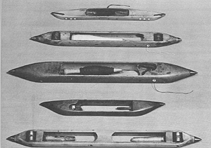  Figure 2http://inventors.about.com/library/inventors/blflyingshuttle.htm  In 1733, John Kay invented the flying shuttle, an improvement to looms that enabled weavers to weave faster. The original shuttle contained a bobbin onto which the weft (weaving term for the crossways yarn) yarn was wound. It was normally pushed from one side of the warp (weaving term for the the series of yarns that extended lengthways in a loom) to the other side by hand. Large looms needed two weavers to throw the shuttle. The flying shuttle was thrown by a lever that could be operated by one weaver.  In 1753, his home was attacked by textile workers who were angry that his inventions might take work away from them.  Kay's invention paved the way for mechanical power looms, however, the technology would have to wait another thirty years before a power loom was invented by Edmund Cartwright in 1787.
spinning jenny | James Hargreaves, 1764 | The spinning of cotton into threads for weaving into cloth had traditionally taken place in the homes of textile workers - known as 'cottage industries'. But the 18th century saw the emergence of the ‘Industrial Revolution’, the great age of steam, canals and factories that changed the face of the British economy forever. James Hargreaves’ ‘Spinning Jenny’, the patent for which is shown here, would revolutionise the process of cotton spinning. The machine used eight spindles onto which the thread was spun, so by turning a single wheel, the operator could now spin eight threads at once. This increased to eighty with improvements in the technology.  New ‘manufactories’ (an early word for 'factory') were a the result of new technologies such as this one. Large industrial buildings usually employed one central source of power to drive a whole network of machines. Richard Arkwright’s cotton factories in Nottingham and Cromford, for example, employed nearly 600 people by the 1770s, including many small children, whose nimble hands made light-work of spinning.  text source: http://www.bl.uk/learning/timeline/item107855.html  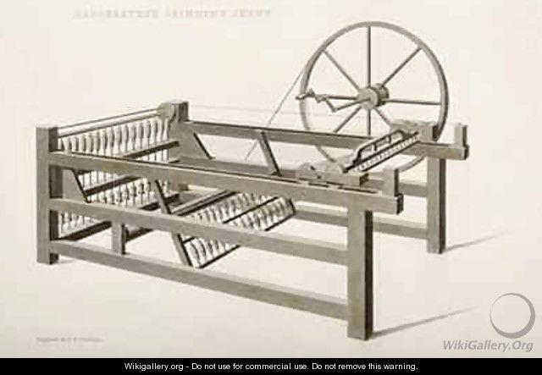  Figure 3http://www.wikigallery.org/wiki/painting_241291/(after)-Nicholson,-Thomas-Henry/The-Spinning-Jenny-invented-by-James-Hargreaves-in-1764-1835
water frame, first factory | Richard Arkwright, 1767 | Richard Arkwright was a barber & wig maker in Bolton, England around 1750 where he learnt that he could make a lot of money if he could invent a machine to spin cotton fibre into yarn, or thread, quickly and easily. He teamed up with a clockmaker called John Kay and by the late 1760's they had a workable machine that could spin four strands of cotton yarn at the same time. Arkwright paid for a patent in 1769 to stop others copying his invention.  This spinning machine spins 96 strands of yarn at once. It was one of many similar machines installed in mills in Derbyshire and Lancashire and powered by waterwheels, so they were called Water Frames. Now it is the only complete machine of its kind in the world. His machines did not need skilled operators so Arkwright paid unskilled women and others to work on them. His spinning mills were the earliest examples of factories where hundreds of workers had to keep pace with the speed of the machines.  Image and text from: A History of the World, BBC and the British Museum, http://www.bbc.co.uk/ahistoryoftheworld/objects/RyHIgvgsSeCYGZRl4Ep5RQ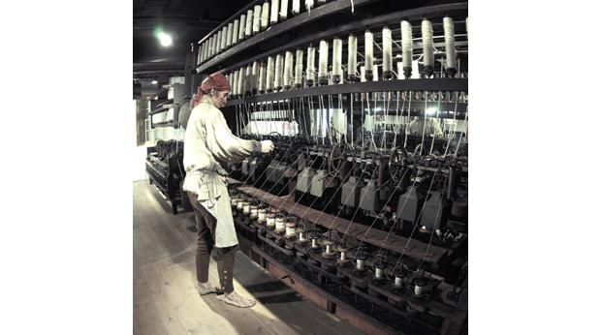  Figure 4http://www.bbc.co.uk/ahistoryoftheworld/objects/RyHIgvgsSeCYGZRl4Ep5RQ  Description: A modern re-enactor demonstrating The Water Frame.
spinning mule | Samuel Crompton, 1779 | Crompton developed the mule in 1779, so called because it combined two previous spinning machines, the water frame and the spinning jenny. It was capable of producing high quantities of fine, strong cotton yarn, and during the early 1800s revolutionised the British cotton industry, heralding the start of the cotton boom.  The application of the mule to industry massively increased the amount of cotton yarn manufacturers could produce, which in turn increased demand for raw cotton to supply the mills. This led to an increase in cotton production by the slave system, and a parallel boom developed in the plantations of the southern states of America. During the period 1781-1791, the first decade of the mule’s use, the amount of raw cotton supplied to Britain more than tripled.  Despite the success of the mule, Samuel Crompton was unable to patent his design and made very little money from it. He eventually died in poverty in 1827.  Image and text from Revealing Histories, Remembering Slavery, Manchester England  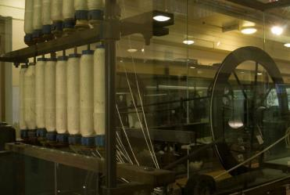  Figure 5http://revealinghistories.org.uk/why-was-cotton-so-important-in-north-west-england/objects/crompton-s-mule.html  Description: the machine in the image was made in 1802.
power loom | Edward Cartwright, 1784, 1789 | In 1784, Cartwright visited Richard Arkwright's cotton-spinning mills at Cromford in Derbyshire and was inspired to construct a similar machine for weaving. His idea was scorned by many who thought that such a complicated procedure would be impossible to automate. Undeterred by these comments, and his complete inexperience in the field, he began work. The first power loom, patented in 1785, was extremely crude but improvements were made in subsequent versions. Cartwright now established a factory in Doncaster for his looms, but his ignorance of industry and commerce meant that the factory never became much more than a testing site for new inventions. In 1793, he went bankrupt and closed the factory. A Manchester company purchased 400 of his looms, but the factory was burnt down, probably in an arson attack - many handloom weavers rightly feared the impact power looms would have on their livelihoods.  Text source: http://www.bbc.co.uk/history/historic_figures/cartwright_edmund.shtml  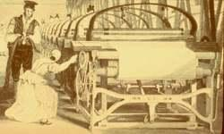  Figure 6http://inventors.about.com/od/cstartinventors/a/power_loom.htm  Description: the machine in this image is from circa 1833

The repeal of the Calico Acts and the new production methods fundamentally changed the cotton trade. Britain could circumvent Indian production entirely by importing cotton picked by slaves in the colonies and refining (processing) it in British factories. This created a closed loop through which Britain controlled the acquisition of the resource, the transportation of the resource, its production into goods, and finally its sale in various markets. This loop was the backbone of the Industrial Revolution, leading to unprecedented economic growth in Britain. Even after the American War of Independence, this trade was so profitable that cotton shipments continued to fill British vessels. However, as you will see in unit 3, these changes were not beneficial for all.
It should also be noted that Britain’s population increased by millions of people during this time so that there was an ever-increasing demand for products to be made more efficiently.

Explore some of the sites of early industrialization in England:
http://www.derbyshireuk.net/cromford.html
https://www.visitpeakdistrict.com/things-to-do/attractions/industrial-heritage
https://www.oup.com.au/__data/assets/pdf_file/0017/58031/Oxford-Big-Ideas-Geography-History-9-ch5-Industrial-revolution.pdf (very thorough overview of industrialization)
http://whc.unesco.org/en/list/371 (world’s first iron bridge)
http://www.channel4.com/programmes/walking-through-history/on-demand/54892-002 (Tony Robinson’s Walking Through History – Derwent Valley)

