CHY4U Unit 3, Activity 4
Imperialism Case Studies: Congo PSDs
Non-PSD Text by Jim Pedrech

The system of imperialism, in which European powers competed to gain colonies, would have far-reaching political, economic and cultural consequences for many peoples around the world. Here you will examine the consequences in the Congo and China.

Congo
Belgium was one of the last European countries to acquire colonies in Africa. At a conference in 1876, Leopold II of Belgium announced his desire for an international committee intended to bring European values, including Christianity, to Central Africa. This committee was followed by similar scientific, economic, and humanitarian committees, all under Belgian influence. When European powers partitioned Africa at the Conference of Berlin in 1884, Belgium claimed the Congo. In 1885, the Belgian parliament passed a resolution that made the Congo the personal property of Leopold.
In truth, however, Leopold’s motivation was not to Christianize the Congo. Instead, he gradually increased his influence in the region in order to gain access to resources that might aid Belgian industry. At first, the key resource was ivory; after 1890, however, rubber became the region’s most desirable export.

Below are two letters written by Leopold to Belgian agents in the Congo. The first letter was public, and available to all. The second letter, however, was intended only for those working for Leopold.

After reading the letters, do the following:
- Explain how Leopold saw the role of religion.
- Explain why the content and tone of these two letters is so different.
- What can you conclude about the consequences of Leopold’s policies in the Congo?
- How do the different primary source documents corroborate each other?

Definition: corroborate - to confirm or give support to a statement, theory or finding.

- The following is an excerpt from a public letter written by King Leopold to all Belgian agents working in the Congo.
“The task which the Belgian agents have to accomplish in the Congo is noble. It is incumbent upon them [necessary] to carry on the work of civilization in Africa. The aim [goal] is to regenerate [re-make] races whose degradation and misfortune is hard to realize. The fearful scourges in the eyes of our humanity, these races are the victim. This is already lessening, little by little, through our intervention. Each step forward by our people should mark an improvement in the condition of the natives. In those vast (huge) regions of land, mostly uncultivated (unused) and mainly unproductive, where the natives hardly knew how to get their own daily food, European experience, knowledge, resources, and enterprise (skills) have brought to light unimaginable wealth. Exploration of virgin (new) lands goes on, communications are established, highways are opened, and legitimate trade and industry are established.
Source: Letter from King Leopold II of Belgium to all government agents in the Congo, June 16, 1897.
2. The following is an excerpt from a private letter written by King Leopold to a group of Belgian missionaries about to leave for the Congo in 1883.
“Reverends, Fathers and Dear Compatriots: The task that is given to you is very difficult. You will go certainly to evangelize, but your priority must be Belgium interests. Your principal mission in the Congo is never to teach the savages to know God, this they know already. They speak and submit to a Mungu, one Nzambi, one Nzakomba, and what else I don’t know (all of these are native African gods).Your essential role is to facilitate the task of administrators and industrialists, which means you will go to interpret the gospel in the way it will be the best to protect our interests in that part of the world. Your knowledge of the gospel will allow you to find texts encouraging your followers to love poverty, like “Happier are the poor because they will inherit theheaven" and, "It’s very difficult for the rich to enter the kingdom of God." You have to make them abandon everything which gives them the courage to affront[resist] us. Evangelize the savages so that they stay forever in submission to the white colonialists, so they never revolt against the restraints they are undergoing. Recite every day-"Happy are those who are weeping because the kingdom of God is for them." Convert the blacks always by using the whip.
Source: Letter from King Leopold II of Belgium to Colonial Missionaries, 1883. Illuminate Education. Reading: King Leopold Primary Source Documents. 2016. https://app.activateinstruction.org/playlist/resource-sview/id/51d3386607121c63391309e2/rid/51d420cd07121c582e828d4b/bc0/explore/bc1/playlist (Jan. 27, 2017)

“Fostering Care”
Despite claims that Leopold’s intent was to aid the Congolese, they were essentially slaves forced to harvest resources, especially rubber, for his regime. His agents regularly used violence, rape, and mutilation to ensure compliance. The practice of cutting off hands as punishment was so commonplace that hands became a pseudo-currency in the region. Due to these methods of control and mistreatment, the Congo’s population decreased from approximately 20 million to 12 million during Leopold’s ownership of the region.
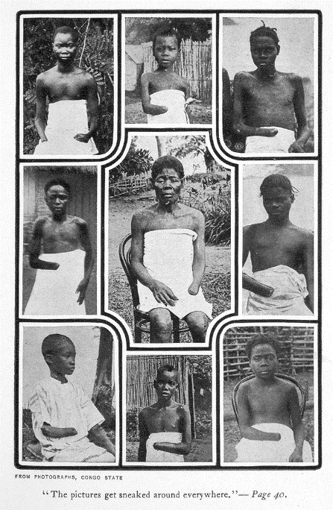
Figure 2 https://en.wikipedia.org/wiki/Leopold_II_of_Belgium#/media/File:MutilatedChildrenFromCongo.jpg

Missionary Reports
Starting around 1890, the treatment of the Congolese became increasingly known to the public. American missionaries wrote openly about the atrocities they witnessed while in the region.

The following in an excerpt from an open letter written by George Washington Williams, a Christian minister and African-American activist, to Leopold of Belgium in 1890. In it, he explains what he saw during his visit to the Congo completely contradicted Leopold’s stated purpose:

I was anxious to see to what extent the natives had “adopted the fostering care” of your Majesty’s “benevolent enterprise” (?), and I was doomed to bitter disappointment. Instead of the natives of the Congo “adopting the fostering care” of your Majesty’s Government, they everywhere complain that their land has been taken from them by force; that the Government is cruel and arbitrary, and declare that they neither love nor respect the Government and its flag. Your Majesty’s Government has sequestered [taken] their land, burned their towns, stolen their property, enslaved their women and children, and committed other crimes too numerous to mention in detail. It is natural that they everywhere shrink from “the fostering care” your Majesty’s Government so eagerly proffers [offers] them.
There has been, to my absolute knowledge, no “honest and practical effort made to increase their knowledge and secure their welfare.” Your Majesty’s Government has never spent one franc for educational purposes, nor instituted any practical system of industrialism. Indeed the most unpractical measures have been adopted against the natives in nearly every respect; and in the capital of your Majesty’s Government at Boma there is not a native employed. The labour system is radically unpractical; the soldiers and labourers of your Majesty’s Government are very largely imported from Zanzibar at a cost of £10 per capita, and from Sierra Leone, Liberia, Accra and Lagos at from £1 to £1/10 per capita. These recruits are transported under circumstances more cruel than cattle in European countries. They eat their rice twice a day by the use of their fingers; they often thirst for water when the season is dry; they are exposed to the heat and rain, and sleep upon the damp and filthy decks of the vessels often so closely crowded as to lie in human ordure. And, of course, many die.
Casement Report
Throughout the 1890s, incriminating articles and accounts circulated through the west about the mistreatment of the Congolese. While evidence continued to mount, Leopold repeatedly proclaimed his innocence, claiming that any mistreatment was done without his consent. In 1902, he even won a libel case against publishers who claimed he was responsible for the atrocities. In 1905, however, the Casement Report, commissioned by the British Parliament, outlined the atrocities in detail. Britain sent copies of the report to the nations who had attended the Conference of Berlin in 1885, and demanded a meeting to review the agreement. The Report also led to the creation of the Congo Reform Association, which is generally considered the first human rights organization in history. The following is an excerpt from the Casement Report. In it, Roger Casement recalls a conversation he had with a sentry [guard] in a Congolese village. The sentry explained why he had detained eleven women:

The remaining eleven women, whom he indicated, he said he had caught and was detaining as prisoners to compel their husbands to bring in the right amount of india-rubber required of them on next market day. When I asked if it was a woman’s work to collect india-rubber, he said, “No; that, of course, it was man’s work.” “Then why do you catch the women and not the men?” I asked. “Don’t you see,” was the answer, “if I caught and kept the men, who would work the rubber? But if I catch their wives, the husbands are anxious to have them home again, and so the rubber is brought in quickly and quite up to the mark.” When I asked what would become of these women if their husbands failed to bring in the right quantity of rubber on the next market day, he said at once that then they would be kept there until their husbands had redeemed them. Their food, he explained, he made the Chief [...] provide, and he himself saw it given to them daily. They came from more than one village of the neighbourhood … It was an institution, he explained, that served well and saved much trouble. When his master came each fortnight to [...] to take away the rubber so collected, if it was found to be sufficient, the women were released and allowed to return with their husbands, but if not sufficient they would undergo continued detention. The sentry’s statements were clear and explicit, as were equally those of several of the villagers with whom I spoke. The sentry further explained, in answer to my inquiry, that he caught women in this way by direction of his employers. That it was a custom generally adopted and found to work well; that the people were very lazy, and that this was much the simplest way of making them do what was required of them.
Source: http://www.gutenberg.org/files/50573/50573-0.txt

In 1908, the Belgian Parliament forced Leopold to turn over control of the Congo to the state. Thus, the Congo was no longer the private property of Leopold, but the property of the Belgian public. Leopold claimed he had never profited from his ownership of the Congo, but according to the British Museum, the exports of rubber from the region in 1905 alone exceeded 43 million Belgian Francs. Many of the profits were used to construct national buildings in Brussels; in fact, the total value of the property received from the Congo by Belgium was 2.4 billion pounds.

