CHY4U Unit 3, Activity 4
Imperialism Case Studies: China and Opium Wars
Non-PSD Text by Jim Pedrech

China

Tea and Opium
By the 19th century, tea had become a central aspect of British life. The large scale importation of tea, sugar, and chocolate changed English diets; breakfast, for example, changed dramatically during this time period due to the influx of these goods. According to Columbia University’s Asia for Educators, a website designed to serve faculty and students in world history, the average worker in London spent approximately 5% of their total household budget on tea. Comparatively few British goods entered Chinese ports, because, as we saw previously, the Chinese did not need European goods and were dismissive of them. This created a considerable trade imbalance; large amounts of silver were flowing out of British cities into China.
To address this trade imbalance, the East India Trading Company smuggled opium from British-controlled India to Chinese ports. Despite the fact that the Chinese Emperor banned the import of opium in 1799, the smuggling continued. By 1804, British trade of tea and opium was at a surplus. By 1838, millions of Chinese people were opium addicts.

As you examine the following sources on the Opium War, consider the variety of historical perspectives on the war, in China and Great Britain. Think about how the sources corroborate and contradict each other, and what conclusions you can draw.

- Lin Zexu to Queen Victoria
In 1838, Lin Zexu, the Governor-General of Hunan and Hubei, was commissioned by the central government in Beijing to try to deal with the problem. Below is a short excerpt of a letter he wrote to Queen Victoria. What were his motivations and rationale for writing this letter?

I am told that in your own country opium smoking is forbidden under severe penalties. This means that you are aware of how harmful it is. . . . So long as you do not take it yourselves, but continue to make it and tempt the people of China to buy it, you will be showing yourselves careful of your own lives, but careless of the lives of other people, indifferent in your greed for gain to the harm you do to others; such conduct is repugnant to human feeling and at variance with the Way of Heaven. . . . .

On receiving this, Your Majesty will be so good as to report to me immediately on the steps that have been taken at each of your ports.

Source: Victorian Web, Commissioner Lin Ze-xu's Letter to Queen Victoria. 2006. http://www.victorianweb.org/history/empire/opiumwars/lin.html (Jan. 27, 2016)
First Opium War
The escalation of opium smuggling and its impact on the Chinese people eventually led to conflict. The outcome of the First Opium War (1839 to 1842) was largely determined by the technologically superior British navy, which had ironclad vessels compared to the wooden ships of the Chinese fleet. The Treaty of Nanjing (1842) was largely designed to ensure British access to Chinese ports; it also opened China up to further western encroachment.
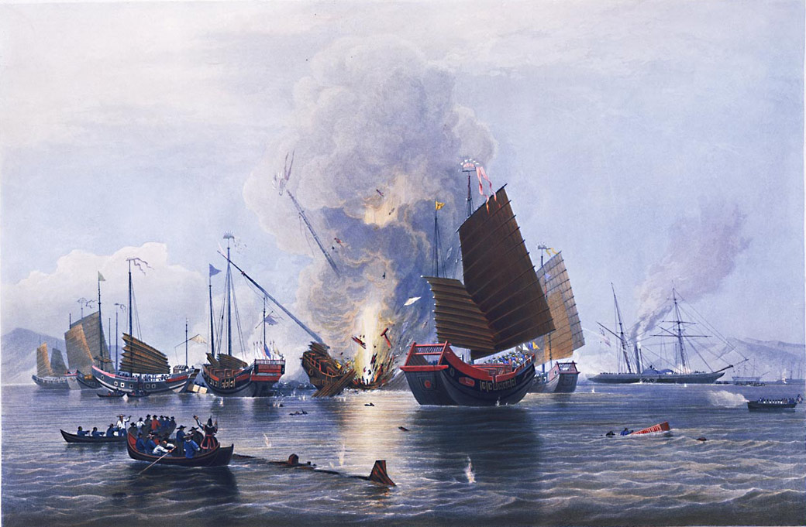
Figure 3 https://commons.wikimedia.org/wiki/File:Destroying_Chinese_war_junks,_by_E._Duncan_(1843).jpg
Destroying Chinese war junks, by British painter, Edward Duncan (1843). This painting depicts British ironclad vessels (background) destroying Chinese vessels.

- The Treaty of Nanjing
Treaty of Nanjing, 1842 – see separate handout (source: http://afe.easia.columbia.edu/ps/china/nanjing.pdf)

Questions:
- How is the imperialistic perspective demonstrated in this treaty?
- What can it tell us about the relationship between China and Great Britain at this time?

- The Century of Humiliation
After the treaty, which gave Britain possession of Hong Kong, other countries attempted to establish treaty ports. This started what has been called in China the century of humiliation or the long century (110 years), a period that included a Second Opium War and increasing encroachment by other countries on Chinese territory that ended with the Communist Revolution. Examine this 1898 cartoon that shows from left to right in the front row: Queen Victoria of England, William II of Germany, Nicholas II of Russia, Marianne (a symbol of France), and a samurai representing Japan. In the back there is a Chinese bureaucrat (government official).

- What can you infer about the relationship between Germany and England?
- How about the relationship between Russia and France?
- A few figures appear to be caricatures, while others appear to be more realistic. What might account for the differences?
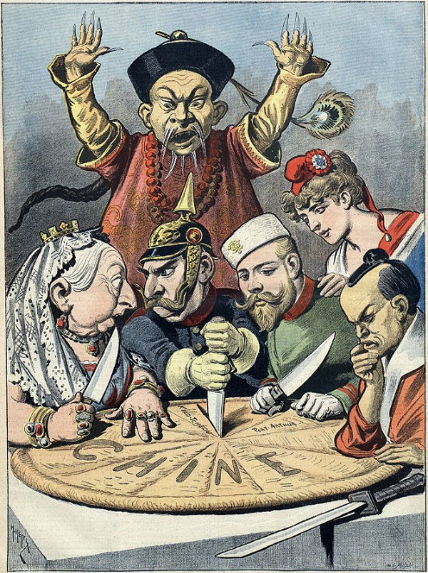
Figure 4 https://upload.wikimedia.org/wikipedia/commons/3/32/China_imperialism_cartoon.jpg
This is a political cartoon published in a French magazine in 1898. It depicts world leaders dividing China as the protests of a Chinese bureaucrat are ignored.

