CHW3M Unit 2: Egyptian Religion - Learning From Artefacts – Egyptian Amulets
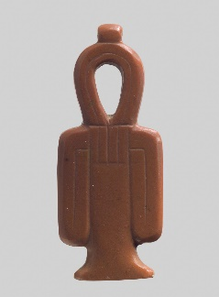
Figure 1 Tit (Isis Knot) Amulet, https://www.metmuseum.org/toah/works-of-art/00.4.39/. From the 18th Dynasty in the New Kingdom. Found in a tomb at Abydos in 1900. Made of Jasper. Approximately 6 cm tall, 3 cm wide.
“Today, we are most familiar with amulets as good luck charms such as a rabbit’s foot or a special bracelet. In ancient Egypt amulets were worn to protect against the evil forces that could bring bad luck, sickness, or death. Most amulets were made out of gemstone that was carved into little sculptures. Amulets were generally worn around the neck, ankle or wrist. In order for amulets to be powerful enough to control the evil forces that were always present, they had to be made and dedicated according to the instructions written in the "Book of the Dead". The Egyptians believed that gods lived in the amulet itself. The gods were to be treated with respect in order for the person wearing the amulet to be protected. The evil forces that amulets were meant to ward off could take the form of poisonous snakes, scorpions, disease, droughts, or floods. Egyptian believed so strongly in the healing and protective powers of amulets, that they were also used to protect the dead. After someone died, two amulets that worked against the same evil force would be placed with the dead person during the burial ceremony, to ensure double protection. If the first amulet didn’t work properly to protect the dead person, the Egyptians believed the duplicate amulet would work to control the evil force. Amulets not only protected the dead and kept the living safe from illness and accidents, they were also used to fulfill peoples’ wishes. The Egyptians would create new amulets in the hope that they would receive such things as gold, jewellery or delicious food. Because so many amulets were created for new purposes, the manufacturing of amulets in ancient Egypt became a major industry. Although amulets do not have the same importance today as they did in ancient Egypt; similar practices still exist. Some religious groups carry symbols of their religion with them to represent their faith. For example, Christians carry a cross to represent their connection to Jesus, who died on the cross for their sins.”
Source: TC², Daily Life in Ancient Egypt – Source Docs,
https://tc2.ca/sourcedocs/picture-sets/topics1/ancient-egypt/daily-life.html

Question: Identify 2 key things about Egyptian religious beliefs that you can infer from highlighted sections of this paragraph. Note: infer means to read between the lines, not summarize what is already there.

About the Isis Knot:
“The tit symbol (pronounced teet) illustrates a knotted piece of cloth whose early meaning is unknown, but in the New Kingdom [the third major time period in Egyptian history] it was clearly associated with the goddess Isis, the great magician and wife of Osiris. By this time, the tit was also associated with blood of Isis. Thetit sign was considered a potent [powerful] symbol of protection in the afterlife and the Book of the Dead specifies that the tit be made of blood-red stone, like this example, and placed at the deceased's neck. … Knots were widely used as amulets because the Egyptians believed they bound and released magic [.]”

Source: Metropolitan Museum of Art, Heilbrunn Timeline of Art History, Tit Amulet, 2000-2017, https://www.metmuseum.org/toah/works-of-art/00.4.39/

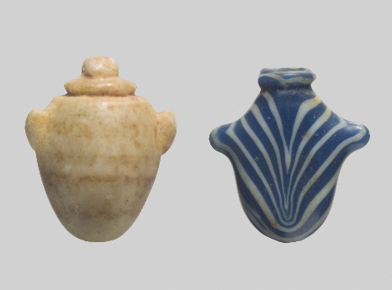
Figure 2 Heart Amulets, https://www.metmuseum.org/toah/works-of-art/10.130.1782_10.130.1804/. From the 18th to 19th dynasties of the New Kingdom. Made of agate and glass, approximately 2 cm tall, 2 cm wide.
About the Heart Amulets
“For the ancient Egyptians, the heart (ib) was the source of intelligence, feelings, and actions. A person's memory was also housed in the heart and so at the judgment ceremony (Weighing of the Heart) in the afterlife, the heart was able to speak on behalf of the deceased, accounting to Osiris for a lifetime of deeds. Therefore, heart amulets were only used on the mummy to protect the owner's organ and to ensure that his heart gave a positive response at judgment.”

Question: Identify 2 key things about Egyptian religious beliefs that you can infer from the two amulets.
- Book of the Dead and the afterlife:

- Judgement ceremony:

Other common amulets included: animals Egyptians might have been scared of (elephants, hippopotamuses, cobras), hands (to confer dexterity, possibly), fish such as catfish or tilapia (for fertility, possibly), certain gods and goddesses (for protection of the household, fertility, protection of the mummy, access to the underworld). The most common were scarabs (dung beetles).

