CHW3M Paleolithic Society Overview
Annotate these pages = note things that are important, write in the margins, use arrows, symbols, highlights, comments… personalize these pages!
Paleolithic Life
Paleolithic people (Homo sapiens) had dispersed around the world, with the exception of Antarctica, by about 20 000 years ago, though these dates are often revised due to new archaeological research. For instance, research from 2015 shows that Paleolithic people were in the southern tip of South America at Monte Verde from 18 500 years ago and they may have eaten seaweed and/or used it as medicine. Living in a world free of modern conveniences, such as the wheel for quicker transportation, or farming, Paleolithic people had to be incredibly well adapted to their various environments around the world.
Visit this website to see a map of human migration:
https://genographic.nationalgeographic.com/human-journey/
Paleolithic Materials
Paleolithic means “Old Stone Age” and refers to the material with which the people primarily made weapons and tools. Over millions of years, with the Lower Paleolithic going back about two million years ago, the tools changed and evolved. They went from simple hand axes to more sophisticated blades made of stone flakes. Stone preserves much better than other materials so archaeologists are not entirely sure what other materials the Paleolithic people might have used, though animal bones, antlers and teeth were used as well. Recently, the oldest fish hooks have been found in Okinawa, Japan, dating to 23 000 years ago. They are made from snail shells.
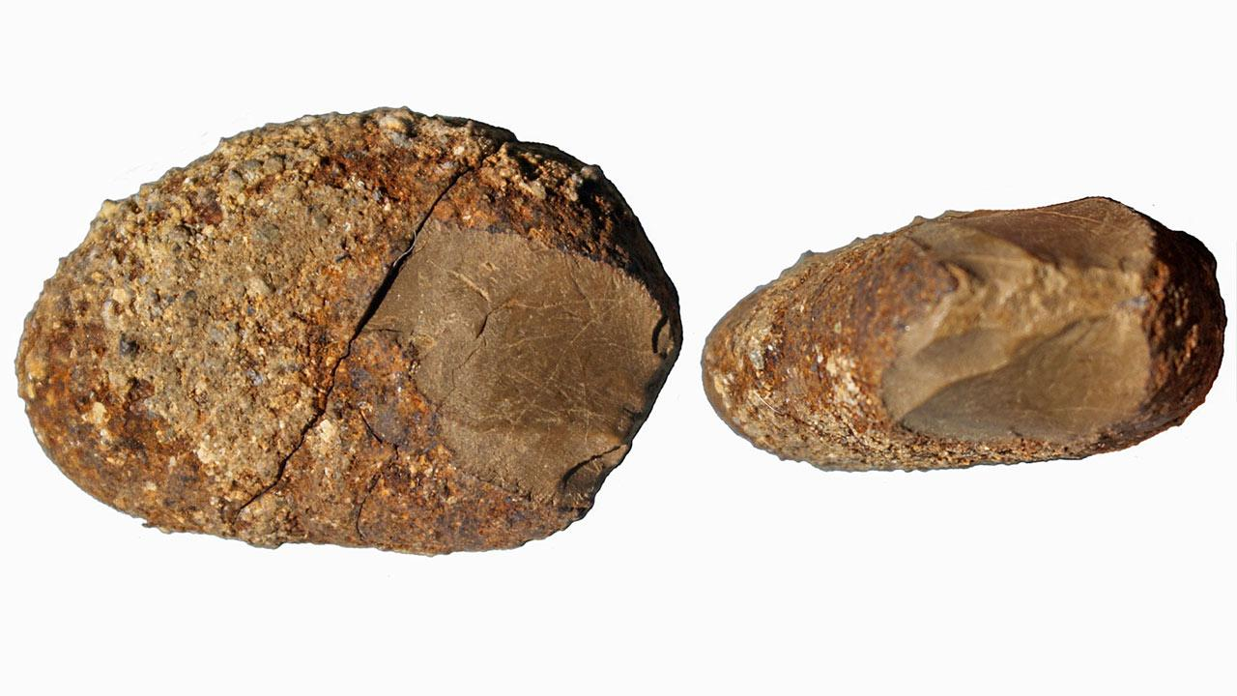
Stone tools from Monte Verde, Chile.
Ann Gibbons, Oldest Stone Tools in the Americas Claimed in Chile, Science, Nov. 18, 2015, http://www.sciencemag.org/news/2015/11/oldest-stone-tools-americas-claimed-chile
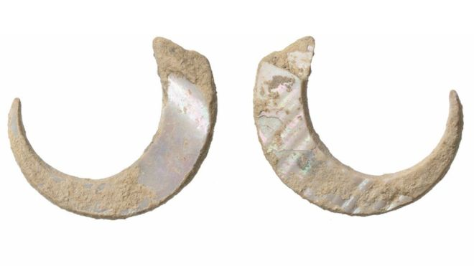
Fish hooks made of snail shells from Japan
World’s Oldest Fish Hooks Found in Japanese Island Cave, BBC, Sept. 18, 2016, http://www.bbc.com/news/world-asia-37402183
Nomadic Way of Life
The Paleolithic way of living, being nomadic and based on hunting and gathering, was quite different from ours. It was likely much more communal as Paleolithic people lived in cooperative bands of 30 to 50 people without, we believe, the modern concept of private property. They probably shared what was hunted and what was gathered and probably all played a role in preparing the food and making use of animal bones and skin for clothing, tools and decorative objects. Moving from place to place following the animals and their seasonal migrations required an intimate knowledge of nature. In the photo below, the carved reindeer shows just how much the Paleolithic people were in tune with their natural surroundings. Carved onto a 27-centimetre long mammoth tusk about 11 000 years ago, the two swimming reindeer are said to be portrayed during the autumn, the time of year when humans made the best use of such animals. So, what was the purpose of the small and elaborate carving? Some have suggested it might have been a charm to assist in hunting, while others felt it might have been made for supernatural purposes, to facilitate communication with some kind of being or force that could facilitate the hunt. These are interpretations.
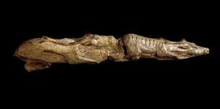
Swimming reindeer carving
The British Museum Collection Online, The Swimming Reindeer, ND, http://www.britishmuseum.org/research/collection_online/collection_object_details.aspx?objectId=808748&partId=1
Food
Though women may have done the bulk of gathering, anthropologists and archaeologists don’t think this would have been exclusive. Women may have participated in the hunts and men may have gathered as well. Gathering of plants, berries, seeds, roots and tubers (plus perhaps insects) did bring in much more of the calories that sustained the bands (about 70% according to some estimates). To be clear, meat from the hunt would have made up the other 30%. Some researchers believed that hunting was not uniformly done by using weapons but by using nets. Newly discovered evidence in Italy, Czech Republic, and Russia also suggests that later Paleolithic people (around 30 000 years ago) ground some gathered plants and mixed them with water to make a bread-like substance.
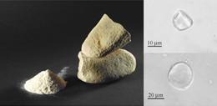
Paleolithic grinding tools
Ewen Callaway, Stone Age Flour Found Across Europe, Nature, Oct. 18, 2010, http://www.nature.com/news/2010/101018/full/news.2010.549.html

Art
Paleolithic people created what we would call art. To them, objects and paintings may have held symbolic meaning – we don’t know for sure because they didn’t have writing to express directly what they believed. The most well-known Paleolithic art comes from caves such as Lascaux in France, thought to be about 20 000 years old. The cave art is either painted on the cave walls with pigment (sprayed or brushed) or engraved into the stone. The most commonly represented animals are horses. There are also bulls and cows, bears, felines, bison, ibexes and aurochs. The cave artists also created many geometric signs such as hooks, crosses, squares and lines of dots. There are no plants or landscapes depicted. Their artistic techniques allowed them to show motion, such as a horse falling or rolling on the ground. Only one human figure was drawn in the entire Lascaux cave – a stick figure with a bird-head. The artists may have used scaffolding to reach their painting or engraving locations. More than 100 animal-fat lamps have been found in the cave showing that this kind of tool was used to light the way into the deep recesses of the cave. Recent research suggests much of cave art might have been made by women owing to interpretations of hand size of the artists.
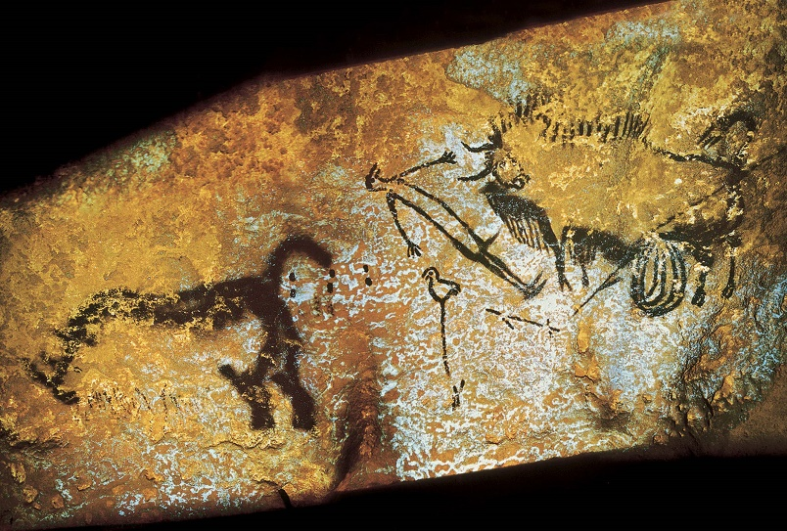
Human figure from Lascaux – Bird-headed man with bison
University at Buffalo Library, Digital Collections, Bird-Headed Man with Bison, N.d., http://digital.lib.buffalo.edu/items/show/35518
Art and Religion
Lascaux raises questions about religion and roles. Did the animals have more than a practical significance for Paleolithic people? Did people specialize as artists? If so, were there other specialized positions in the bands? The following quote from the Lascaux website gives an interpretation of the spiritual meaning of the artwork.

“More recently, research carried out at Lascaux by Norbert Aujoulat between 1988 and 1999 revealed the fact that the construction of the panels followed a fixed and unchanging protocol, according to which horses were always drawn first, followed by aurochs and then stags. Under such conditions, time itself becomes a crucial factor. This sequence, systematically used for every composition in the sanctuary, responds to biological requirements, revealed by the seasonal attributes seen on the animals. This analysis shows that the horses' features correspond to the early spring, the aurochs to the summer and the stags to the autumn. The various phases of these biological cycles indicate, for each species, the beginnings of mating rituals, which bring life. Over and beyond this literal reading, it is the rhythm, and even the regeneration, of time that is symbolised. The phases of Spring, Summer and Autumn are thus reproduced, a metaphoric evocation that, in this setting, links biological and cosmic time.
These vast painted and engraved compositions seem like witnesses to a spiritual way of thinking, whose symbolic significance is based on a cosmogonic approach. From the entrance of the cave to its very depths, the great book of the first – the founding – mythologies unfurls before our eyes, with its central theme, the creation of the world.” (Ministiere de la Culture, Lascaux Cave, ND, http://www.lascaux.culture.fr/index.php?fichier=04_07.xml)

Another well-documented but still open-to-interpretation area of Paleolithic art is venus figurines. These statues of seemingly pregnant women have been found in many locations. Their reproductive features, such as breasts and genitalia, are usually exaggerated. An interpretation is that they relate to female fertility in some way. The oldest such figure now dates from 35 000 years ago in the Hohle Fels caves in Germany. Are they religious or spiritual objects? Works of art? Were they made by women or men?
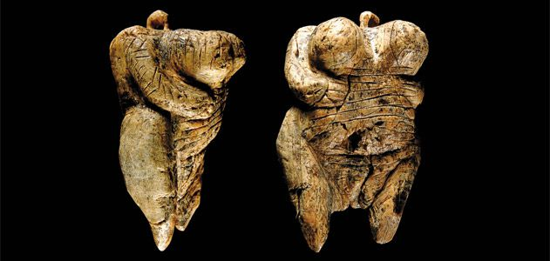
Tiny Venus figurines from Hohle Fels cave
Andrew Curry, The Cave Art Debate, Smithsonian, March 2012, http://www.smithsonianmag.com/history/the-cave-art-debate-100617099/

Study of Paleolithic people is always advancing with new and creative scientific techniques. With so much of their lives open to speculation, it will be interesting to see what is discovered in the near future. Our focus now turns to why Paleolithic life changed around 10 000 years ago.
Sources
http://anthro.palomar.edu/homo2/mod_homo_5.htm
https://www.penn.museum/documents/publications/expedition/PDFs/34-3/Dibble.pdf
http://news.nationalgeographic.com/news/2006/12/061207-sex-humans.html
https://www.theguardian.com/artanddesign/2013/feb/16/ice-age-carvings-british-museum
http://www.britishmuseum.org/research/collection_online/collection_object_details.aspx?objectId=808748&partId=1
http://discovermagazine.com/1998/apr/newwomenoftheice1430
http://web.a.ebscohost.com/hrc/detail/detail?vid=24&sid=a612d088-f4c7-4290-98a2-a5c4e5c21e8e%40sessionmgr4006&bdata=JnNpdGU9aHJjLWxpdmU%3d#AN=118184422&db=khh (Weston Williams, World’s Oldest Fish Hooks: What They Tell Us About Paleolithic Japan, Christian Science Monitor, Sept. 19, 2016)
http://www.nature.com/news/2010/101018/full/news.2010.549.html

