GLS Stress in the Time of COVID-19
Adapted by R. Gluskin from Lisa M. Schab, Workbook for Teens: Activities to Help You Deal with Anxiety & Worry, 2008.

The feeling of stress has been described with many different words. Here are some of them. Circle/bold/highlight those that you’ve applied to yourself:

anxiety
edginess
apprehension
the jitters
worry
jumpiness
nervousness
the shakes
fear
butterflies
uneasiness
freaking out
panic
disquiet
agitation
angst

While everyone experiences stress, some of us feel it more often, some more deeply, some less frequently, and some less intensely. Your own experience of stress will depend on:
1. Genetics—how your parents, grandparents, and ancestors experienced anxiety
2. Brain chemistry—the type, amount, and movement of the chemicals working in your brain
3. Life events—the situations you are faced with in your life
4. Personality—how you look at and interpret things that happen to you
This Photo by Unknown Author is licensed under CC BY-NC
G
ood news! Genetics, brain chemistry, and life events are factors that you have little or no control over. Your personality, or the way you perceive and handle life events, is something you have a great deal of control over—probably more than you realize. For that reason, most of the activities in this worksheet will focus on working with your personality, helping you to understand the way you look at and respond to life and suggesting ways to do it that will help you to lower your stress level.
The Chemistry of Anxiety/Stress
Our bodies respond to anxious/stressful thoughts by emitting stress hormones. This built-in biological reaction is called the fight-or flight response.

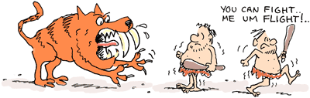

In prehistoric times (millions to thousands of years ago), humans faced challenges different from those they face today. For example, a common challenge for prehistoric man may have been to walk outside his cave in the morning and find himself face-to-face with a huge, hungry lion. Human bodies are miraculous creations that are programmed to survive. When confronted with a threat such as a lion, the brain would send the signal, “Threat!” and the body would respond by shooting hormones, such as adrenaline, into the bloodstream at lightning speed. That made the body immediately stronger and faster so the human could either wrestle the lion (fight) or run away very fast (flight). When humans either fought or ran away, the physical exertion (energy) would disperse (break up) the hormones, and the body chemistry would quickly return to normal. In today’s world, our bodies still release stress hormones when we are faced with a threat. The chemical release raises our blood sugar, heart rate, blood pressure, and pulse; slows our digestion; dilates our pupils; and causes us to breathe more shallowly. While these changes prepare us for fast action, we don’t usually take fast action, so our hormones don’t disperse. You may become anxious when you look at the history test your teacher has just handed you and realize you don’t know any of the answers, but you are not likely to respond by fighting with the history teacher or running from the classroom. As you sit at your desk “stewing,” the anxiety just continues to build. Built-up anxiety makes us vulnerable to emotional and physical problems. To stay healthy, we have to find ways to avoid or disperse those chemicals.

Prevention and Intervention (Knowledge / 5 marks)
- Put a “P” next to the phrases that describe activities done as prevention (before a situation or event) and an “I” next to the phrases that describe activities done as intervention (at the time of a situation or event).
___ Studying for a test in advance
___ Recalling information at the time of a test
___ Eating a variety of healthy foods daily
___ Drinking orange juice when you have a cold
___ Slamming on your brakes to avoid an accident
___ Driving at the speed limit
___ Washing your face on a daily basis
___ Applying acne cover-up when your face breaks out
___ Bringing a granola bar in your backpack in case you get hungry
___ Buying a granola bar at a vending machine when you get hungry

- Reflect on and answer these questions (Thinking /7 marks)
- Describe three activities you have done in the past week that could be considered prevention of stress.

2.
3.
b) Describe three activities you have done in the past week that could be considered intervention in stressful situations.

2.
3.

- Describe a situation in which your intervention would have been better/more successful if you had also practiced prevention.

Having an Awesome Attitude
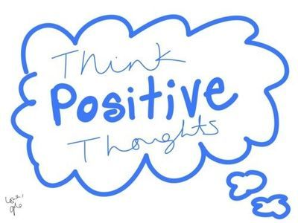
Do you think? If the answer to that question is yes, then you already know how to use an awesome stress-management tool. Your thoughts create your experience of life. Your attitude, or the way you think about things, is one of the most powerful tools you have to help you prevent and manage feelings of anxiety. And since you are the only one who controls your thoughts, at every moment you have the ability to create a peaceful experience or an anxious experience for yourself.
Thoughts → Attitude

Read this example:
Tristan and Jon were training for their school’s big cross-country meet. They decided to meet at the field house at noon on Saturday to run a ten-mile course through the surrounding neighbourhoods. Saturday turned out to be the hottest, most humid day of the summer. The boys began to run. About one-third of the way through, both boys were really feeling the heat, but they didn’t want to stop because they needed the training. They kept running, getting hotter and thirstier with every step. By the time they were two-thirds of the way through, all that either of them could think about was a cool drink of water. When they finally hit the last stretch, they were hotter than ever and their clothes were drenched with sweat. Upon reaching the school, they both ran straight for the drinking fountain, only to find that it wasn’t working. There was no drinking water at all except for a half-full water bottle sitting next to the fountain. Tristan had left it there before they started their run. Both boys looked at the same water bottle, and both had different reactions. Tristan said, “Oh man! I am so glad I left this water bottle here! It’s just half full, but that’s better than nothing! Gee, are we lucky to have this!” Tristan’s attitude made him feel peaceful. Jon looked at the very same water bottle and said, “Oh no! I can’t believe this is all we have! This is terrible! I could drink ten full bottles myself, and all we have is a half of one!” Jon’s attitude made him feel anxious.
Each boy was in the same situation, but each experienced it very differently having nothing to do with the situation itself. Their experiences came from within each of them—from their attitudes.

- Reflect and answer the questions below. (Thinking /3 marks)
- Under normal circumstances, are you more like Tristan or Jon?

- Do you think under current (pandemic, online learning) circumstances this has changed a bit? How so?

- In the pair of quotes below, two young people are in the same situation, but one has a positive attitude and one has a negative attitude. Under the quotes, write what each person might be thinking to cause their individual feelings. (Knowledge /2 marks)
- “the sun is setting on another boring day of social distancing”

- “the beautiful orangey-red sun is setting on another day of COVID-19 indoor adventures”

- Please reflect and answer these personal questions. (Thinking / 6 marks)
- Describe a recent situation in which you experienced stress.

- Describe what you were thinking that caused this stress.

- What could you have thought to make the experience a more peaceful one instead?

- Describe a recent situation in which you felt peaceful.

- Describe what you were thinking that caused you to feel peaceful.

- What could you have thought that would have made the experience a stressful one instead?

Reflect and Think Ahead
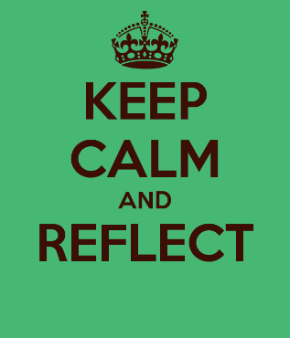
- Read over the two situations you just wrote about. If possible, share them with another person. Think and talk about the awesome power of your attitude to affect how you experience life. As you go through the upcoming days, notice how your attitude about anything that happens affects your stress level. (Application /6 marks)

- What are some ways that you can demonstrate a more positive/peaceful attitude in these difficult circumstances (pandemic/online learning)?

- How can you help others (friends, family, class members, teachers, etc.) to do the same?

- How are these stress-relief techniques related to growth mindset? If you don’t remember growth mindset, please go to this page on Ms. G’s blog to read over the worksheet again: http://gluskin.ca/gls-2020/gls-worksheets/ There is also a graphic there that will really help you understand what an obstacle a fixed mindset can be.

More to come on stress. Thank you for participating in this GLS activity. We hope it is helpful.
Total Marks
Knowledge = / 7 marks
Thinking = / 16 marks
Application = / 6 marks

Curriculum Expectations:
- Overall: apply knowledge of their personal skills and learning strengths to develop strategies for success in secondary school;
- use personal knowledge and an understanding of self-advocacy to develop effective strategies for enhancing success in school (e.g., stress management, scheduling homework, seeking academic assistance).
• Overall: identify and describe personal-management skills required for success, and explain their use to help maximize learning;
- analyse the importance of personal management skills in school, work, and daily life (e.g., dealing with stress related to test taking, managing time to accomplish multiple tasks, persisting with work related tasks until completion) and their impact on success;
- identify and describe personal lifestyle strategies that enhance health and wellness and improve one’s readiness to learn (e.g., exercising regularly, getting enough rest, following a nutritious diet, maintaining a balance among priorities; adopting holistic approaches to well-being, such as those found in Aboriginal cultures);
• Overall: demonstrate the use of personal-management skills and strategies to enhance learning.
- use personal-management skills (e.g., prioritizing tasks, being punctual, completing assignments) to improve learning in different environments (e.g., classroom, school, workplace, community);
- identify internal and external factors that affect behaviour and school performance (e.g., emotional stress, motivation, racism, peer attitudes, exclusion, physical distractions), and identify strategies for improving behaviour to enhance learning;
- demonstrate behaviours that reflect self motivation and self-reliance (e.g., taking initiative to apply stress management techniques, being persistent in pursuing a goal, completing tasks independently);
- explain how stress can positively and negatively affect learning performance (e.g., with regard to test taking and work completion), and demonstrate effective use of stress-management techniques to maximize performance.

