GLS: Motivation in the Time of COVID-19
Self-Reflection and Action Plan

Days are long and repetitive. Familiar and much-loved activities are barred. This is the new normal.
What motivates you? What makes you wake up in the morning and get to school work?

Complications with Motivation During COVID
In his “Hierarchy of Needs” theory, psychologist Abraham Maslow identified and categorized people’s needs, from basic to highest, and arranged them in a hierarchy or triangle.

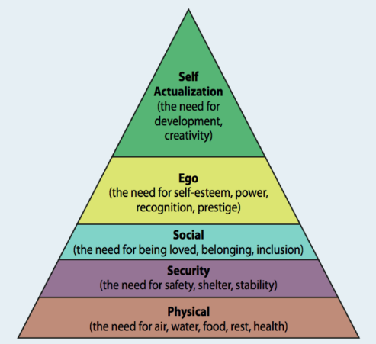
Maslow’s idea was that if a person’s physical needs are being met (food, water, shelter, sleep, clothing), they can concentrate on the next level up. And so on for each level. His goal was to reflect the way that a positive attitude to mental health, growth and development could be achieved in life.
The trouble during the pandemic is that our physical and security needs are not necessarily being met on a daily basis, depending on the individual. That makes it more difficult to focus on the higher needs. Teachers recognize this. However, it is up to you to make your needs known to your teachers. If we know that you are struggling, we can find ways to support you.
Keep in mind, Maslow didn’t necessarily believe everyone would achieve the top level – self-actualization – during their lifetime.

A Time of Transition to Remote Learning
Does online learning require more motivation and attention? It’s obvious that students on their phones or computers can be easily distracted. Now, in some ways, there is less accountability than before – if your camera and microphone are off during a class “Google Meet” you could be doing something completely unproductive. You might not even be online at all. The teacher may not even notice.
Has your learning been disrupted and/or changed? The transition to this new form of learning has its own complications. Sure, for most of you, your time is more flexible now. But that doesn’t mean it’s easy to make the right or best choices.
Motivation is a complex psychological phenomenon. Here, we will keep it simple and relevant to remote learning for grade 9, 10 and 11 students.

The Motivation Trap
Ms. Gluskin is the student success teacher at York Mills. She normally meets with students one-on-one in her office. The vast majority say they suffer from motivation problems; they have no motivation to do their work, or to learn, they say. After hearing this over and over for the last eight years, Ms. Gluskin, upon doing some research into the subject, came up with the idea that motivation is a trap. Beware: Ms. Gluskin is not a psychologist, nor is she a therapist. She’s a teacher. Her views on the subject are anecdotal (based on what she says, not on data or science).
Ms. G began to think that lack of motivation was an excuse. Though students definitely lacked motivation, they would use it (the lack of it) as the reason for not doing their work. Or at least their misunderstanding of motivation would lead to work not being done. This really bothered Ms. Gluskin because she got the sense that students were waiting for some magical moment when motivation would fall from the sky and hit the student on the head. Poof – motivation would arrive, and the student would move on with studying.
In fact, the psychology of motivation reveals it to be a complex thing. The rest of this worksheet is based on the science behind motivation (not Ms. G’s ideas).
Two Kinds of Motivation (Thinking /4 marks)
Intrinsic (internal – inside of you) – check the aspects of intrinsic academic motivation that apply to you (may differ from course to course – write the name of the course)
I push myself to learn because of:
- My own curiosity
- My own interest
- Wanting to prove something to myself
- My own love of the subject
- My belief in relevance of the subject to the real world
Psychologists say that intrinsic motivation is more self-sustaining. This means people are more likely to maintain it on their own without outside involvement. Why would this be?

Extrinsic (external – learning is dependent on factors outside of yourself) - check the aspects of extrinsic academic motivation that apply to you (may differ from course to course – write the name of the course)
I learn because of:
- Marks
- Expectations of others (including parents, friends, other students, teachers)
- Fear (of failing, of falling behind, etc.)
- Desire to get into a post-secondary destination
Psychologists say that extrinsic motivation can distract students from learning because it often depends on the use of reward and punishments which can become the focus more than the learning. Can you think of an example when that has happened to you?
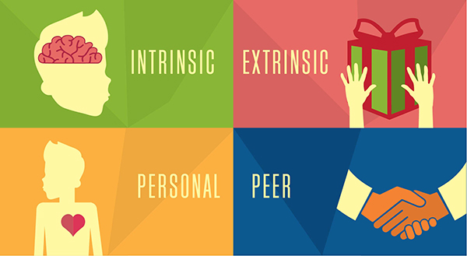
Figure 1 This diagram could help you remember the difference between types of motivation.

Things Related to Motivation:
Answer the questions that are relevant to you (at least four): (Thinking /4 marks)
Long-term thinking
- thinking ahead to when the pandemic is over, or to two or three years from now when you leave high school
  - will you be ready? Will you have the skills you need?

Procrastination
- we all do it – we leave things until the last minute
  - is it worsening for you?

Rewards and punishments
- rewards work best but they aren’t self-sustaining because they often have to be increased to make them effective
- punishments don’t tend to produce good results
  - how do you reward yourself for studying?

Goals
- now is the time for SMART goals, especially for goals to be achievable/realistic
  - are you using your SMART goal sheet for other subjects (not just GLS?)

Risks
- often people are afraid of taking a risk for fear of failure
  - are you willing to try something new and unfamiliar (such as dropping into a virtual extra help room, or emailing your teacher a question)?

Avoidance
- some people deal with lack of motivation by not doing any work
  - is your procrastination or stress so bad that you’re avoiding work altogether?

Control
- we tend to feel more comfortable when we are in control of the situation
  - do you feel you have more or less control over your learning in this remote format?

Initiative
- now is the time to apply what you have learned about taking initiative (being pro-active, not waiting for something to happen but making it happen yourself)
  - how have you noticed yourself taking more or less initiative than before?

Persistence
- hang in there – times are tough but you will get through
  - what’s your general level of persistence when times are tough?

Ways to Find a Bit of Motivation
Remind yourself that school will continue again, some day. You don’t want to make your future too much worse by turning yourself “off” during the pandemic.
It’s nice to feel proud of yourself. It provides a little dopamine reward in your brain – something that makes you feel good.
Build on the good habits you developed in GLS in room 145. Try to repeat that success. Phones were away, most of you were working fabulously well, and relatively independently.
Even If You Lack Motivation Now, Try These Things: (Thinking /2 marks)
For each of the following rank yourself from 0 to 5 (5 being the best, 0 being the worst):
Organize your time and materials – make a schedule to follow – it doesn’t have to account for every single minute of your day, but it should give you some control over your time and a way to say no to distractions during class or work time! Keep your work space (wherever it is) neat and your materials easily accessible. Also, keep your files on your computer or phone organized; give everything a title and place it in a labeled folder.
0 1 2 3 4 5
Follow a growth mindset; even in remote learning, your brain still learns the same way, through neuron connections that are strengthened with practice.
0 1 2 3 4 5
Improvement in focus (especially avoiding so-called multi-tasking where you do multiple things at once. Actually, multi-tasking isn’t an accurate term. It’s best to think of it as switching between tasks. We all know that focus is required in order to learn so switching quickly between tasks is very bad for learning. Constant switching actually makes the task take longer!) So, close those Instagram and YouTube tabs while you are supposed to be doing schoolwork.
0 1 2 3 4 5
Take short breaks. Use a timer so you will actually come back to your task after 5-10 minutes!
0 1 2 3 4 5
Connect with people – learning can still be interactive; it is the human connection that most of us crave. Feeling good might make you want to learn.
0 1 2 3 4 5
Make time for fun (just not all the time).
0 1 2 3 4 5
Recognize that you are experiencing something difficult, new and potentially very traumatizing. Give yourself permission to feel sad, upset, uncertain – whatever it is you feel. Reach out to your supports: don’t wallow alone in your sadness. Email your guidance counsellor. Request a “google meet” or hangout with your favourite teacher. Talk to your family. Don’t bottle it up – people want to help you.
0 1 2 3 4 5

Time to Take Action (Application /8 marks)
Now that you have read the above information about motivation and you have self-reflected (through answers to the questions), it’s time to make a plan. Answer the questions below to develop a plan.

Step 1: Based on your self-reflection, what’s your overall motivation level for learning right now? Circle one.
low medium high
Comment/Explain:

Step 2: Based on your current motivation level (above), what is the one tip from the previous pages that is most likely to get you more motivated? Explain your answer.

Step 3: Turn the tip from above into an action plan for you. In other words, make it a SMART goal (specific, measurable, achievable, results-oriented and time-bound).
S
M
A
R
T

Step 4: Incorporate your motivation goal into your weekly SMART goal sheets to help you increase your motivation level on an ongoing basis.
Evaluation (based on curriculum expectations below)
Total Thinking Mark = /10 (honest and open reflections)
Total Application Mark = /8 (high quality, well-explained answers with details)

Curriculum Expectations:
Thinking (reflect)
- analyse the importance of personal management skills in school, work, and daily life (e.g., managing time to accomplish multiple tasks, persisting with work related tasks until completion) and their impact on success;
- identify internal and external factors that affect behaviour and school performance (e.g., motivation), and identify strategies for improving behaviour to enhance learning;
Application (use a skill)
- produce an action plan for improving personal-management skills that identifies personal strengths, challenges, and steps for improvement.
- use personal-management skills (e.g., prioritizing tasks, being punctual, completing assignments) to improve learning in different environments (e.g., classroom, school, workplace, community, home).
- demonstrate behaviours that reflect self motivation and self-reliance (e.g., taking initiative, being persistent in pursuing a goal, completing tasks independently – SMART goal sheets).

