CHW3M Course Culminating Activity (CCA) Overview
Choose a civilization that we won’t study together as a class. It can be a rising civ, a flourishing civ, or a declining civ. Apply all the skills that you have developed during the course to your inquiry into this new civ. Cite everything and use multiple, reliable sources! Use CRAAP tests if you use websites. Use the criteria for civ that we have used throughout the course.
Choices of civ include Mali (west Africa), Japan (Yamato, Asuka, Nara, Heian, Kamakura), India (Maurya, Gupta), Mongols, Vikings, Inca, or Shang dynasty China.
For most of these civs you would focus on a particular time period, such as some of the dynasties/periods mentioned above. Remember that the course ends in 1450. You cannot go past that date.
You don’t have to have a theme at the beginning. However, as your research proceeds you should develop a focus on something: technology, social classes, religious movements. It will be your choice AFTER you do basic research.
Every step of the way, notes and writing MUST be in your own words. Plagiarism will result in zeroes.

The Inquiry Process 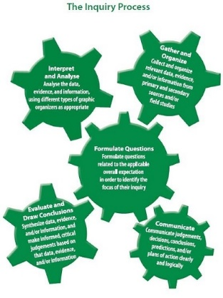
CCA Step 1
In CCA Step 1, address and show evidence of the following aspects of the inquiry process. Evidence must be given in a list of questions.
- Formulate questions – what is driving your curiosity about this civ? What deep questions do you have about this civ? Use the inquiry question grid on the blog to help you.
Read a bit and create some questions that show your knowledge. Questions should also show what you wonder about.
Good question: With the Taino people moving from Caribbean island to island, how did they establish a unified culture?
Bad question: Were the Taino people unified?
In CCA Step 1, you will also begin your note-taking process using books and resources from the YM library and the databases. Evidence must be given in the form of note-taking sheets.

- Gather and organize evidence – take notes from three book sources using the column note-taking method. Record bibliographic information (in Chicago style) at the top and page numbers in the first column.
Curriculum Expectations for Step 1
Address the following curriculum expectations when researching the civ. Each needs to be represented in your notes (see the fourth column).
- Analysis of social, economic and political structures and developments (PERSIAT)
- Analysis of stability and/or expansion factors (re: territory)
- Assessment of contributions of key individuals and groups
- Analysis of good and bad interactions with other parts of the world

CCA Step 2
In CCA Step 2 you will continue taking notes as needed AND do the following parts of the inquiry process while narrowing in on more particular aspects of the civ:
- Interpret and analyze evidence
- Evaluate and draw conclusions from evidence

For the continuity and change HTC:
- Create a timeline with attitude with five events described on it (progress above the x axis and decline below the y axis from the perspective of at least two selected groups of people, such as upper class, peasants)

CCA Step 3
In CCA Step 3 you will take everything you have learned and put it together in a creative final product.
- Communicate arguments, conclusions and judgements
Choose the format of your final product:

- Children’s book (historical fiction)
- Museum display
- Set of four HTC posters with accompanying explanations
- Five-paragraph essay

