GLS10 INTERPERSONAL SKI LLS – SELF-ASSESSMENT
Interacting with Others
Name: __________________________ Date: ____________________
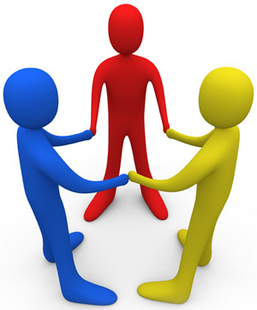
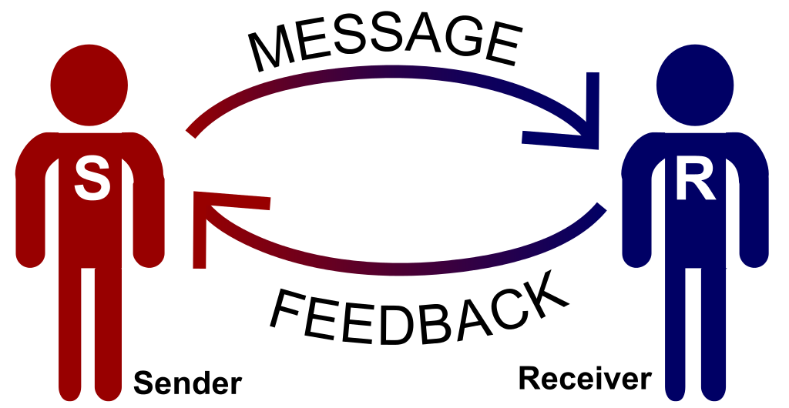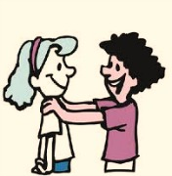

With whom do you have relationships?

At school | At home | Other
e.g., teachers | e.g., sibling | e.g., boss

Interpersonal skills improve communication and relationships between people. They are especially important in school and work where you often have to cooperate with others, for marks or for pay.

Speaking
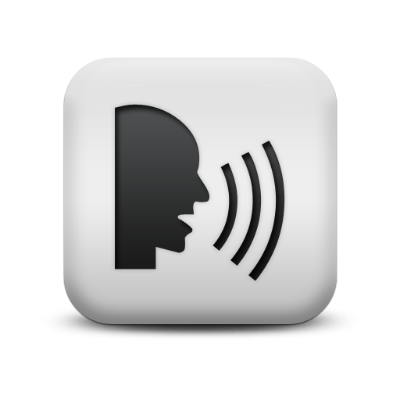

Verbal Communication
How you say something can be as important as what you say.

Your voice can be loud, quiet, or at just the right volume.

You can speak quickly, slowly, or at just the right pace (speed).

You need to speak clearly, too, so that the listener can understand your words. Clear pronunciation is very important.

Question: What are your strengths and weaknesses in this area?

Non-verbal Communication
We communicate with more than just our words and voices. We have other ways to send messages, intentionally or not.

- eye contact
- facial expressions
- tone of voice
- gestures
- physical distance

We express feelings and send signals through our non-verbal communication. We agree or disagree through a simple nod of the head. Since communication is a two-way process, non-verbal forms can be very important in giving feedback – indicating to the other person that you understand, or are perplexed or surprised by what they are saying.

We also have to realize that the place where an interaction occurs can influence the message. The way you carry yourself when you hang out with your friends should be different from the way you carry yourself in class.

Another way that we communicate non-verbally is through how close or far we are from others. Distance can convey both respect and aloofness – it depends on the circumstance. Being very close can send a message of trust, or it can make the other person feel uncomfortable.

Active Listening 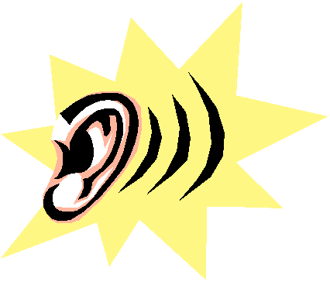
Listening is part of having relationships with other people. If you’re listening, it means you’re not just hearing the speaker’s words, you’re also paying attention to the non-verbal messages that show their feelings. A person can say she is happy but might sound sad. Similarly, a person can smile but have a tear in his eye. If you’re a good listener, you can interpret (try to understand) feelings and words.

It takes a lot of focus (paying close attention) to listen actively.

Questions:
For you, what is the hardest part about listening?

What do you think is the most comfortable distance to be apart from someone when having a conversation with them?

Non-Verbal Communication
We communicate with more than just our words and voices. We have other ways to send messages, such as how we feel. Sometimes we mean to send them, sometimes we don’t.
- Sometimes they are positive messages, sometimes they are negative messages.

 | Which messages can we send through each type of non-verbal communication? (Fill in five additional boxes. There are a few samples for you. Some sentences are started for you.)
 | Good message | Good message | Bad Message | Bad Message | Other?
Eye contact |  |  | When I don’t look at the teacher when she speaks my message is that I don’t think what she’s saying is very important.
Facial expressions | I smile when someone tells a joke. My message is that I’m listening to the speaker.
Tone of voice (the emotional in your voice) |  |  | I whine when I speak. My message is that …
Gestures (hand movements to emphasize speech) |  |  | I play on my phone when the teacher is talking to me. This sends a message that…
Physical distance (how close or far we are from someone when we communicate) |  |  |  | When I stand really far away from someone when they speak, my message is that…

GLS10 INTERPERSONAL SKI LLS – Reflection

- Describe a time when you had an unsuccessful interpersonal interaction in a social setting (with friends).
Once, I

- A) Describe a time when you had an unsuccessful interpersonal interaction with a teacher.

Once, I…

B) How did it affect your learning?

It caused me to…

- A) What are some interpersonal skills that you need to improve on in school?

I need to improve my _________________________________________________.

B) In social settings?

When I interact with friends, I need to improve my ___________________________.

- Go back to one of your long-term goals (from the goals and habits worksheet). How would improvement of a certain interpersonal skill help you achieve this goal?

My goal is to ________________________________________________________________________. To meet this goal, I can improve my ______________________________________________________.
This will help me because I will be able to …

Curriculum Expectations: By the end of the course students will:
- Identify and describe a variety of verbal and non-verbal communication skills necessary for successful interpersonal relations in a variety of settings; Describe how interpersonal and teamwork skills can promote achievement of individual learning goals; Use appropriate interpersonal skills to maximize learning; Evaluate the importance of various interpersonal and teamwork skills in a variety of learning situation

