GLS10 STRESS – PART 1

Stress Is Not Necessarily A Bad Thing

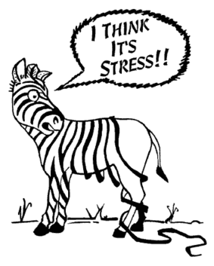
‘We all talk about stress, but we are not always clear about what it is. This is because stress comes from both the good and the bad things that happen to us. If we did not feel any stress, we would not be alive! Stress becomes a problem when we are not sure how to handle an event or a situation. Then worry sets in, and we feel “stressed.” …

Stress is a reaction to a situation — it isn’t about the actual situation. …

Stress is part of being human—no one can eliminate all stress from their life or prevent stress from ever happening in the future.’

(Canadian Mental Health Association)

Stress is Helpful
Stress is a natural part of life. Stress motivates us to do things! Without it we wouldn’t feel the urge to try hard, study, or do assignments, exercise, or address problems with friends. Stress makes us focus. It pushes us to solve problems.

Stress Effects
Stress can affect people physically (inability to sleep, sweating, tense muscles, quick heartbeat, headaches). Stress can affect people mentally/emotionally by causing worry and perhaps a feeling of being overwhelmed.

React/Reflect (2) Thinking

I am surprised to learn that _________________________________________________________________
________________________________________________________________________________________.

My most common symptoms of stress are ________________________________________________________________________________________
________________________________________________________________________________________.
________________________________________________________________________________________

Stress Management Strategies
There are many strategies that can be used to cope with stress.
- Break problems into smaller, manageable pieces or steps that you can address one at a time.
  - This makes the tasks seem less overwhelming – a hill is easier to climb than a mountain.
- Thought-stopping – learn to replace negative thoughts or worries with things that make you feel more relaxed.
- Positive affirmations – talk to yourself positively:
  - Instead of saying “I’ve got so much homework I’ll never get it done”, say: “I can get my homework done because I will use my time wisely.”
- Talk out your concerns with a friend, family member, guidance councillor, or teacher.
- Write out your concerns in a journal, diary or list.
- Focus on the moment - here and now, not “what if” - this is called mindfulness.
  - Visualize a peaceful situation or a lovely place you’d like to go.
- Breathe: focus on relaxing your breathing pattern – this can bring you back to calm, especially if you breathe deeply and slowly (hold for 4 then 8 counts). Yoga can be quite helpful.
- Meditation allows you to focus on peaceful thoughts and to reduce tension.
- Physical activity reduces stress hormones: move your body!
- Get the proper amount and quality of sleep. Try not to worry in bed – this causes you to associate the bed with stress, not sleep.
- Eat healthy food! Junk food causes blood sugar to rise and fall – not good for stress.
- Worry less about things you cannot control. Release your emotions through creativity, prayer, or laughter.
React / Reflect (4) Thinking

For each bullet point above, indicate if you’ve ever used this management strategy. 3 = frequently 2 = sometimes 1 = never

Describe a time you used one of these strategies successfully.

Describe a time you SHOULD have used one of these strategies but didn’t. How would it have helped?

Stress Scenarios (5) Knowledge

- Student X arrives home after school and is tired and feeling lazy. He doesn’t want to do anything other than watch television and play video games. He plays for an hour. After an hour, he starts to get a gnawing feeling in his stomach that he should do his work. He puts aside his video games and creates a list of his most high priority school work. After dinner he starts work on the first task on the priority list.

Is stress a positive or negative factor here? ______________________________
Which stress management strategy is/is not being used here?
_________________________________________________________________

- Student Y is feeling nervous during a math test. He starts to sweat and his heart races, distracting him from the test. He takes a few moments to calm himself down by breathing deeply and settling his heart rate. After, he continues the test.

Is stress a positive or negative factor here? ______________________________
Which stress management strategy is/is not being used here?
_________________________________________________________________

- Student Z has an oral presentation tomorrow in class. She feels worried about presenting in front of the class. She has a quick talk with her mother who suggests that she practice the presentation in front of her. After that, she feels more prepared.

Is stress a positive or negative factor here? ______________________________
Which stress management strategy is/is not being used here?
_________________________________________________________________

- Student M has been missing deadlines for work in English class all semester. By the end of the semester she tries to hand in some really low quality work. The teacher will not accept it.
Is stress a positive or negative factor here? ______________________________
Which stress management strategy is/is not being used here?
_________________________________________________________________

- Student N spends a lot of time worrying about what will happen if she doesn’t get an amazing mark on her math test and what will happen if she doesn’t get her desired mark in physics class. Her worries lead to procrastination and inability to sleep at night. Eventually she stops coming to school.
Is stress a positive or negative factor here? ______________________________
Which stress management strategy is/is not being used here?
_________________________________________________________________

Maladapted Responses to Stress 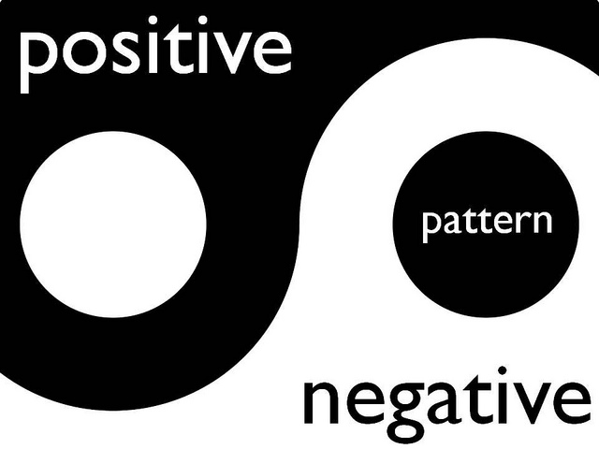
Sometimes teenagers choose to relieve their stress in ways that aren’t really helpful. They may seem comforting at the time (in the short-term), but in the long-term they aren’t really addressing the problem. They end up actually causing more stress.
- Drug use
- Smoking
- Alcohol use
- Excessive video gaming
- Self-harm
- Extreme procrastination / work avoidance / ignoring the problem
- Poor school attendance
React/Reflect (3) Thinking
Have you ever used one of these maladapted responses?* If so, which one? ________________________
When? ___________________________________________
For which stressor? _____________________________________________________________________
Describe how it might have helped you feel better in the short-term but only led to more problems in the long-term.

*If no, please explain why you have not resorted to a maladaptive response to even your worst stressor.

Part 1 Assessment

1-4 = filling up space on the lines 5-7 = giving it some thought 8-9 = being honest, precise and reflective

TOTAL = /9 marks thinking

TOTAL = /5 marks knowledge
Curriculum Expectation: Explain how stress can positively and negatively affect learning performance and demonstrate effective use of stress management techniques to maximize performance.

GLS Stress Part 2 – Reading attached (pages 5a and 5b)

Read “How does the Body Handle Stress?”.

- Identify a time when your “relaxed” nervous system pathway would engage (become active):

- Identify a time when your “emergency” nervous system pathway would engage:

Read “Is Stress Always Bad?”

- How are hormones helpful? Give 2 reasons.

Read “If Stress Is a Survival Tool, Why Does It Make Us Feel Awful?”

- How do our brains get confused between ‘real emergencies’ and imagined emergencies?

- Give (describe) an example of a time when you thought something was a ‘real emergency’ and your body reacted that way but in fact it was not.

Part 2 Assessment

0-3 = filling up space on the lines 3.25-4.75 = giving it some thought 5-6 = being honest, precise and reflective

TOTAL = /6 marks knowledge
Curriculum Expectation: Explain how stress can positively and negatively affect learning performance and demonstrate effective use of stress management techniques to maximize performance.

GLS Stress Part 3 - Connecting Growth Mindset to Stress Management
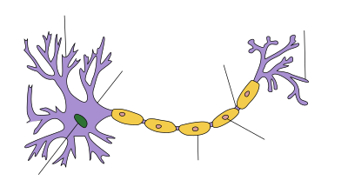

You have learned a lot about Growth Mindset (how we learn) already, both through the presentation at Academic Orientation and the worksheets we did in class. Now it is time to connect what you learned about the brain to what you have just learned about stress. This is a practice (or scaffold) for what you will do in the culminating project of GLS, Growth Mindset Portfolio.

Answer these questions using appropriate vocabulary from both topics (2 marks each):

- Explain why stress is especially likely to result when a person is in the novice stage of learning something.

- How does lack of sleep in teenagers contribute to stress?

- Give a personal example of a time when you either a) applied growth mindset and it reduced stress, or b) you didn’t apply growth mindset and it caused more stress.

Part 3 Assessment

0-3 = filling up space on the lines 3.25-4.75 = starting to get the vocabulary right 5-6 = using correct vocabulary in a precise
and deep way
TOTAL = /6 marks application and communication (recorded in both)
Curriculum Expectation: Explain how stress can positively and negatively affect learning performance and demonstrate effective use of stress management techniques to maximize performance.

