GLS10 Reading Skills and Strategies #3 – Reading Graphic Texts
Story #4 - “Vertical Farms Come to Town”, page 88 in Nelson Literacy = graphic text
Graphic text refers to the use of images, words, symbols and charts/tables to convey meaning in a visual format.
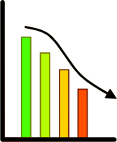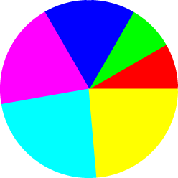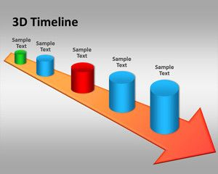
What kinds of graphic text could you expect to see in each subject?
History:
Geography:
Math:
English/French:
Science:

How To Read Graphic Texts
- Start by scanning for overall impression. It is very important to try to figure out the topic and purpose of the text. Without figuring out the purpose, you may get lost in the details without seeing the big picture (topic and purpose).
- At first, graphic texts can seem dizzying and random because there are so many features. However, your job is to connect the different features (parts) to each other to see what the graphic text actually means.
There are certain features you may see in graphic texts:

- Title
- Captions
- Legend
- Headings
- Labels
- Symbols such as arrows, lines, shapes
- Font size and colour of words
- Images, drawings and/or photos

Minds On: Questions to get you thinking about the topic BEFORE you read.
Is farming a crucial part of life?

During Reading: Notice that the questions take you through each quadrant of the graphic text.
- Top left: Why will farms be necessary in cities in the future?

- Top right: Do you think the photo of the vertical farm in a body of water is real or faked? Explain your answer.

- Bottom left: On the Advantages/Disadvantages chart, which bullet point seems most important to you? Explain your answer.

- Bottom right: Does the more detailed photo help you understand the content of the graphic text more easily? How so, or how not?

After Reading: for each, identify which type of question: direct, indirect, big ideas.
- What is the topic of this graphic text? [type:____________]

- What is the purpose of this graphic text? [type:____________]

- If you were to add a graph to this graphic text, what would it have on the x axis and on the y axis? What would be the title? [type:____________]

- Why would you add the above-mentioned graph?

- Do you think “Vertical Farms Come to Town” is a successful/effective graphic text? Why, or why not? [ type: _______________]

Story #5 - “What Might Happen Next”, pages 90-91 in Nelson Literacy = graphic text
Minds On: Questions to get you thinking about the topic BEFORE you read.
Global warming is a serious challenge to humanity. Agree or disagree. Explain your answer.

During Reading:
- Read the potential timeline superimposed on the earth. Which potential is most shocking to you? Why?

- Read the temperature timebomb timeline at the bottom of the page. Which effect will have the biggest impact on Canada? Why?

After Reading: for each, identify which type of question: direct, indirect, big ideas.
- What is the topic of this graphic text? [type:____________]

- What is the purpose of this graphic text? [type:____________]

- Do you think “What Might Happen Next” is a successful/effective graphic text? Why, or why not? [ type: _______________]

- What connection can you make between this graphic text and the previous reading “Inuit Voices on Climate Change”?

