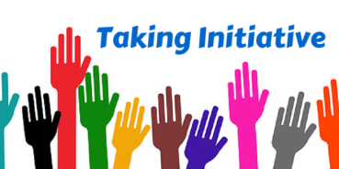
Initiative: Self-Assessment and Reflection
What does it look like when you take initiative? Rate yourself and be reflective about your abilities so you can grow and improve. Taking initiative in GLS class is desperately needed!
Definition = a new plan or process to achieve something or solve a problem (Cambridge Dictionary)

Circle the appropriate skill level
E = excellent (consistently)
G = good (a lot of the time)
S = satisfactory (sometimes)
N = needs improvement (hardly or never)

Initiative | In your PERSONAL LIFE | In SCHOOL
I approach new tasks with a positive attitude

I am not afraid | E G S N | E G S N
I think I will be successful with effort and practice | E G S N | E G S N
I see challenges as a good thing | E G S N | E G S N
I am confident but not cocky (over-confident) | E G S N | E G S N
I start a new task right away | E G S N | E G S N
I put my phone away when asked and keep it away | E G S N | E G S N
If I have no independent work to do in GLS I make sure my GLS binder is organized |  | E G S N

Turn the page, please
I have curiosity

I ask questions | E G S N | E G S N
I like to learn new things | E G S N | E G S N
I am open-minded (I don’t know all the answers and am willing to listen to others’ perspectives) | E G S N | E G S N
I look for opportunities for learning and take them

I use my time wisely for independent work in GLS |  | E G S N
I fill out my log carefully at the beginning of every GLS class |  | E G S N
I participate in class/group discussions |  | E G S N
I am awake and attentive in class (off my phone) |  | E G S N
I am willing to take risks
I answer questions in class even if I’m not sure I am right |  | E G S N
I try new activities and skills | E G S N | E G S N
I persevere through challenges (especially in the novice stage of learning something) | E G S N | E G S N
I speak to and interact with group members even if I’m not friends with them |  | E G S N
I reach out and talk to new people in class in a friendly, welcoming way |  | E G S N
I try to be creative | E G S N | E G S N

- Reflection: Now that we’ve been through 30 GLS classes, I realize/ I notice/ I believe…

- Action Plan: Next week in GLS class I will…

