Financial Literacy in Mathematics

Minds on: Discuss the following questions with your partner and write down your answers.
- What jobs do you know that pay an hourly wage? List three (3).
________________________________________________________________________________________________________________________________________________________________________________________________
- What jobs have a weekly, monthly or annual salary? List three (3).
________________________________________________________________________________________________________________________________________________________________________________________________
- What jobs do you think pay a commission? Explain your thinking.
________________________________________________________________________________________________________________________________________________________________________________________________
- What jobs do you think might pay a combination of salary and commission^ Explain your thinking.
________________________________________________________________________________________________________________________________________________________________________________________________
- If you owned a business, what are the advantages and disadvantages of paying your employees hourly wages rather than a fixed salary? Make a t-chart and list the advantages and disadvantages.

Action: With your partner, solve the following problems.
Problem 1

Maria is starting a job at Company XYZ. She is offered 3 options for her pay. Choose one option and answer the questions.

Option 1: Maria earns a weekly salary of $350 plus a 4% commission on her total weekly sales.

Option 2: Maria earns 10% commission on her total weekly sales.

Option 3: Marie earns a weekly salary of $350 regardless of her total weekly sales.

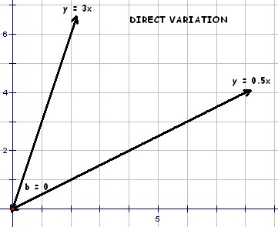

- Does the option you selected represent a direct variation or a partial variation? Explain your answer.

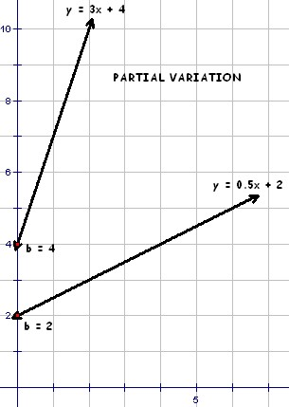

- Create an equation to represent Maria’s total weekly earnings E in dollars, if s represents Maria’s total weekly sales in dollars.

c) What are Maria’s total weekly earnings on total sales of $6000?

Problem 2

Marco earns a base salary each week and a commission based on his total sales.
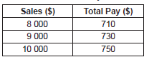

- Determine Marco’s rate of commission. Show all of your work.

- Determine Marco’s base salary. Show your work.

- Determine Marco’s total pay when sales are $26 850

- Create an equation to model Marco’s weekly earnings. Clearly identify your variables (Use “Let” statements).

Consolidate: Solve the following problem individually.
Problem 1: The graph below shows Rene’s weekly earnings.
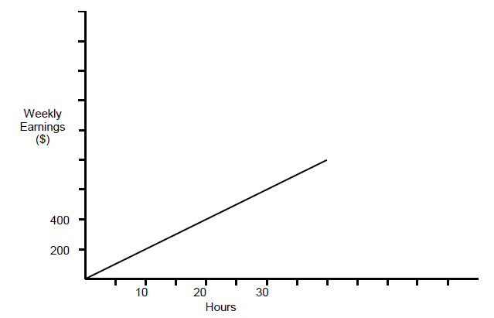
- Is Rene paid a wage or a salary? Explain how you know.

- Use the information from the graph to determine her rate of pay.

- Rene is paid ‘time and a half’ for hours worked over 40 hours per week. Complete the graph to show weekly earnings if Rene works between 40 hours and 60 hours in a week.

- If E is Rene’s weekly earnings in dollars, and h is the number of hours she worked in a week, create an equation that could be used to calculate Rene’s weekly wage if she were to work over 40 hours in a week.

