# Learning How to Learn – Growth Mindset – GLS Part 1

Name: __________________

This series of lessons will help you understand what happens in your brain when you learn.

## A: Thinking About Intelligence

1. **Discuss/Think.**  Is a grown person’s amount of intelligence a fixed quantity or can it change during his or her life? Record your opinion.

## B: A Look into the Brain

Now it’s time to learn a bit about what goes on inside the brain when you learn. This is a short science lesson. Read it over carefully, but don’t worry, you won’t be quizzed!

|  |  |
| --- | --- |
| Your brain is a collection of billions and billions of fantastic cells called *neurons*. Each neuron is like a tiny computer that **receives** signals through its *dendrites* and **sends** signals through its *axon terminals*. The axon terminal of one neuron connects with the dendrite of another, which allows the two cells to communicate. The location where they connect is called a *synapse*.[1] | https://askabiologist.asu.edu/sites/default/files/resources/articles/neuron_anatomy.jpg |
| While people learn something new, neurons will gradually sprout (grow) more axon terminals and grow more dendrites, making more connections. Each connection can grow stronger by forming more synapses[2]. Scientists can detect (find) these changes in people’s brains after they have learned a new skill. The part of the brain being used becomes larger and thicker because of the neuron growth. | Candidate cellular mechanisms. |

1. **Reason.** When youdo physicalexercise, your muscles change in response. How does the growth of neurons during the learning process compare with what happens during physical exercise? Explain.

|  |  |
| --- | --- |
| **Learning** | **Physical Exercise** |
| Neurons… | Muscles… |



|  |
| --- |
| When you are born, many of the neuron connections in the brain are just random (in no specific order). As you learn, the helpful connections are gradually **reinforced** and connections that are not used slowly **shrink** away. A new connection is very **fragile** (weak) and might only last a few hours if it is not reinforced. Only frequent, challenging tasks help reinforce or grow the connections. |

1. 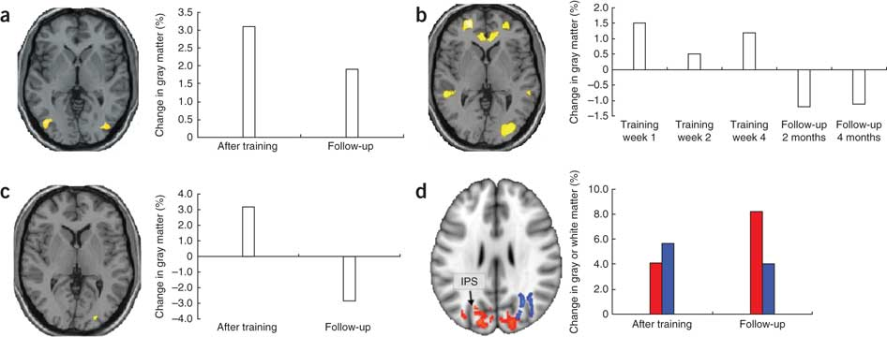**a) Explain.** In one experiment, people were trained to **juggle** during a four week period2. The graph to the right shows how the amount of grey matter (neurons) in their brains changed as time went by.

**b) Explain:** Use the ideas you just learned to explain, according to the graph, what is happening to the connections in their brain.

*During training the jugglers’ neurons…*

*After 2 months the jugglers’ neurons…*

*After 4 months the jugglers’ neurons…*

**GLS Part 1 completion and quality mark /5 thinking**

1 2 3 4 5

Poor quality or incomplete Good quality answers

Date: ____________________

# Learning How to Learn – Growth Mindset – GLS Part 2

Name: __________________

## C: Understanding the Learning Process

A brain scan shows the active areas of the brain where the connections are sending the most signals (white colour). The brain scan shown below shows a person’s brain at three stages of learning: **novice** (new to the task), **intermediate** (some practice), and **skilled** (lots of careful practice)[3].



1. **Reason.** Which brain is using more energy (more effort)? Explain.
2. **Reason.** There are many more connections sending signals in the novice brain than in the skilled brain. What can we say about the **usefulness** of the connections in the novice brain?
3. **Reason.** Making mistakes and learning from them is important part of the learning process. Why?
4. **Reflect.** Think of your own experience when you started learning a new skill. How does it feel in terms of energy? How does it feel emotionally?

*When I started learning to _________________________, I…*

When we learn something new, we might feel frustrated or discouraged at the start. We make a lot of mistakes – everyone does. All those connections in our brain are sorting themselves out: sometimes they send the right signals, and sometimes they don’t. Learning something new requires **persistence** to move past the uncomfortable novice stage. Luckily, we can reduce the time, energy, and frustration by choosing the most helpful learning habits based on how our brains work. When we do, **our brains grow stronger and we become smarter**. This is important: **learning helps your brain grow and you become more intelligent.**

# Learning How to Learn – Growth Mindset – GLS Part 3

Name: __________________

**D: Smart Learning**

For each situation below, use your understanding of *neurons* to help explain to a friend what they should do to learn better and why it works. Be sure to **mention what is happening to the neurons or connections** in your friend’s brain!

1. **Explain.** A friend says, “Instead of doing my homework tonight, I would rather wait until the weekend when I have more time.” What is your advice to your friend?

*You should…*

*It works because…*

1. **Explain.** A different friend says, “I’m going to study the night before the test. I’ll catch up on my work then.” What is your advice to your friend?

*You should…*

*It works because…*

1. **Explain.** A third friend says, “I’m just going to do my work quickly. I’ll check later to see if it’s correct.” What is your advice to your friend?

*You should…*

*It works because…*

**GLS Parts 2 + 3 completion and quality mark /5 application**

1 2 3 4 5

Poor quality or incomplete Good quality answers

Date: ____________________

# Learning How to Learn – Growth Mindset – GLS Part 4

Name: __________________

## E: Sleep and Learning

Sleep plays a critical (important) role in the **learning process**. When you have a **deep** sleep, the brain replays activity from the day allowing new connections to form or to be reinforced. Even intense practice can’t make up for lost sleep[4]. Sleep also helps to wash away the waste products (toxins) that build up in the brain after a day of thinking[5].

 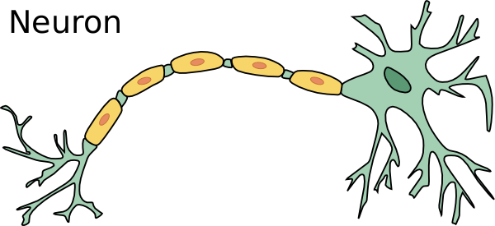

1. **Reflect.** What are the most common **reasons** that you do not get enough sleep (be specific)?
2. **Reason.** What is one simple **change** that you could reasonably make to **improve** the amount or quality of your sleep?
3. **Apply**. How will making this change help you learn?

**F: Help Your Friend**

Not all students know that the brain can grow and get smarter, even though this knowledge may help them succeed. We want to get your help, so we can learn more about how to explain it to them. We're hoping you can explain--in your own words--that the brain gets smarter when people use good strategies and try hard.

Imagine a friend who is struggling in school. This friend used to do pretty well in school but now is having a hard time and is starting to feel dumb. Write a letter to your friend to encourage him or her—tell them about what you just learned about the brain and why they shouldn’t be discouraged.

**GLS Part 4 completion and quality mark /5 communication**

1 2 3 4 5

Poor quality or incomplete Good quality answers

Date: ____________________

By the end of this course students will:

* Select and use strategies to improve their performance in school (e.g., knowing how we learn)
* Identify and describe personal lifestyle strategies that enhance health and wellness and improve one’s readiness to learn (e.g., sleep)

**References**

1. https://askabiologist.asu.edu/neuron-anatomy
2. Robert J Zatorre, R Douglas Fields & Heidi Johansen-Berg, *Plasticity in gray and white: neuroimaging changes in brain structure during learning,*  Nature Neuroscience 15, 528–536 (2012)
3. Ericsson, K. Anders, et al., eds. *The Cambridge handbook of expertise and expert performance.* Cambridge University Press, 2006.
4. Yang, Guang, et al. "Sleep promotes branch-specific formation of dendritic spines after learning." *Science* 344.6188 (2014): 1173-1178.
5. Xie, Lulu, et al. "Sleep drives metabolite clearance from the adult brain." science 342.6156 (2013): 373-377.