CHY4U Timeline with Attitude – Sample from Unit 1 – Catholic Church officials = Perspective
Progress
Looking for new souls to convert to Catholicism because of the success of Protestantism, Jesuit missionaries arrived in Japan. They found the Japanese people open to Christianity and ultimately converted up to 100 000 people in a short period.
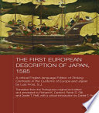 This is a translation of Luis Frois’ Historia de Japan. Frois was a Jesuit missionary who wrote about his experiences in Japan. The First European Description of Japan, 1585. Via Google Books.

Decline
Martin Luther posted his 95 Theses on the Castle Church door in Wittenberg, Germany, prompting the beginning of the Protestant Reformation and the loss of millions of Catholic souls. His complaints against the Catholic Church related to the practice of selling indulgences, which he labelled sinful, and to the power of the Pope, which he labelled as non-existent.
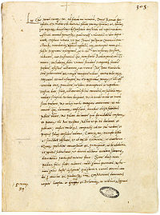 This is a copy of the 1521 Papal Bull that excommunicated Luther for his actions, Decet Romanum Pontificem. From Wikipedia, Decet Romanum Pontificem, March 19, 2017, https://en.wikipedia.org/wiki/Decet_Romanum_Pontificem (April 7, 2017)
Elated
1549
Dejected
1517

