CHY4U Unit 2, Activity 4
PSDs Related to the Global Nature of the Seven Years War
Non-PSD Text by Jim Pedrech with adaptations by Risa Gluskin

Mercantilism - Context

Colonies and Navigation Acts
- The Dutch were dominating trade so the French and British set up regulatory policies to defend against them. They wanted to subsidize and establish national industries. One of the most famous reactions was the British Navigation Acts, 1660-1663. The British were most concerned about the Dutch because smuggling had been increasing in the 13 colonies.

- a) colonial merchants could only ship goods on their own or on British ships (not Dutch)
- British wanted American colonists to stop importing things on Dutch ships; this strengthened the British shipbuilding industry
b) colonists could trade certain goods (e.g., sugar, cotton) only with Britain
- British wanted American colonists to stop using third party traders
c) imports had to first be sent to Britain, only then could they go on to the colonies (taxed in Britain)
- British wanted to make financial gain from trade from colonists

The Pie Analogy
From the mercantilist point of view, colonies existed to serve the mother country, not to trade with other countries. This led to many wars; since wealth and empire went hand in hand, and wealth was thought to be based on gold and silver, and there was said to be a fixed amount of wealth in the world, countries had to compete for their share of the pie. The only way to get more pie was to take it from another country.

Task: Consequences of Exploration and Colonization Activity

- Read this worksheet and the attached PSDs (7 of them). This will take about 2 days. Make notes on them as you rotate from table to table.
- After reading, identify and rank your top five causes or consequences from the primary sources.
- For each of your five choices, briefly explain your reasoning (using criteria for your judgments). Make sure that your explanations include specific references to the appropriate primary sources.

The Causes of Global Conflict
Global conflict has a number of causes. Some causes may be direct, meaning that their immediate consequence was war; others are indirect, meaning that they contributed to a general condition that made war more likely.

The Seven Years War (1756-1763) was the first truly global war. The main combatants were European states fighting on four continents, often through their colonial holdings. Thus, the names by which this war is identified depends on the region, or theatre, being considered: for example, the conflict is called the Seven Years War in Europe and English Canada, The War of the Conquest in French Canada, the French and Indian War in the United States, and the Third Carnatic War in India. Each name reflects not only how the war was perceived by various communities, but also how long-term global war can be made up of numerous conflicts that are shaped by local realities.

Some Specific Causes
- A 1748 treaty that ended a conflict known as the War of Austrian Succession did little to prevent future problems. It did not address conflicts between the East India companies of France and Britain, which were sources of wealth and trade goods for both states. In 1755, French-British struggles over land, trade, and influence in the Americas were so frequent that they escalated into conflict. Though the forces of both states fought regularly, Britain and France did not officially declare war.

- Alliances divided the states of Europe, and eventually the world. Britain and Prussia were allied against France and Austria, despite the fact that France and Austria were traditional enemies. During the course of the war, France and Austria were allied with Spain, Sweden, Russia, the Mughal Empire, and others. Britain and Prussia were allied with Portugal, Hanover, and the Haudenosaunee Confederacy.

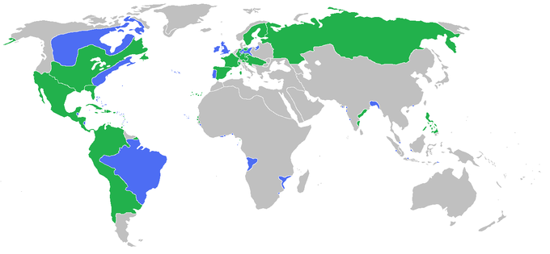
Figure 1 https://en.wikipedia.org/wiki/Seven_Years'_War shows the various locations that this war known by many names was fought.

PSD 1
The state of the English colonies, 1755 from the Maryland Gazette, originally published in London’s Gentlemen’s Magazine
This source provides an overview of Virginia from a British perspective for a British audience. Note that the writer provides considerable detail about the advantages Virginia possessed.

Virginia, is the most ancient of all the Colonies, and is of great Extent, having about 180 Miles Sea Coast; and its Extent back in the Country is unbounded. The Soil is extremely good, producing all Sorts of European and Indian Corn, in great Abundance; but is most famous for Tobacco. As it lies in 37 Degrees it is not so cold as the other Northern Colonies, and therefore, as the Farmer is not obliged to procure so much Hay for his Cattle in Winter, they have great Stocks of black Cattle. They have very fine Rivers, all well supplied with Fish, and wild and tame Fowl in prodigious Quantities. The People live in great Plenty, but are not quite so Numerous as in some other Colonies, because they employ Negroes in the raising of their Tobacco. Williamsburg is the Capital of the Province, but is not large. Here their Courts are kept and their Governor resides: Here they also have a College, at which the Youth receive their Education. In New-England are two Universities, Cambridge and Newhaven, which are very large and elegant Buildings, and have very considerable Libraries. No Country is better supplied with fine Rivers than Virginia; so that Ships from England go 150 Miles up them to load at the Planter’s Door with Tobacco, the Revenue of which Article to the Crown is prodigious; and vast Quantities of it are imported to Britain, and exported again to other Countries, which we pay in Cloths, Stuffs, Hardware, and every other Manufacture
...the British Empire in North-America; which from Nova-Scotia to Georgia, is a Tract of 1600 Miles Sea-Coast; [is] a Country productive of all the Necessaries and Conveniences of Life. . . . This is the Country, which the French have many Years envied us, and which they have been long meditating to make themselves Masters of . . . Everyone knows, that the English were the first and only Europeans who settled Virginia . . . the Invaders from Canada must be subdued.”

Source: https://www.gilderlehrman.org/history-by-era/thirteen-colonies/resources/state-english-colonies-1755
PSD 2
Painting: British victory at Plassey in Bengal, on June 23rd, 1757

The battle at Plassey may have been relatively small, but its impact on Indian history was massive. In this battle--which was so small that it is sometimes referred to as a skirmish--British forces fought on behalf of the East India Company, defeating the ruler of Bengal and his French allies. This victory cemented British influence in the region, allowing Britain and the East India Company to rule Bengal from behind the scenes. By the 1770s, East India Company officials were governors, judges, and officials of the Bengalese state. Initially, the legal system was based on Indian traditions. Key British figures believed that maintaining the legal traditions of the regions were in the best interests of Bengal; thus, British judges initially tried cases according to Islamic or Hindu customs. In the following decades, however, this view was replaced by a desire to impose British culture and traditions in the region.

This painting depicts Robert Clive, head of the British forces, meeting with Mir Jafar after the battle. Clive made Mir Jafar nawab, or emperor, after Plassey, but the real power lay with Clive.

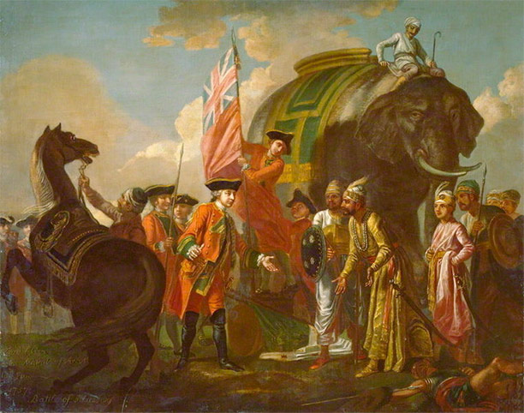
Figure 2http://www.historytoday.com/richard-cavendish/battle-plassey#sthash.4QQ8i5Fd.d
British victory at Plassey in Bengal, on June 23rd, 1757

PSD 3
The Battle of Quebec, 1759

This painting depicts the death of General Wolfe, leader of the British forces at the Battle of Quebec. The battle itself, which took place on the Plains of Abraham between fairly small British and French forces, was only fifteen minutes long; Wolfe was mortally wounded within the opening moments.

Still, the long-term consequences of this short battle were substantial. French forces were forced to leave the city, never to return. While French forces continued to fight elsewhere in the colonies, the Battle of Quebec was a turning point for French in the Americas; British control of the French settlements was only a matter of time.
The Battle of Quebec was part of the Annus Mirabilis, or miraculous year, of 1759, a term used to describe a time during which the English enjoyed repeated victories against the French around the globe. Upon hearing the news of Wolfe’s victory, British politician Horace Walpole exclaimed “Our Bells are worn threadbare with ringing for victory.”

Source for quotation: http://www.cambridge.org/be/academic/subjects/history/british-history-after-1450/bells-victory-pitt-newcastle-ministry-and-conduct-seven-years-war-1757-1762?format=PB&isbn=9780521521321

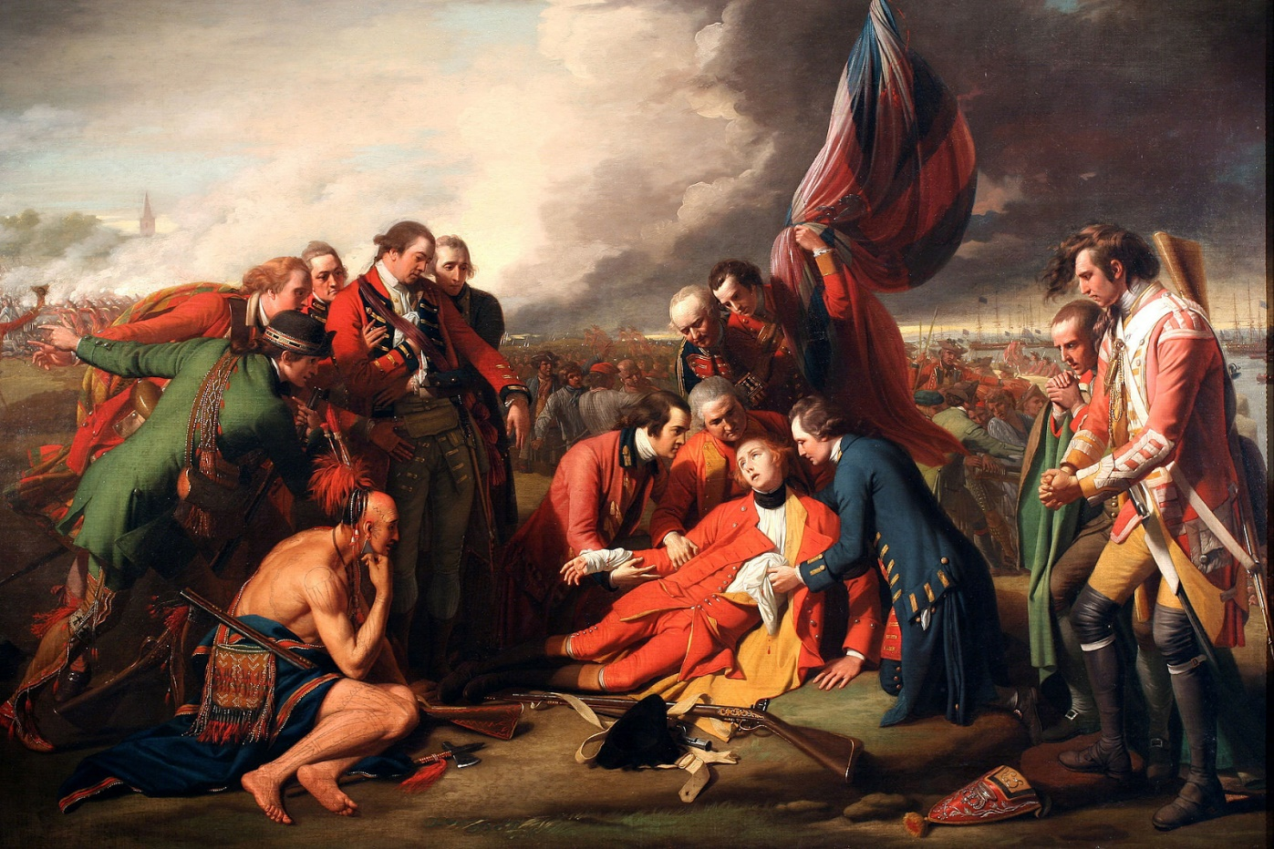
Figure 3https://en.wikipedia.org/wiki/The_Death_of_General_Wolfe#/media/File:Benjamin_West_005.jpg
The death of General Wolfe, 1759 (painting by Benjamin West, 1771).
PSD 4
Minavavana, a Chippewa chief, addressing trader Alexander Henry, as recorded by Henry, 1761

This address was given by Minavavana to a British trader following the defeat of the French by the British. In the address, Minavavana asserts that his people are not subject to British rule. In particular, note how he uses the terms father and brother to define this relationship.
“Englishman, although you have conquered the French, you have not yet conquered us! We are not your slaves. . . .
Englishman, our father, the King of France, employed our young men to make war upon your nation. In this warfare many of them have been killed, and it is our custom to retaliate until such time as the spirits of the slain are satisfied. But the spirits of the slain are to be satisfied in either of two ways; the first is by the spilling of the blood of the nation by which they fell; the other by covering the bodies of the dead, and thus allaying the resentment of their relations. This is done by making presents.
Englishman, your king has never sent us any presents, . . . wherefore he and we are still at war; and until he does these things we must consider that we have no other father, nor friend among the white men than the King of France. . . . You do not come armed with an intention to make war. . . . We shall regard you, therefore, as a brother. . . . As a token of our friendship we present you with this pipe to smoke.”

Source: http://www.smithsoniansource.org/display/primarysource/viewdetails.aspx?PrimarySourceId=1183

PSD 5

The Attack of Manilla, October 1762

This map shows the British attack of Manilla, a city in the Spanish colony of the Philippines. Britain attacked because Spain was, at the time, an ally of France. In fact, the Anglo-Spanish War became a sub-war of the larger Seven Years War. Britain also attacked Havana’s port (in Cuba) as part of this war.

The map is highly detailed, depicting the British navy and where the troops landed. The British maintained control of the colony until 1764, when it was returned to the Spanish as part of a peace treaty.

The attack reflects the global nature of the Seven Years War. Manilla is over 10 000 kilometres away from London over land, and much farther away by sea; thus, it was one of the theatres of war farthest away from Britain. It also provides insight into Britain’s victory in the war itself. The key to Britain’s success in Manilla and elsewhere was its navy, which was far superior to the navies of its adversaries. In fact, its navy allowed Britain to surpass France as the world’s great power.

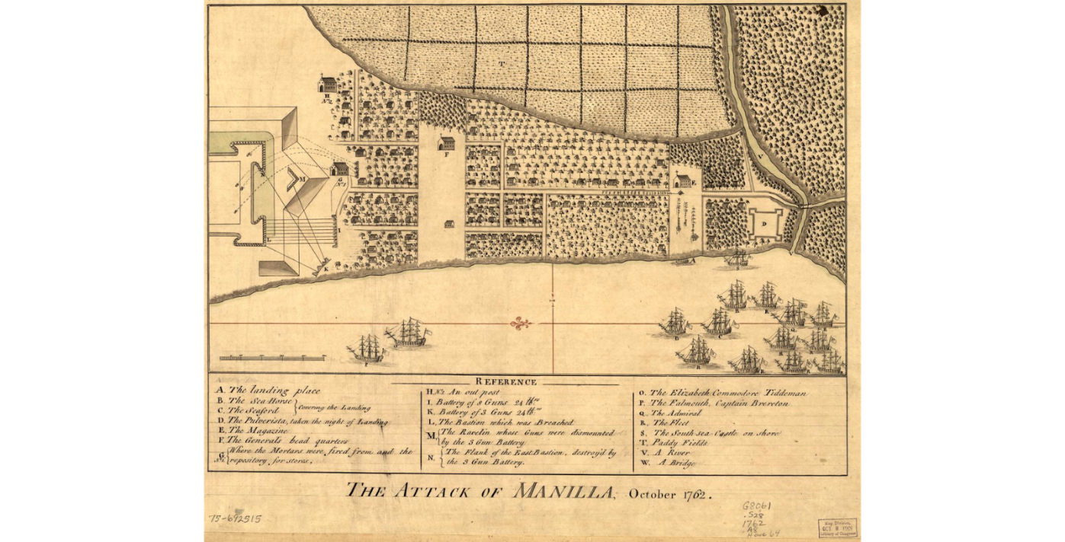
Figure 4https://www.wdl.org/en/item/213/#q=seven+years+war&time_periods=1700-1799

PSD 6
Royal Proclamation of 1763

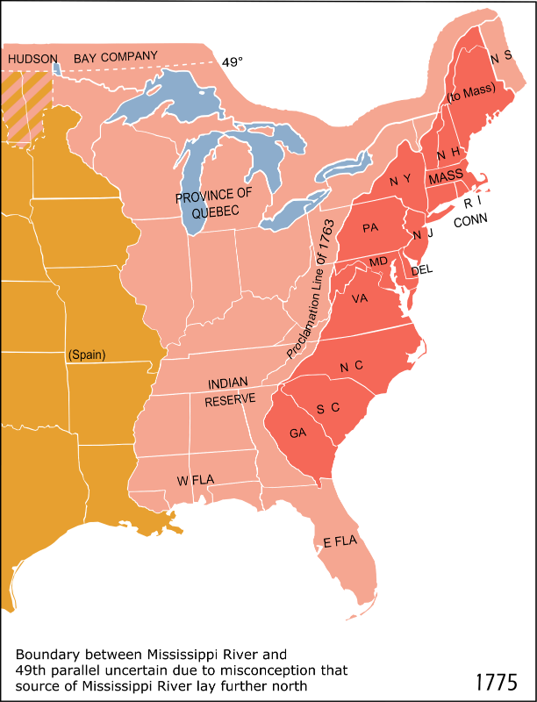

The Royal Proclamation of 1763 outlines the administration and governance of the territories surrendered by the French to the British. The section below outlines the rights granted to the Indigenous peoples, including control of all land west of the Mississippi River to the Spanish territories in the west. This was highly controversial in the Thirteen Colonies because it limited their westward expansion; thus, the Royal Proclamation was later one of the causes of the American War of Independence.
And whereas it is just and reasonable, and essential to our Interest, and the Security of our Colonies, that the several Nations or Tribes of Indians with whom We are connected, and who live under our Protection, should not be molested or disturbed in the Possession of such Parts of Our Dominions and Territories as, not having been ceded to or purchased by Us, are reserved to them. or any of them, as their Hunting Grounds.
And We do further declare it to be Our Royal Will and Pleasure, for the present as aforesaid, to reserve under our Sovereignty, Protection, and Dominion, for the use of the said Indians, all the Lands and Territories not included within the Limits of Our said Three new Governments, or within the Limits of the Territory granted to the Hudson's Bay Company, as also all the Lands and Territories lying to the Westward of the Sources of the Rivers which fall into the Sea from the West and North West as aforesaid.
And We do hereby strictly forbid, on Pain of our Displeasure, all our loving Subjects from making any Purchases or Settlements whatever, or taking Possession of any of the Lands above reserved. without our especial leave and Licence for that Purpose first obtained.
And.
We do further strictly enjoin and require all Persons whatever who have either wilfully or inadvertently seated themselves upon any Lands within the Countries above described. or upon any other Lands which, not having been ceded to or purchased by Us, are still reserved to the said Indians as aforesaid, forthwith to remove themselves from such Settlements.
And whereas great Frauds and Abuses have been committed in purchasing Lands of the Indians, to the great Prejudice of our Interests. and to the great Dissatisfaction of the said Indians: In order, therefore, to prevent such Irregularities for the future, and to the end that the Indians may be convinced of our Justice and determined Resolution to remove all reasonable Cause of Discontent, We do. with the Advice of our Privy Council strictly enjoin and require. that no private Person do presume to make any purchase from the said Indians of any Lands reserved to the said Indians, within those parts of our Colonies where, We have thought proper to allow Settlement: but that. if at any Time any of the Said Indians should be inclined to dispose of the said Lands, the same shall be Purchased only for Us, in our Name, at some public Meeting or Assembly of the said Indians, to be held for that Purpose by the Governor or Commander in Chief of our Colony respectively within which they shall lie: and in case they shall lie within the limits of any Proprietary Government. they shall be purchased only for the Use and in the name of such Proprietaries, conformable to such Directions and Instructions as We or they shall think proper to give for that Purpose: And we do. by the Advice of our Privy Council, declare and enjoin, that the Trade with the said Indians shall be free and open to all our Subjects whatever. provided that every Person who may incline to Trade with the said Indians do take out a Licence for carrying on such Trade from the Governor or Commander in Chief of any of our Colonies respectively where such Person shall reside. and also give Security to observe such Regulations as We shall at any Time think fit. by ourselves or by our Commissaries to be appointed for this Purpose, to direct and appoint for the Benefit of the said Trade.
Source:
http://indigenousfoundations.arts.ubc.ca/home/government-policy/royal-proclamation-1763.html

PSD 7
The Quebec Act, 1774
The Quebec Act was an attempt by the British Parliament to secure the loyalty of colonists in Quebec. The need for their allegiance had become more pressing with the discontent in the Thirteen Colonies; Britain feared that if revolution occurred in the Thirteen Colonies, the revolution might spread to Quebec. Thus, the Quebec Act outlined key provisions. First, it granted colonists in Quebec the right to practice Catholicism. Second, it expanded the borders of Quebec. An excerpt pertaining to the religious freedoms is below:

And, for the more perfect Security and Ease of the Minds of the Inhabitants of the said Province, it is hereby declared: That his Majesty's Subjects, professing the Religion of the Church of Rome of and in the said Province of Quebec, may have, hold, and enjoy, the free Exercise of the Religion of the Church of Rome, subject to the King's Supremacy, declared and established by an Act, made in the first Year of the Reign of Queen Elizabeth, over all the Dominions and Countries which then did, or thereafter should belong, to the Imperial Crown of this Realm; and that the Clergy of the said Church may hold, receive, and enjoy, their accustomed Dues and Rights, with respect to such Persons only as shall profess the said Religion.
Source: http://ushistoryscene.com/article/quebec-act/

The Thirteen Colonies disapproved of all three provisions, but the third was particularly contentious. Colonists worried that if Britain could arbitrarily restructure the government of Quebec, it might attempt the same thing in the Thirteen Colonies. Below is a 1774 cartoon demonstrating some of the colonists’ concerns. Their clothes are in rags, and many of them say they are starving. They are all pointing to a stagecoach being driven by the British. Note the Quebec Act is one of the papers on the ground spurring American resentment of the British. The papers represent broken promises by the British.

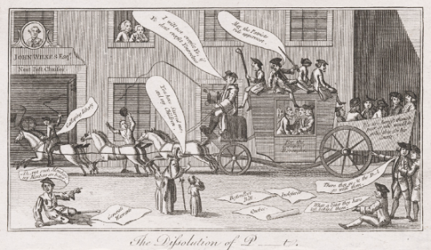
Figure 5 Source: Stephens, Frederic George; George, Mary Dorothy, Catalogue of Political and Personal Satires in the Department of Prints and Drawings in the British Museum, 11 vols, London, BMP, 1870

