Peter the Great, Decree on Western Dress, 1701
Western Dress shall be worn by all the boyars [nobles], members of our councils and of our court…
…excepting the clergy and peasant tillers of the soil.
The upper dress shall be of French or Saxon cut, and the lower dress… shall be of the German type.
…
From now on no one of the above-mentioned is to wear Russian dress or …Russian peasant coats, trousers, boots, and shoes.

Decree on Shaving, 1705
Henceforth … all court attendants, provincial service men, government officials of all ranks, military men, all the gosti, members of the wholesale merchants’ guild, and members of the guilds purveying for our household must shave their beards and moustaches. But if it happens that some of them do not wish to shave their beards and moustaches, let a yearly tax be collected from such persons; …
60 rubles per person; from the … [upper classes]
100 rubles per person; from …middle and the lower class
60 rubles per person; from … boyars’ servants …
And from Moscow residents of all ranks, 30 rubles per person.
…
As for the peasants, let a toll of two half-copecks per beard be collected at the town gates each time they enter or leave a town; and do not let the peasants pass the town gates, onto or out of town, without paying this toll.

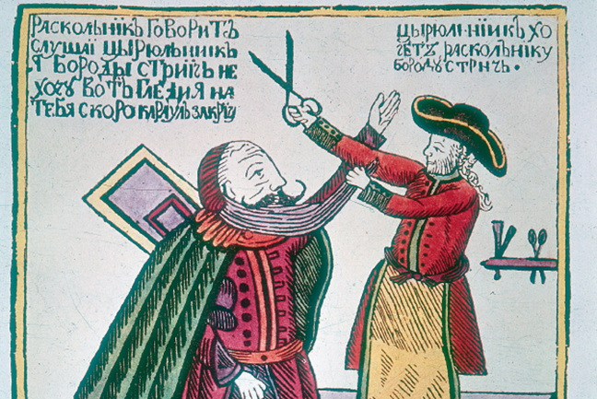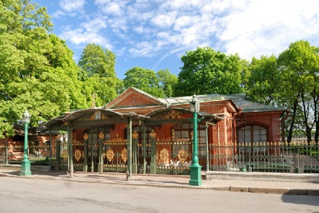
An early 18th century woodcut showing Peter the Great cutting off the beard of an unhappy boyar (noble).
The cabin of Peter, first home in the new city of St. Petersburg, combines Dutch and Russian elements.
Saint-Petersburg.com, The Cabin of Peter the Great, 2013, http://www.saint-petersburg.com/virtual-tour/cabin/ (Oct. 1, 2013).

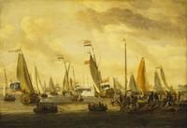
Dutch yachts sailing by Peter, 1697
Royal Museums Greenwich, Peter the Great, Review of Dutch Yachts Before Peter the Great, 1697, Abraham Storck, 2000, http://www.rmg.co.uk/explore/sea-and-ships/facts/explorers-and-leaders/peter-the-great (Oct. 1, 2013).
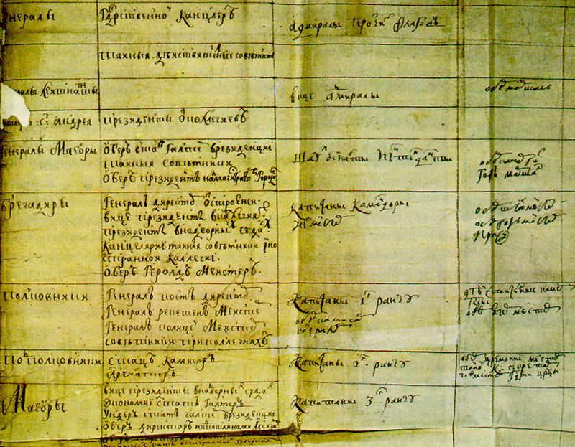
A page from the Table of Ranks.
https://en.wikipedia.org/wiki/Government_reform_of_Peter_the_Great#/media/File:Tabel_o_rangah.jpg

