CHY4U Unit 2, Activity 5
Cultural Exchange - Absolutism in France and Russia
Non-PSD Text by Jim Pedrech

The Idea of Absolutism
In a previous activity, you learned that thinkers from across Europe defined the period called the Enlightenment. Some of the values espoused by these thinkers were adopted by rulers who sought to reform their states. One of the consequences of this era was Absolutism, a system in which a monarch has complete control over the state. In some ways, Absolutism may seem to contradict Enlightenment values because of the ruler’s god-like control over everything in his/her domain; however, some theorists, like Thomas Hobbes, argued that a monarch with absolute control was by far the best option. Thus, while Absolutism may seem contradictory to Enlightenment values, it is actually a product of them.

Absolutism in France
Louis XIV of France used Absolutism to centralize power around the throne. When he was 10, he witnessed a series of civil wars led by nobles who wanted to limit the power of the crown; when he was older, he imposed a series of changes that strengthened the monarchy at the expense of the nobility. The embodiment of Louis’ Absolutism is Versailles, a massive palace that also served as the new location for the French government. Versailles was designed to intimidate visitors, making them more aware of Louis’ power; because it was built some distance from Paris, anyone who wished to conduct business with the French government needed to travel outside Paris to Versailles, the king’s personal residence, to do so.

The video below shows the changes made under Louis XIV, and shows you how Versailles was an architectural manifestation of his power.

https://www.youtube.com/watch?v=X235vpOToVU

While centralizing power in France, Louis disempowered the once independent nobles through redefining his expectations of them. He used routine, ceremony, and access to control his court; the structure was so strict that his personal valet, Duke de Saint-Simon, said that "with an almanac and a watch, you could be three hundred leagues from here and say what [Louis] was doing." Where they no longer had power, the nobles now had privileges at court.

Source: http://en.chateauversailles.fr/history/versailles-during-the-centuries/living-at-the-court/a-day-in-the-life-of-louis-xiv

Below is an excerpt from the Duke’s memoirs:

Excerpt from Duc de St. Simon
The frequent fêtes (parties), the private promenades at Versailles, the journeys, were the means on which the King seized in order to distinguish or mortify the courtiers, and thus render them more assiduous in pleasing him. He felt that of real favors he had not enough to bestow; in order to keep up the spirit of devotion, he therefore unceasingly invented all sorts of ideal ones, little preferences and petty distinctions, which answered his purpose as well.

He was exceedingly jealous of the attention paid him. Not only did he notice the presence of the most distinguished courtiers, but those of inferior degree also. He looked to the right and to the left, not only upon rising, but upon going to bed, at his meals, in passing through his apartments, or his gardens of Versailles, where alone the courtiers were allowed to follow him; he saw and noticed everybody; not one escaped him, not even those who hoped to remain unnoticed.

Source: From The Memoirs of the Duke de Saint-Simon, ed. F. Arkwright (New York Brentano's), Vol. V, pp. 254, 259-63, 271-274, 276-278, date unknown. http://www4.wittenberg.edu/academics/hist/crom/civ2001/abso.htm

Absolutism in Russia
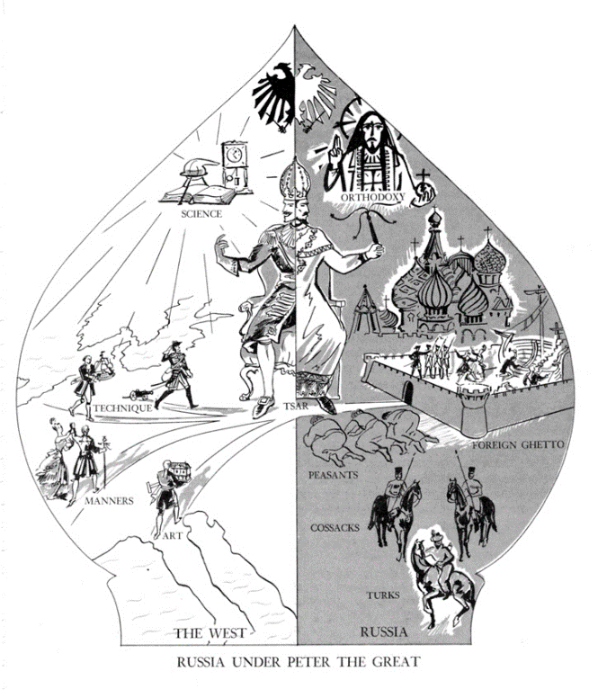
Figure 1 https://library.osu.edu/projects/bela-petheo/peterthegreat.htm

This is a cartoon commenting on the hypocrisy of Peter’s policies. It is the shape of an onion dome, divided into East and West. Peter is sitting in between the two and, when he is looking west, appears benevolent, clean-shaven and looking at technology, manners and art. When he is looking east to Russia, he appears as a traditional, autocratic tsar. The Western innovations are penned up in a foreign ghetto, the peasants are bowing to him, and the architecture is clearly eastern.

Absolutism was a tool used by Peter the Great to westernize Russia based on Enlightenment ideals. As the image above indicates, he enacted a number of policies designed to limit the Byzantine and Eastern influences in nearly every facet of Russian society. For example, he ordered the construction of a new city, St. Petersburg, that was European in style and, in fact, not very far from Europe (see map for proximity to Finland). The first image below is of a Church in Moscow that predates Peter’s reign; the second image is the Winter Palace built for Peter in St. Petersburg. Note its resemblance to Versailles.

Definition Byzantine: Referring to Byzantium, or the Eastern Roman Empire (330 to 1453 CE). In this context, Byzantine means old, filled with elaborate bureaucracy, systems of privilege and ceremony. The antithesis of Enlightenment values.

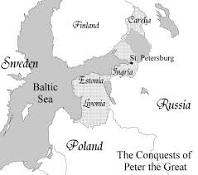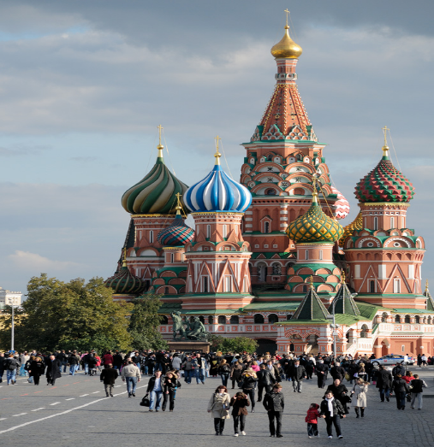
Figure 2 https://en.wikipedia.org/wiki/Red_Square#/media/File:RedSquare_SaintBasile_(pixinn.net).jpg
Like Louis, Peter had to contend with a noble class that had previously enjoyed considerable influence, and thus were not likely to accept Absolutist rule uncontested. In response, Peter created the Table of Ranks, a complex ranking system for all aristocrats or boyars. Initially, all nobles were placed in the lowest rank, regardless of their previous titles and prestige. In order to move up the ranks a nobleman had to demonstrate loyalty and service to Peter; since literacy was a requirement for many of the tasks, the nobles of Russia had to become literate to achieve higher status. Thus, Peter not only ensured that the highest ranking nobles were loyal to him, but also ensured that these same nobles were educated.
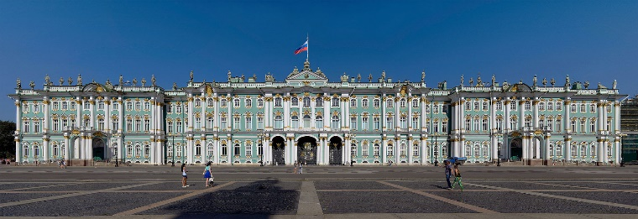
Figure 3 https://en.wikipedia.org/wiki/Winter_Palace#/media/File:Winter_Palace_Panorama_2.jpg
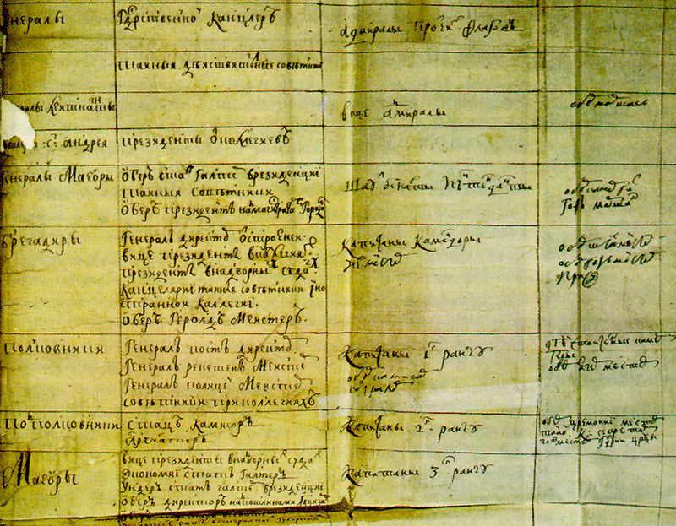
Figure 4 https://en.wikipedia.org/wiki/Government_reform_of_Peter_the_Great#/media/File:Tabel_o_rangah.jpg
This document is a page from the Table of Ranks.

Peter’s reforms were not limited to the government. He also passed a law that required all men (with the exception of priests and peasants) to shave their beards. While this might seem unimportant, this decision directly contradicted centuries of tradition; in fact, one of his predecessors had argued that shaving one’s beard was an affront to God. Thus, the law was designed to stamp out this tradition and the Orthodox values that accompanied it.

Definition: The Orthodox Church is a Christian faith associated with Eastern Europe and Russia; it has its origins in Constantinople in the Byzantine Era.

Peter introduced the law by pulling out a shaving knife during an official ceremony and shaving a few of the nearby nobles; because of Peter’s authority, no one dared to stop him. Officials were given the authority to cut men’s beards on sight if they were not complying with the law. Eventually, the mandatory shaving law was replaced with a beard tax. Those who wished to save their beards could pay a tax proportionate to their class.

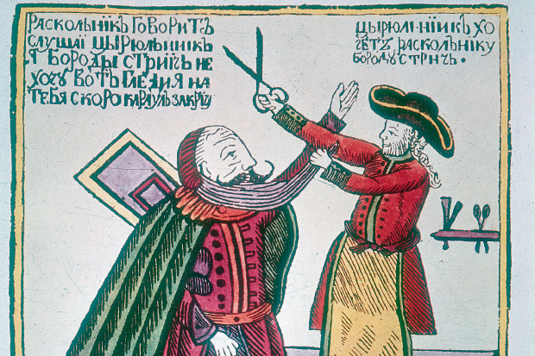
Figure 5 http://www.spectator.co.uk/2016/02/why-do-men-grow-beards/
An early 18th century woodcut showing Peter the Great cutting off the beard of an unhappy boyar (noble).

Questions on the Shaving Law:

- How is this new shaving law a consequence of cultural exchanges?

- Do you see this as intended or unintended?

- Do you see it as positive or negative?

Questions on Louis XIV and Peter the Great:

- Identify some similarities between Louis’ and Peter’s versions of absolutism.

- Identity some ways their styles of absolutism were different.

