Beijing
Who Ruled Beijing?
The Mongols, nomads from the north who had governed China a few centuries earlier, had moved their capital to Beijing. The Ming Dynasty, which overthrew the Mongols (or Yuan Dynasty) in 1368, also made their capital at Beijing starting in the early 1400s. They constructed a palace compound, separated from the city by high walls, called The Forbidden City.

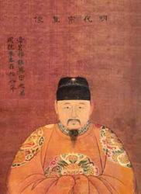
Figure 1https://upload.wikimedia.org/wikipedia/commons/7/76/Jingtai.jpg
The Jingtai Emperor of the Ming Dynasty had come to the throne in 1449 under very unusual circumstances. His half-brother, the previous emperor, had been captured by invading Mongols. Government officials refused to pay the ransom for his brother; instead, Jingtai was made emperor. When his brother was returned, the Jingtai Emperor put him under house arrest. Six years later, his brother orchestrated a coup with the help of palace eunuchs and regained the throne. This time, it was Jingtai who was under house arrest. He died a month later. While power undoubtedly was in the hands of the emperor, China’s complex bureaucracy featured branches of government with considerable influence. Recently, scholars have unearthed evidence that the eunuchs were more than just palace guards; they may have been the equivalent of an entire branch of government.

Westerners did not interact significantly with the Chinese at this point (not until 1517 when the Portuguese arrived in southern China).

How Was the View of Religion Changing?
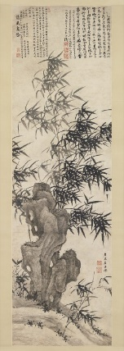
Figure 2http://www.metmuseum.org/toah/works-of-art/1989.235.1/
The previous Yuan dynasty had been tolerant of different religions, especially of Tibetan-style Buddhism. Although the Ming dynasty was less tolerant in the 16th century, 15th century Ming emperors upheld their predecessor’s practices. Buddhism, which had been present in China since the Han dynasty over 1000 years earlier, was taking on Chinese values and esthetics. This work of calligraphy from around 1460 shows Ming love of depictions of landscapes, in this case bamboo.

How Did Confucianism Shape Chinese Culture?
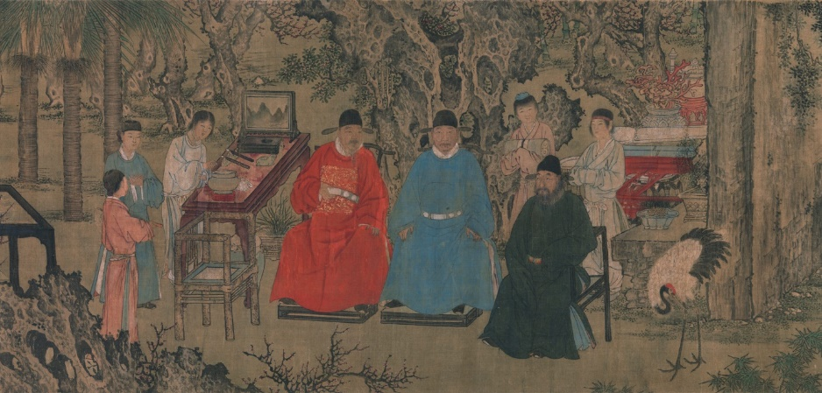
Figure 3http://www.metmuseum.org/toah/works-of-art/1989.141.3/
Neo-Confucianism was the dominant system of thought at this time. Though a very complex concept, it can be described as a system that emphasized Confucianism more than it did Buddhism and Taoism.

Despite China’s tolerance of other belief systems, Confucianism still held the most sway. The Mandarins, or government bureaucrats, were required to study for years in order to pass an exam based on the teachings of Confucius. The painting above from around 1437 depicts nine scholar-officials gathered in Beijing. Confucianism also shaped daily life for the lower classes. For centuries, various versions of a book entitled Twenty-Four Exemplars of Piety formed the basis of social interaction. These exemplars featured parables designed to instruct the entire society. Examples include a child whose love for his parents is so strong that he would rather endure the bites of mosquitoes at night than drive them away, lest they bother his parents.
Kyoto
What Was Kyoto Like in 1450?
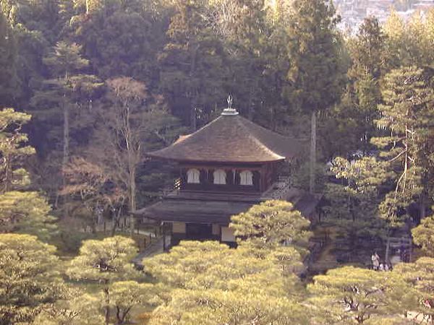
Figure 4http://yamasa.org/japan/english/destinations/kyoto/ginkakuji.html

The city of Kyoto was much more important than Edo, or modern-day Tokyo, which didn’t exist until 1457. Kyoto remained the official seat of power until the 19th century. During this time, the Ashikaga rulers lived in the Muromachi district of Kyoto. They built pavilions, which later became temples, one of which is pictured above. Kyoto, however, was far from peaceful. In fact, it was almost completely destroyed by combatants during the Onin War (1467-1477).
Who Ruled During the Sengoku Period?
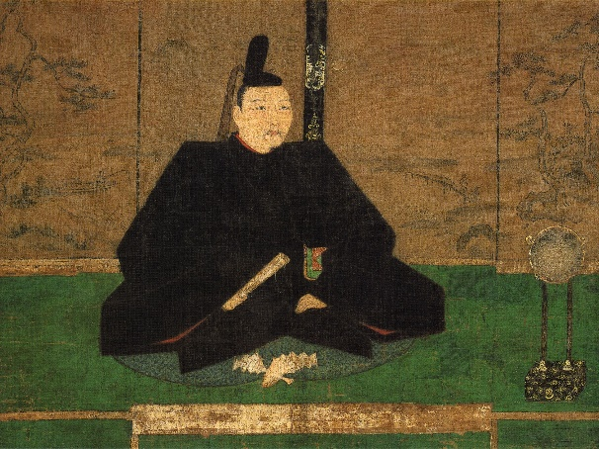
Figure 5https://en.wikipedia.org/wiki/Ashikaga_Yoshimasa#/media/File:Ashikaga_Yoshimasa.jpg
As its name suggests, the Sengoku, or “Warring States,” period (1467-1603) was tumultuous. It started with the Onin War, a bloody internal power struggle following the death of Shogun Ashikaga Yoshimasa, whose attempts to provide a clear successor left Japan with two: his brother and his young child. Two camps quickly formed, and civil war ensued. Interestingly, Ashikaga was not emperor. He was a Shogun, a military ruler who was, in theory, responsible to the emperor, but in truth ruled Japan.
How Was Religion Changing Japan?
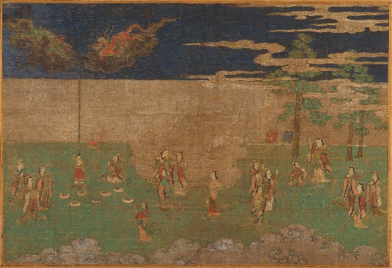
Figure 6http://www.metmuseum.org/art/collection/search/45209
Shinto, a collection of mythologies and traditions, was indigenous to Japan. From the year 500, however, belief systems from other regions found footholds in Japan and became increasingly popular. Approximately every five centuries, a new faith reached Japan, starting with Buddhism, then Confucianism, and finally Christianity. This painting, depicting the birth of Buddha, reflects the popularity of the faith in the 15th century. Notice the dragons bathing Buddha after his birth. The tea ceremony, based on Buddhist rituals, was a key cultural practice that came into being at this time.
Life for Women
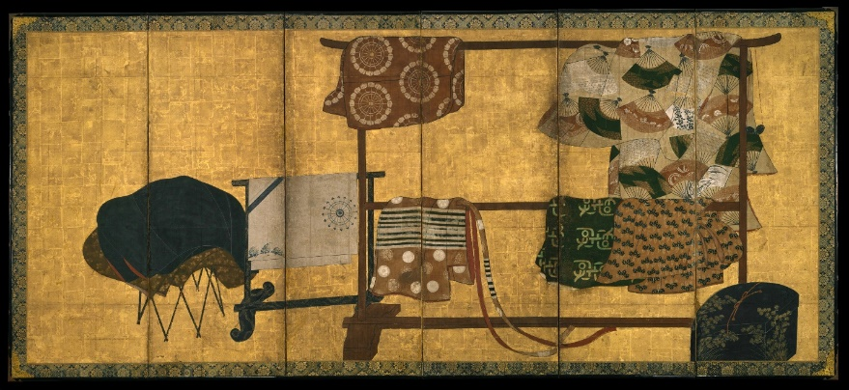
Figure 7http://www.metmuseum.org/art/collection/search/45375
Life for women depended on their class. Up to the 16th century, for example, women of the Samurai (warrior) class were formally trained in combat. During times of war, they were responsible for the protection of the home. They upheld a code of honour, and were prepared to commit ritual suicide if they believed their honour had been compromised. Women born in the upper class were educated, owned property. and contributed to the culture through writing and poetry. The status of women was reflected in their clothes. This painting, Whose Sleeves, is one of many that depicts the clothes of someone of status, but not the owner herself. Thus, the viewer is left to guess the identity of the owner based on the beauty of the items.
Timbuktu
Who Ruled Timbuktu?
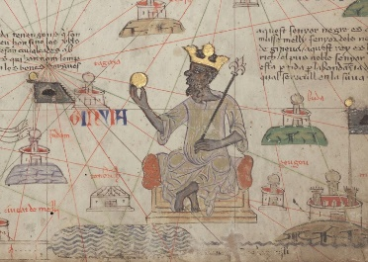
Figure 8https://en.wikipedia.org/wiki/Mali_Empire#/media/File:Catalan_Atlas_BNF_Sheet_6_Western_Sahara.jpg
This image depicts Mansa Musa, the first Mali king (1280-1337), holding a golden nugget. During Mali rule, Timbuktu earned its reputation as a place of great trade, wealth, and learning. When the Songhai empire took control of the very wealthy city in the 1460s, Timbuktu experienced some turmoil. However, later under Askia Mohammad I, the city enjoyed prosperity (1493-1598).
How Did Others See Timbuktu?
Dutch cartographer Abraham Ortelius made maps of Africa in the late 1500s. According to the Timbuktu exhibit of the Library of Congress, Ortelius’ map reveals the primacy of land travel and trade routes in 16th century Africa. Despite being created in 1572 (during the decline of the city), the map still indicates the importance of Timbuktu as a place of trade. The picture of Mansa Musa above shows European interest in Mali since it was published in a Catalan (part of Spain) atlas. Also, Leo Africanus, a Moor born in Spain, wrote travel books exploring Africa and gained a lot of attention for the riches of Timbuktu in the early 1500s.
What was Islam’s Impact on the City?
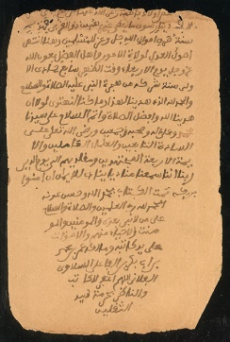
Figure 9http://www.loc.gov/exhibits/mali/mali-exhibit.html#obj1
This is part of a Maghili’s Tract on Politics written by Muhammad ibn Abd al-Karim al-Maghili. In the work, the author answers seven questions asked by the Emperor of Songhai. In this section, the author argues that because the Emperor is required to follow Islamic law, he needs to apply the advice of Islamic scholars to all aspects of his rule, including economics and politics. While scholars, courtiers, and rulers were Muslim, inhabitants in the rural areas outside the city followed traditional beliefs.

Constantinople
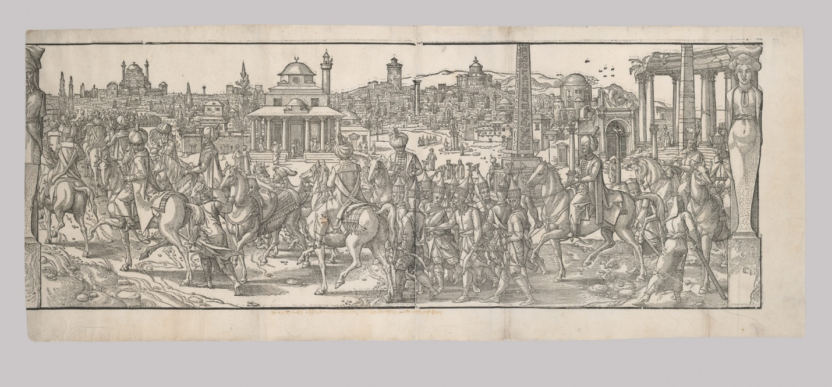
Figure 10http://www.metmuseum.org/toah/works-of-art/28.85.7a/

How Did Architecture Reflect its History?
This panorama provides some insight into the complex mix of cultures and traditions of the city. Behind the Ottoman riders, the history of the city seems to move from right to left: newer mosques and Ottoman Islamic architecture are on the left, while the right features older Roman buildings. There are, however, more structures in the image that hint at the city’s diversity, such as the Hagia Sophia representing Eastern Orthodox Christian traditions, and even an Egyptian-inspired obelisk.
Who Ruled Constantinople?
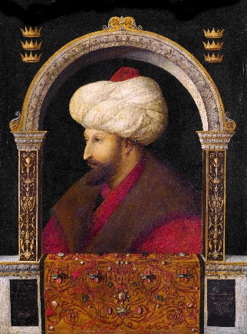
Figure 11https://upload.wikimedia.org/wikipedia/commons/c/c6/Gentile_Bellini_003.jpg
According to one observer, Mehmed II’s conquest of the city in 1453 made blood run “like rainwater in the gutters after a sudden storm.” Despite this violent beginning, Mehmed sought to revitalise the city. He made it the capital of the Ottoman Empire, and enforced policies to ensure population growth. He also built upon its cosmopolitan origins by not only encouraging immigration, but also by surrounding himself with advisors and courtiers from Europe and the Middle East. This portrait was painted by Venetian artist Gentile Bellini in 1479. Mehmed made a treaty with Venice very shortly after coming to power.
What Was Constantinople Like in 1450?
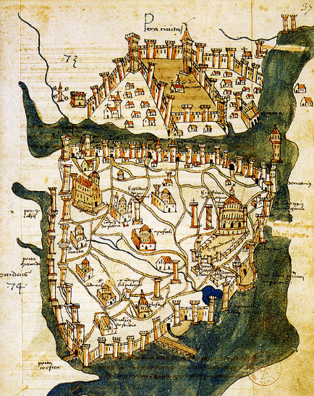
Figure 12https://upload.wikimedia.org/wikipedia/commons/9/91/Map_of_Constantinople_(1422)_by_Florentine_cartographer_Cristoforo_Buondelmonte.jpg

Several times in its long history, Constantinople had reached a population of 500 000. During its golden eras, it was a centre of art, architecture, and trade, a place where traditions of the west and the east mingled. Unfortunately, due to conquest and plague, its population in 1450 was around 50 000. When the city fell to Mehmed II and the Ottomans in 1453, the invading force outnumbered the entire population. Still, hints of the city’s cosmopolitan origins persisted. At the time of the conquest, the small population of Constantinople consisted of Greeks, Slavs, Turks, Venetians, and descendants of the Crusaders. This map is the oldest surviving map of the city, and the only one from before the conquest of the Ottomans. Mehmed began to rebuild the once great city.

Venice

What Was Venice Like in 1450?
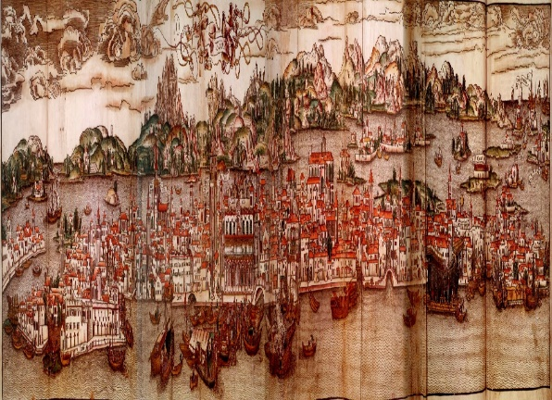
Figure 13https://commons.wikimedia.org/wiki/File:Map_of_Venice,_15th_century.jpg
This map was drawn in the 15th century. In 1450, Italy was divided into city-states vying for dominance. Venice was in the perfect location for trade, and goods from the eastern and western world entered its harbours. Venice had a rich economy, and used its powerful navy and strategic alliances to protect it. Not all was positive, however. The rise of the Ottomans was hampering Venetian trade, shutting down major trade routes. The fall of Constantinople was a major blow to the city’s economy.
Who Ruled Venice in 1450?
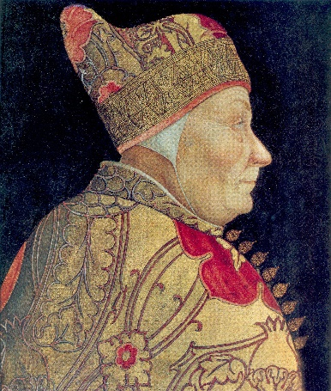
Figure 14https://en.wikipedia.org/wiki/Francesco_Foscari#/media/File:FrancescoFoscariBastiani.jpg

In 1450, the Doge (roughly, duke) of Venice was Francesco Foscari. While the role of Doge was a life-long position, it was not the same as a noble title. The city of Venice was a republic; the Doge was elected by his fellow members of the aristocracy, usually based on his shrewdness. Foscari’s fall reveals the power held by the city’s elite class. The Council of Ten, a secretive group of city elders, forced him to abdicate (step down) following a scandal implicating his son.
What was Education for Women Like?
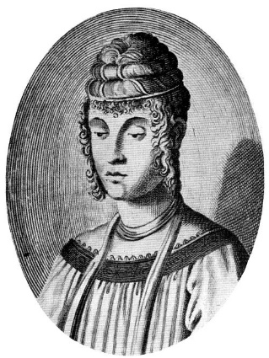
Figure 15https://en.wikipedia.org/wiki/File:Image_from_Maria_Bandini_Buti,_Enciclopedia..._(Roma,_1941),_vol._1,_p._258.jpg
The education of aristocratic women aligned with Humanist values, but it also benefited their parents; the public perception of one’s daughter could impact the perception of the entire family. Some women achieved considerable status in Venice due to their publications and orations. The work of Cassandra Fedele, shown here, drew praise from across Italy and Spain. In fact, she was actively recruited by Isabella of Castile to join the Spanish Court. One of the hallmarks of her career occurred when she delivered an address to the Doge and the Senate about the importance of higher education for women.
How Did the Renaissance Change Venice
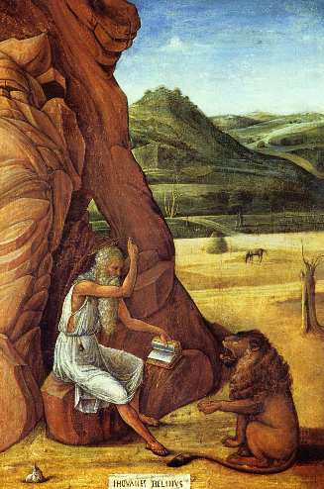
Figure 16https://upload.wikimedia.org/wikipedia/commons/a/ab/Giovanni_Bellini_-_San_Girolamo_nel_deserto.jpg
The Italian Renaissance rekindled interest in the classical world of the Ancient Greeks and Romans. Understanding of art, science, and philosophy changed considerably, and a new way of viewing the role of the individual, called Humanism, dominated cultural discourse. The Renaissance certainly impacted Venice, but the city’s culture owed much to its old connections to the Byzantine empire (the former eastern part of the Roman empire in what we would call present day Turkey). In both trade and in art, Venice was an intermediary between worlds.
Seville

What Was Seville Like in 1450?

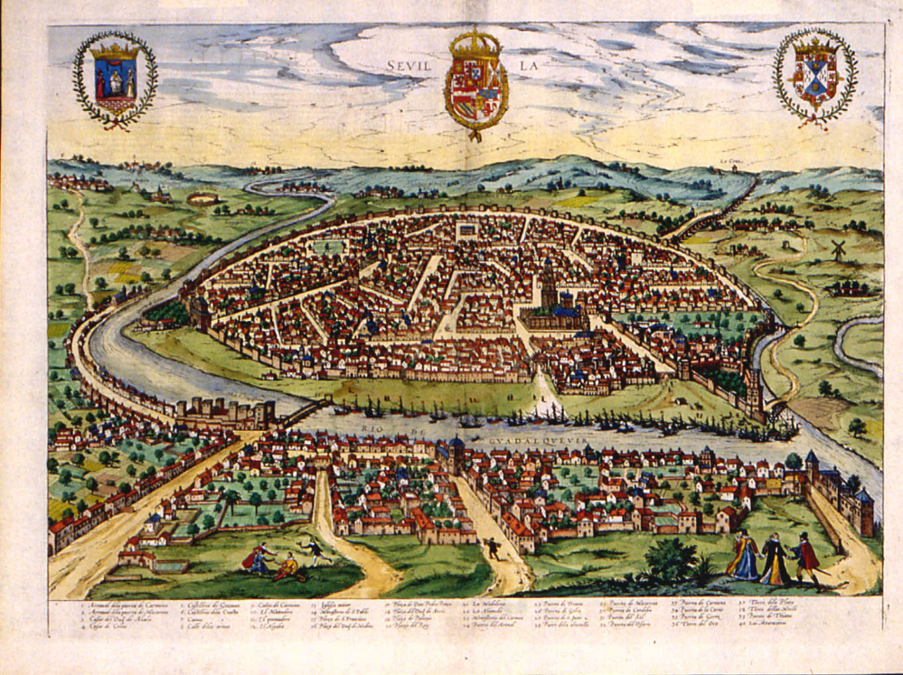
Figure 17https://upload.wikimedia.org/wikipedia/commons/1/1e/Sevilla_siglo_XVI.jpg

Seville, in present-day Spain, was changing. From 712 to 1248, the city had been under the control of Islamic Moors originating from North Africa. The population of the city had been a mix of Moors, Spaniards, and Jews, Under the control of Castile, a neighbouring Catholic kingdom, the Moors and Jews faced persecution in the 15th century. Many Jews had been massacred in a pogrom in the 1420s; the majority of the Jewish population was forced to convert, and its synagogues were converted to churches. Many of the architectural elements of Moorish and Jewish culture were still visible in 1450. This map of the city, for example, shows a large cathedral next to a palace built for Moorish rulers in the Islamic style.
Who Ruled Seville?
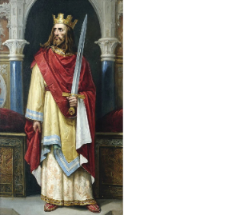
Figure 18https://upload.wikimedia.org/wikipedia/commons/a/ad/Juan_II_de_Castilla_%28Ayuntamiento_de_Le%C3%B3n%29.jpg

The ruler of Castile, the area in which the city of Seville is located, in 1450 was John II. His reign was one of many Christian kings during the Reconquista, a lengthy period stretching from the first Moorish conquests to their last defeat by the Christian kings in the 15th century. From the Castilian perspective, this was also a period of consolidation. While the region would not be officially called Spain for decades, the union of John’s daughter, Isabella, and Ferdinand of Aragon, a neighbouring kingdom, centralized power in the region. This is an imagined portrait of John II painted in the 1890s.
What Was the Inquisition?
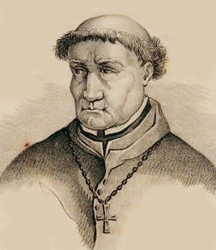
Figure 19https://en.wikipedia.org/wiki/Tom%C3%A1s_de_Torquemada#/media/File:Torquemada.jpg
In 1478, the kingdoms of Ferdinand and Isabella launched an Inquisition to ensure full adherence to the Catholic faith, especially among Jewish and Moorish converts. While the Inquisition was initially sanctioned by the Church as a means of addressing heresy (a belief that is contrary to established religious beliefs and practices), concerns over its severity and scope prompted Pope Sixtus IV to call for leniency. The position of Grand Inquisitor was created in order to supervise the Inquisition. The first Grand Inquisitor was a Dominican Monk named Tomás de Torquemada, who escalated rather than curtailed the Inquisition. Anyone who was accused of committing an act condemned by the Church, including blasphemy and witchcraft, could be subject to autos-da-fé, or acts of faith, during which they might be publicly humiliated and beaten. Some were burned at the stake as heretics.

Tenochtitlan

What Was Tenochtitlan Like in 1450?
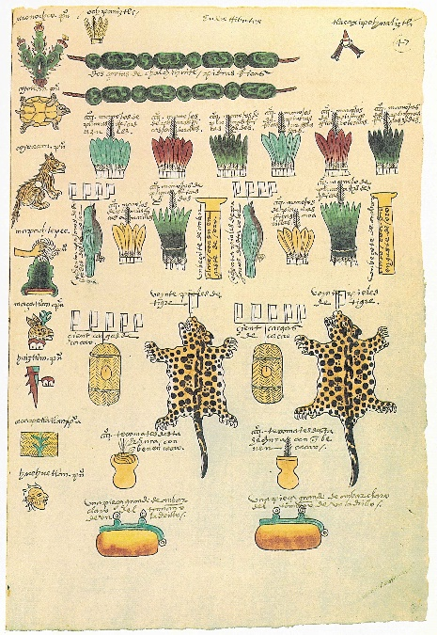
Figure 20https://en.wikipedia.org/wiki/Codex_Mendoza#/media/File:Codex_Mendoza_folio_47r.jpg
Tenochtitlan was situated on an island in Lake Texcoco. Many of its structures were built in the water, and were connected by canals and bridges. The city was also a bustling trade centre, with merchants and farmers from neighbouring cities flocking to Tenochtitlan and its sister city to sell their goods. In 1450, Tenochtitlan was one of three cities in the Triple Alliance. This alliance was intended to stabilize trade and keep peace in the region. This image shows some of the items that would be paid to the Triple Alliance by subjugated cities. It was created as part of the Codex Mendoza, an account commissioned by Europeans after the conquest of the city.
How Did the Aztecs See the World?
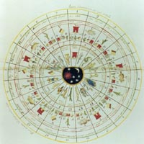
Figure 21https://www.loc.gov/exhibits/1492/america.html

This image is of the tonalpohualli, or sacred Aztec calendar, a highly accurate method of tracking the year based on 20 month cycles. The Aztecs also had a daily calendar, the xiuhpohuali, of 365 days used to track agricultural activities. Both calendars together describe the rituals to be performed on that day to appease the gods. These rituals varied, but did include blood sacrifices ranging from a small amount of bloodletting to human sacrifice. Historians agree that around 1450, the Aztecs engaged in a series of ritualistic conflicts with neighbouring cities. These unusual wars seemed to be pre-arranged with their opponents, featured equal number of combatants, and were waged only with weapons that allowed warriors to show their skills. The Flower Wars may have been a way to obtain more slaves for human sacrifice. Historians who support this view cite a Spanish source which claims the Aztecs needed regular and consistent human sacrifices to appease their gods.
What Was Aztec Society Like?
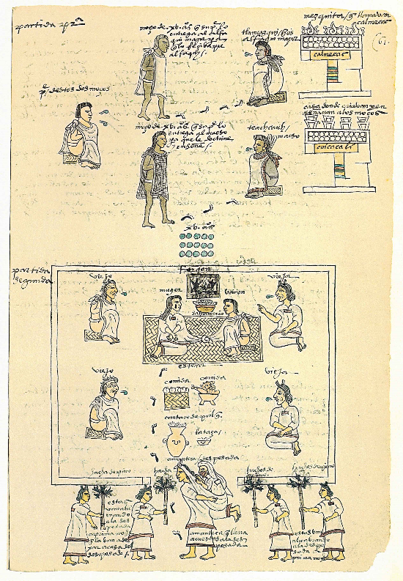
Figure 22https://upload.wikimedia.org/wikipedia/commons/b/bb/Codex_Mendoza_folio_61r.jpg
Aztec culture featured a rigid and sophisticated class structure. Nobles and commoners, for example, featured subclasses with their own complex ranks and rules. The image is from the Mendoza Codex, which was created to provide the Spanish king with an understanding of Aztec life. It depicts the education of Aztec youths. Though the education for the sexes and classes differed, all males and females who were not slaves received some kind of structured education.

