CHW 3M Middle Ages Continuity and Change Poster
AKA Middle Ages Living Timeline Pageant

The search for Ms. or Mr. Middle Ages has begun! Each student will research a medieval person or topic and prepare to present it to the class in the form of a poster pageant, which entails role-playing a character and comparing yourself to other roles. Students may choose to enter the Ms. or Mr. Continuity contest (for those who contributed to or reinforced continuity, stability, or had a preference for tradition), or the Ms. or Mr. Change contest (for those who contributed to change in their society). Each student will do the following:

- Research the character/topic. Start with the basic facts and details (who, what, where, when, etc.). Then decide if the person/topic reflects more continuity or more change. For either, think about things such as reinforcing or challenging established religious beliefs, traditional family roles, and administrative bureaucracies. Once you’ve made your choice of contest, find three pieces of evidence to prove it. You will have three library periods to use the excellent middle ages books in our collection (they’re not from the middle ages☺).

Consult the text and two other historical sources for information (not the Internet). You must have handwritten notes from at least two sources. Notes must be shown to the teacher by the end of the last day in the library. You may not participate in the timeline/pageant if you haven't shown your research notes.

- Write a 2- minute speech about your character in paragraph form. It should have a catchy and persuasive topic sentence outlining which contest you’re trying to win and your main area of proof. The paragraph should have three pieces of evidence, each one followed by an argument. The final sentence should sum up why you should win the contest. [this is some students’ last opportunity to improve their paragraph writing mark]

- Create a one-page poster. It should include:
- Your character’s name and contest
- An image that relates to your character and your argument about continuity or change (cite the image properly)

- Students will have the opportunity to interact with other characters in role. This is how we will determine nominees for the big prizes beyond Continuity and Change!

EVALUATION: See rubric (A, C)

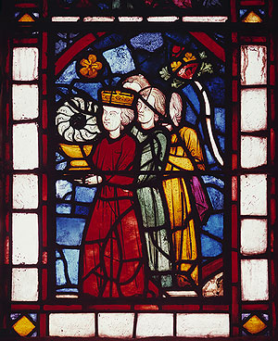
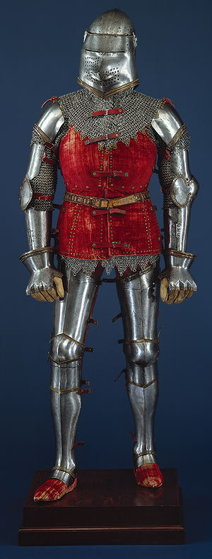
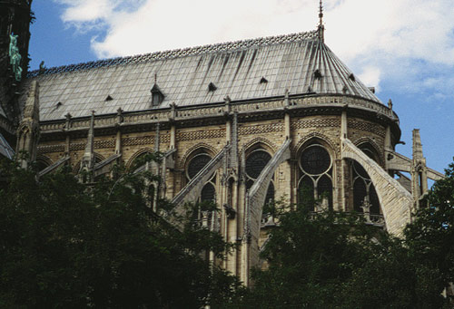
Stained-Glass Panel, ca. 1245–1248

Armor, ca. 1400 and later,
Italian

Notre Dame Cathedral, 1163-13445, Paris
Images from Metropolitan Museum of Art, Timeline of
Art History – Medieval Art. 2007.
http://www.metmuseum.org/toah/hi/te_index.asp?i=15 (Dec. 9, 2007).

TOPICS (page numbers in round brackets; suggested role in italics):

Early Middle Ages

- Justinian the Great (497-499) [Byzantine Emperor]
- Charlemagne (509-511) [unity, Christianity]
- Al Farghani [Muslim astronomer]
- Avicenna or Ibn Sina [Muslim thinker and medical writer]
- Al Khwarizmi [Muslim mathematician]
- Al Razi [Muslim medical researcher]

High Middle Ages

- William the Conqueror (532-534) [invasion, Domesday Book]
- Henry II (World History 207) [common law, jury]
- King John (535-536) [Magna Carta]

Marco Polo (350, 354, 634, World History 218)

Al Tusi [Muslim astronomer]

Saladin (238, 239, 537) [Muslim leader]

Eleanor of Aquitaine (World History 189) [wife of French and English kings, mother of Richard the Lion-Hearted]

Richard I [Crusader and king]

Manor life (552-554) [village] - peasant/serf, lord, man, woman, child
- Castle life (551) - architect
- Knight (547-549) [apprenticeship, tournaments] - crusader
- Monastery life (545-547) - monk or nun

Late Middle Ages

- Mansa Musa [leader of Mali]
- Ibn Battuta [Muslim explorer]
- Thomas Aquinas (541) [compatibility of science and religion]
- Hundred Years’ War (572-574) [France vs. England] – soldier (English or French)
- Joan of Arc (575, 576-577) [French leader and hero]
- Johannes Gutenberg (575, 580-581) [printing press]
- Tomas de Torquemada (586) [Spanish Inquisitor - Church trials against heresy]
- Christine de Pizan (575, 578) [French writer]

Due Date: ______________________________________________

CHW 3M Checklist for Middle Ages Living Timeline

Paragraph/Speech and Poster

Criteria | Yes | No
Have you consulted the text and other historical sources? | □ | □
Have you taken handwritten notes from your sources in your own words? | □ | □
In your notes, have you included key biographical data (summary of main points, not minute detail) that covers who, what, where, when? | □ | □
In your notes have you made notes on how your person connects either to change or continuity? (not both) | □ | □
Does your paragraph have a catchy/argumentative topic sentence? | □ | □
Does your paragraph have three key proofs? | □ | □
Is each proof followed by a persuasive argument fully explaining how your character is best for change or continuity? | □ | □
Does your paragraph have a sharp concluding sentence? | □ | □
Does your poster have a relevant image and citation? | □ | □
Does your poster include your main argument? | □ | □
Are you familiar enough with your person that you can boast about “yourself” as Mr. or Ms. Change/Continuity? | □ | □

