CHW3M Freedom and Control in the Persian Empire

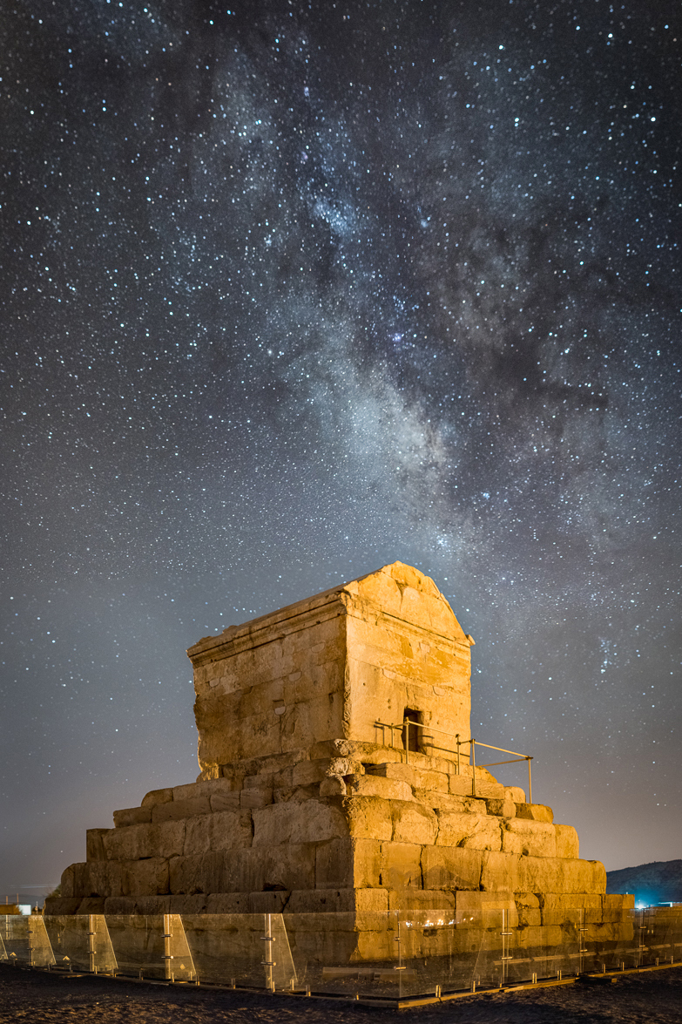 Tomb of Cyrus 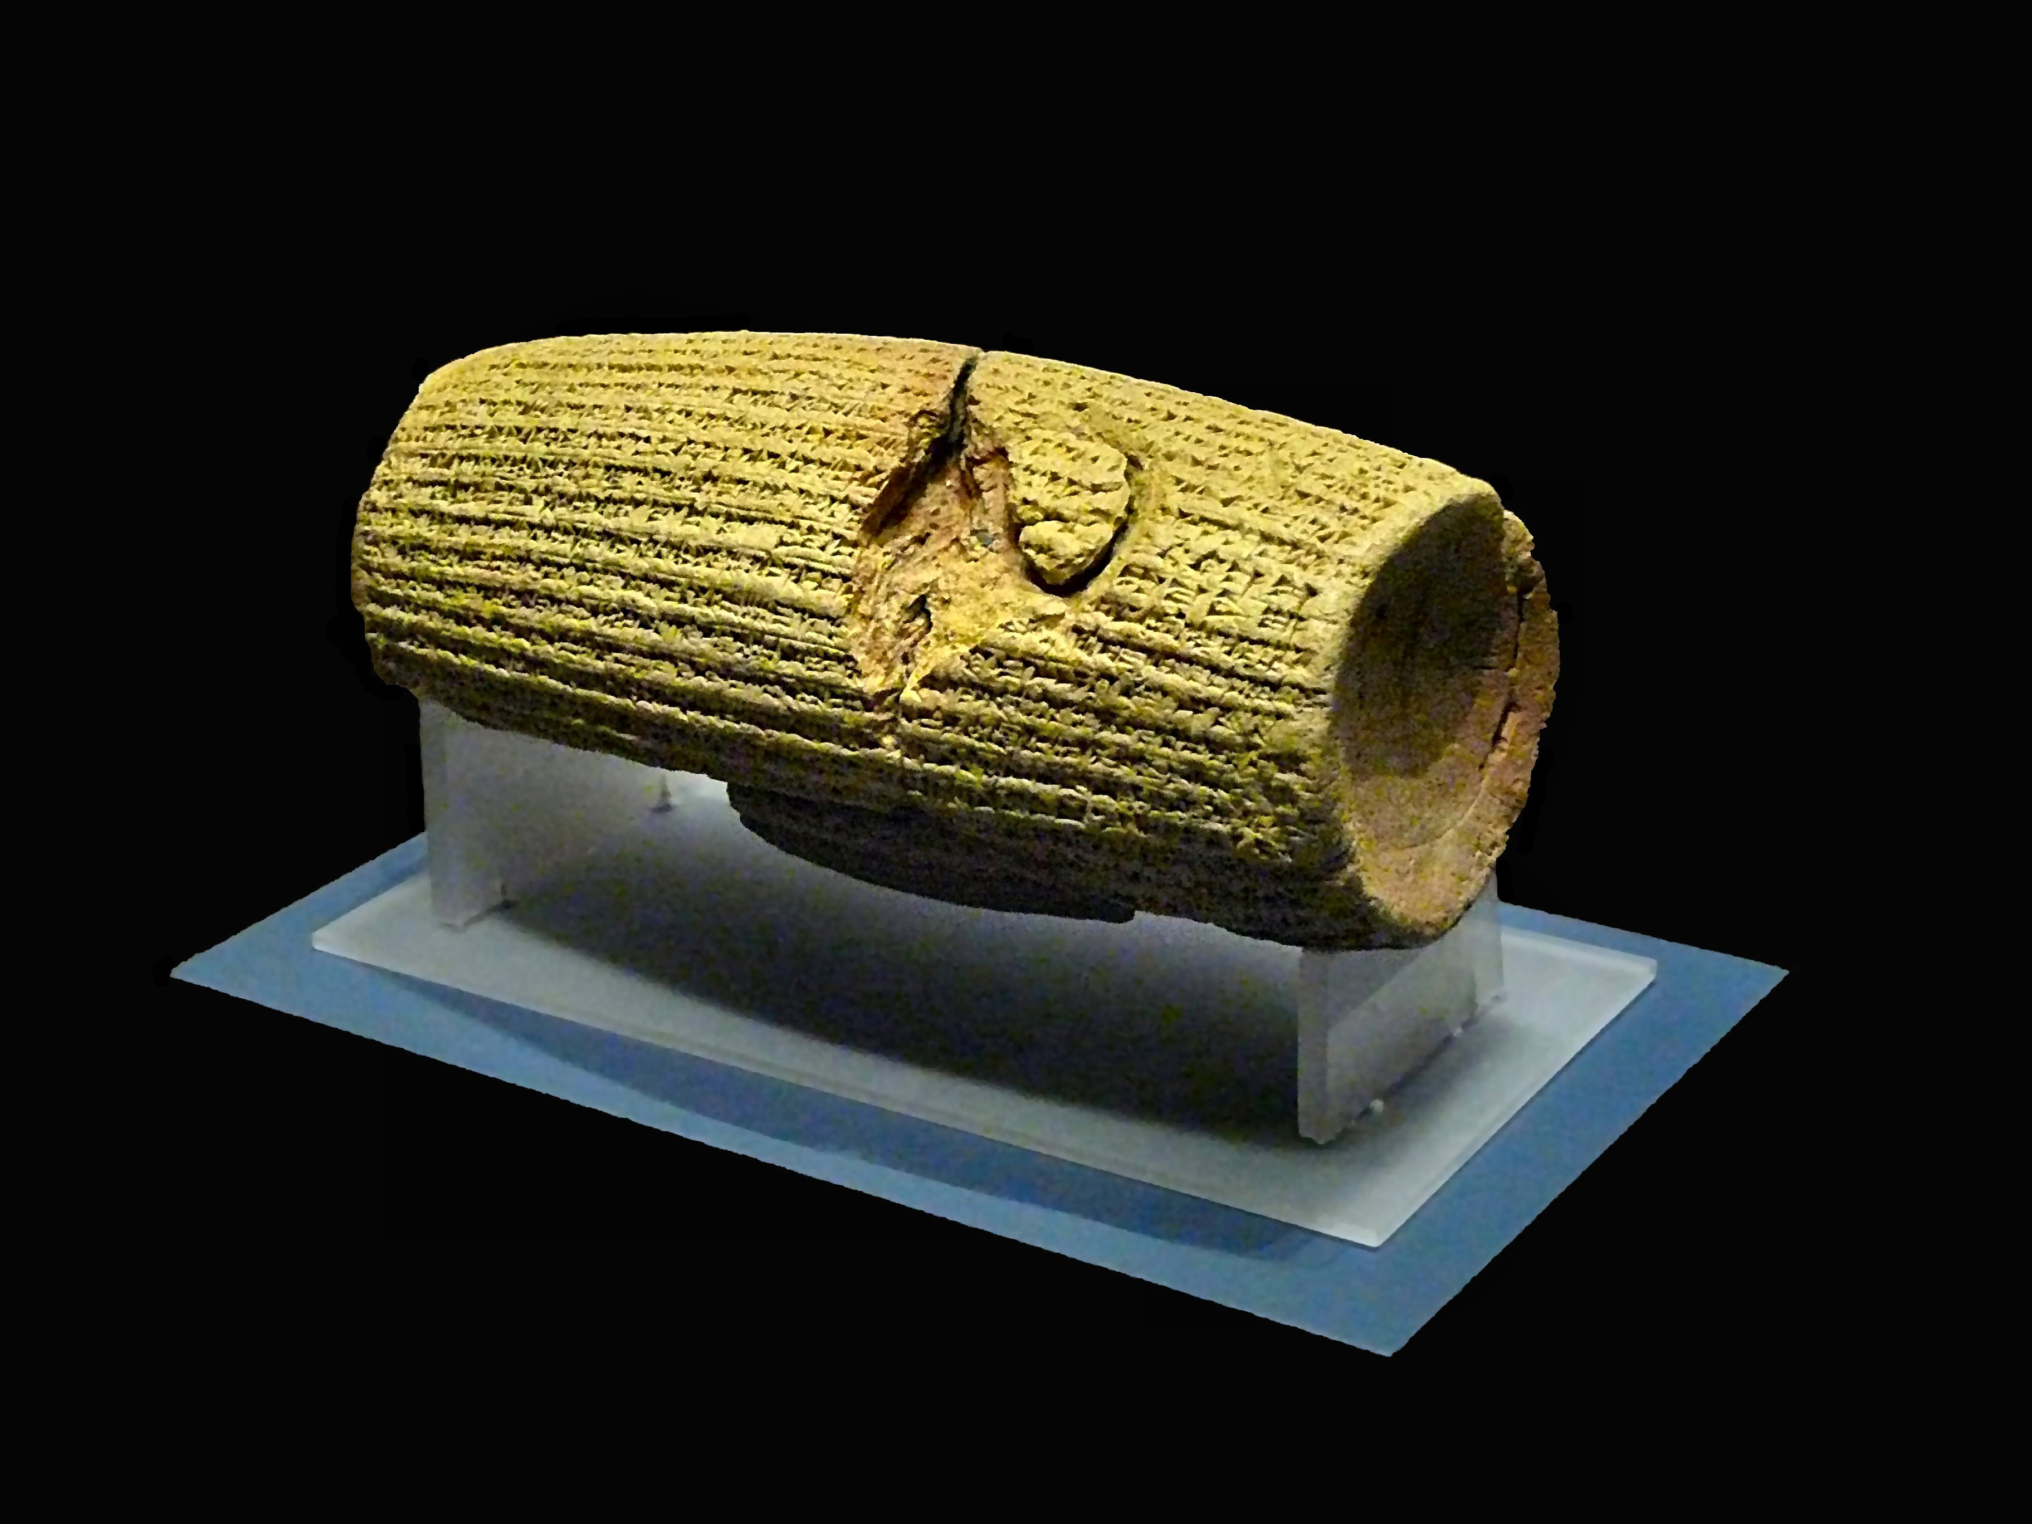 Cyrus Cylinder

Whether you see freedom and control as two ends of a spectrum or as two concepts between which there is tension, you can definitely appreciate that the use of freedom and control was a defining theme in the Persian Empire. Let’s explore more thoroughly.

- Let’s start by asking you to identify the best examples of each – find 2 each. After that, consider if there are some negative examples. This process is called selection of evidence.

Freedom – Best 2 Examples | Control – Best 2 Examples
1.  2. | 1.  2.
Freedom – Unsuccessful or Negative Example | Control – Unsuccessful or Negative Example

- Now, let’s think about this tension/spectrum in a deeper way. This process is called analysis. Analysis requires you to break down the evidence into parts.

- Recognize a few things and think about them, giving evidence from Persia:
- Freedom and control can exist at the same time. They can overlap. They can even be designed to work together. Give evidence from Persia:

- There can be unintended consequences of government policies. Things don’t always work out the way they are intended. Give evidence from Persia:

- Different groups of people might have had different views on things (historical perspectives). You may have to infer. Give evidence from Persia:

- Now put your different thoughts together and form an argument in response to a question. This is called synthesis.

Question: To what extent did the Persian Empire flourish because of its balanced use of freedom and control?

Before you answer the question using the evidence, note the word extent. This word opens the answer up to many possible interpretations. You don’t have to say yes 100% or no 100%. Yours can be a more complex and sophisticated answer, as long as you can support it with evidence. You are making up your own mind based on what the evidence tells you. You are not merely reciting facts.

Lastly, don’t forget the balance see-saw when you answer. 



