CHY 4U Unit 4, Activity 1
Imperialism / Decolonization Assignment

- Form a group of three to four people. Your overall goals are to understand:
- the imperialism background and how it lead to the demand for decolonization (cause and consequences) in two particular countries
- the process in which decolonization occurred in those countries

Content Curriculum Expectation: E2.5: Analyze some significant developments related to colonization, decolonization…, including their impact on different groups in various regions in the world.

- Individually take notes on two examples of the imperialism / decolonization relationship. You must include India, plus one example from Africa. The attached organizer suggests the topics that should be included in your notes. You may divide the work but all group members are responsible for being familiar with the information. You may enter information directly on the organizer and expand it if necessary (on computer).

- Participate in an in-class group activity in which you try to draw out (explicitly) the lessons learned from imperialism/decolonization from both the colonizer and colonized perspectives. Instructions will follow on the day of participation.

Skill Curriculum Expectations: A1.7: evaluate and synthesize their findings to formulate conclusions and/or make informed judgements or predictions about the issues, events, and/or developments they are investigating. A1.8: communicate their ideas, arguments and conclusions using various formats and styles, as appropriate for the audience and purpose.

Areas:

- India or Pakistan from Britain (pages 191-194, 370-371, 404-405)
- Africa – Algeria from France (page 405)
- Africa – Ghana from Britain (page 405)
- Africa – Kenya from Britain (page 405)

Research/preparation in Library: Mon. May 13, Tues. May 14, Wed. May 15, Thurs. May 16
Participation Day: Fri. May 17 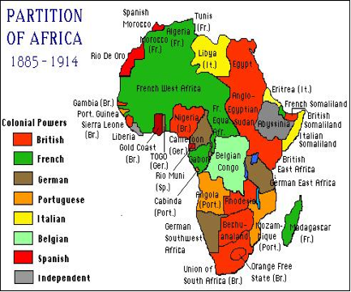 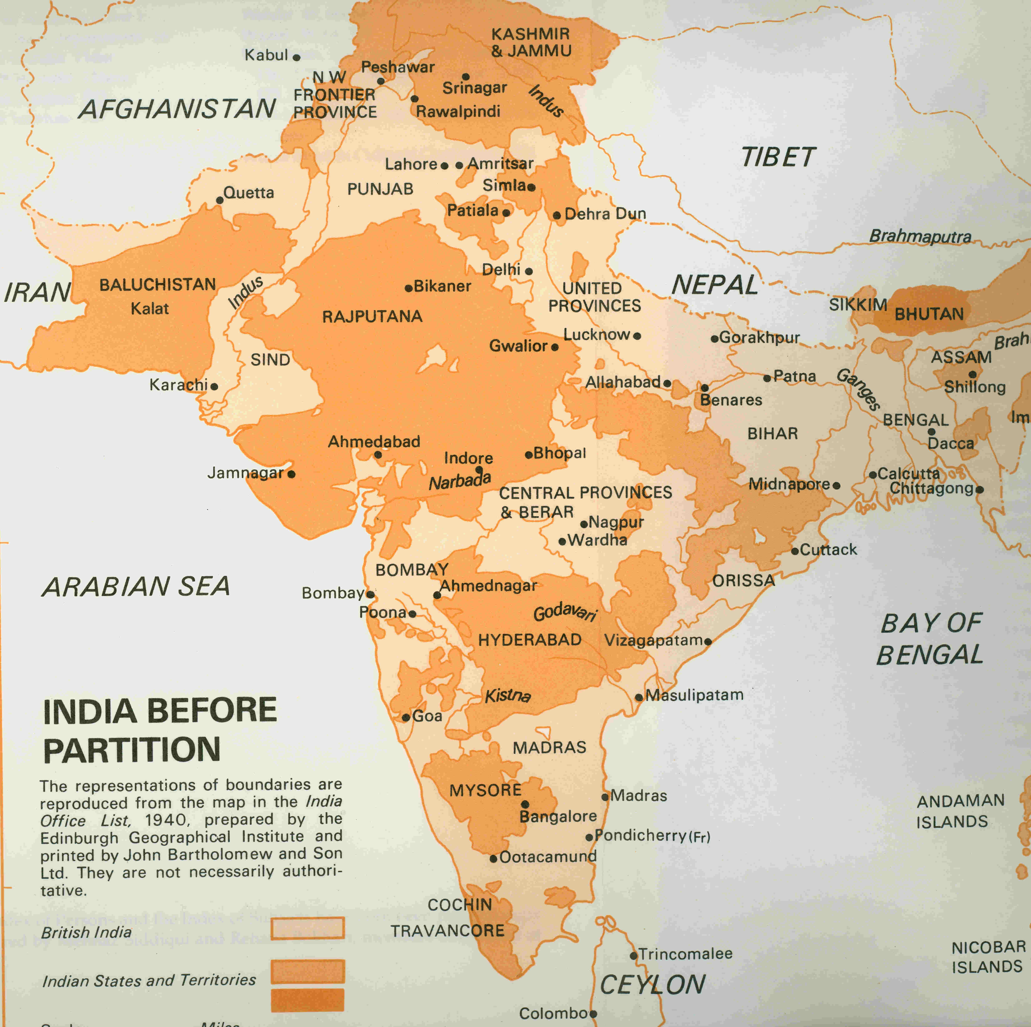
CHY 4U: Imperialism/Decolonization Note-Taking Replacement Organizer
Country: __________________________________________
Imperialism Background
Decolonization Key Questions | Colonial Power’s Perspective | Independence Movement’s Perspective
What (main events)
Who (who colonized, who resisted – class, ethnicity, political groups, leaders)
When and where (background of colonization, origins, significant dates of resistance and holding on; where – boundaries, geo-political significance of location, sites and dates of resistance)

How (methods of colonization, methods of resistance - peaceful/violent, and methods of holding on to power or punishing rebel/nationalist leaders – imprisonment, death, education)

Why (reasons for colonization, reasons to push for independence/nationalism, reasons for mother country to hold on or relent)

