CHW3M Pillars of Civilization Charts

Indus Valley Civ
 | State religion | Specialization and stratification | Writing | Monumental architecture | Centralized Gov’t
Indus Valley  This civilization peaked from 2600 to 1900 BCE. Its two largest cities were Harappa and Mohenjo Daro. However, there is evidence of about 100 other cities.  Video; walk through by Al Jazeera TV  https://www.harappa.com/video/moenjodaro-360-%E2%80%93-walkthrough-ancient-civilisation | Seals were very important objects in this civilization; they may have been used to sign letters and record trade. Many of them are decorated with images that may relate to religion; a God-like figure (that bears some resemblance to Hinduism’s God named Shiva)  Image: seals with god-like figure | There is evidence of difference in level of wealth; some homes had two storeys and a bath – these were probably for the more well off.  There were different roles in society such as merchants who brought in valuable raw materials such as lapus lazuli, artisans who used the raw materials to craft fine products, and farmers outside of the cities who produced the food and some materials such as cotton.  The top positions are not known with certainty. The leaders may have been priests (or priest-like), traders or landlords, or a combination. Their wealth was shown through their jewellery and their seals, objects used to sign letters and record trade.  Image:  Standard weight sizes  https://www.harappa.com/blog/ancient-indus-weights  An example of a standard-sized weight that was used by Indus Valley traders and merchants.  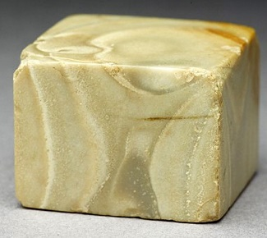  Zebu bull seal made by artisans.  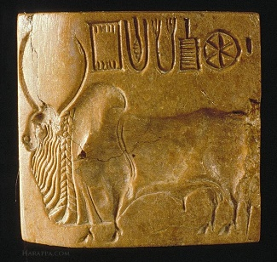  https://www.harappa.com/video/moenjodaro-360-%E2%80%93-walkthrough-ancient-civilisation | Though their script has not been fully deciphered, it is sometimes referred to as Indus script. Some signs have been identified, but no systematic understanding exists, yet. Like many scripts, it changed over time.  Image: script  Seals containing Indus script.  https://www.harappa.com/content/cracking-indus-script  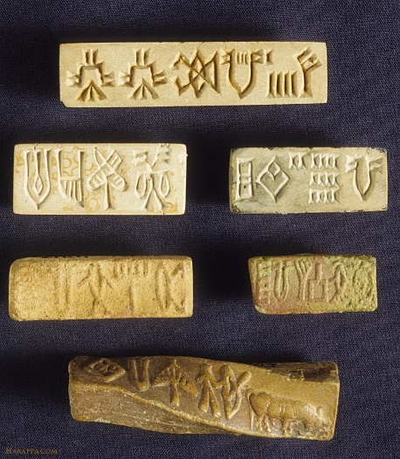 | No palaces have been unearthed by archaeologists. However, the cities of the Indus Valley are very well planned, including much infrastructure devoted to water and sanitation. There were wells for drinking, a waste removal system that collected sewage from houses, stored it and emptied it onto fields for fertilizer.  Image: water or sewage related  UNESCO, Moenjodaro World Heritage Site, http://whc.unesco.org/en/documents/108235  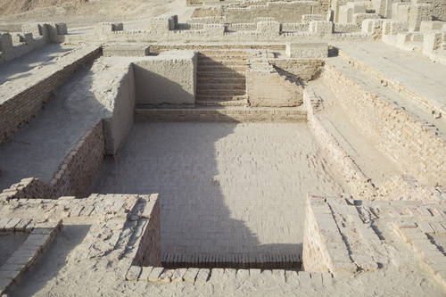  Figure 1 UNESCO World Heritage Site - architectural ruins at Moenjodaro - perhaps water -related | The government structure did not appear to be based on military power. Instead, it is thought that leaders maintained control through of religion and trade.  In terms of administrative ability, clearly life was organized for every-day Indus Valley people; the planned nature of the cities and their water and waste-related functions indicate that.  One estimate says that Harappa may have had a population of 80 000 people.  Image:  This 1959 photo shows the drains that led from ordinary houses in Mohenjo-Daro.  https://www.harappa.com/blog/  mohenjo-daro-street-drains  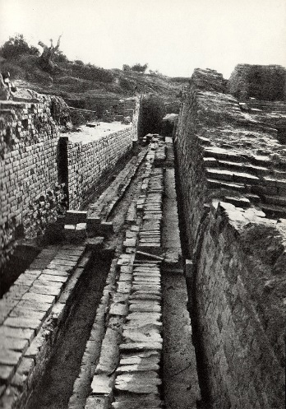

Mesopotamia
 | State religion | Specialization and stratification | Writing | Monumental architecture | Centralized Gov’t
Mesopotamia – Sumer first  3500 BCE  Urbanized  18 city states  First unified into an empire by Sargon of Akkad (Akkad was the northern region of Sumeria) | Large walled cities with a temple to the local god were common in Sumer. Temples owned a lot of the land, perhaps up to a third. Eventually, as kings took on more power than temples, they were seen to be given their positions by the gods.  In their polytheistic religion with more than 2000 gods and goddesses, the chief god changed over time and in different places. Enlin (the sky god) was the main god of Sumer.  Since they believed the purpose of human life was to serve the gods, the city states focused on their gods to a great degree, thus the importance of temples.  People made offerings to the gods to please them. They also placed worshipper (votive) statues in temples to give the god/goddess the impression they were there praying all the time.  Priests observed the movements of the planets and stars in order to determine their effect on human life as they were thought to give signs or clues about what would happen to the king and society.  Image:  Votive statue of a standing woman worshipper from Nippur, 2600-2500 BCE  http://www.metmuseum.org/toah/works-of-art/62.70.2/  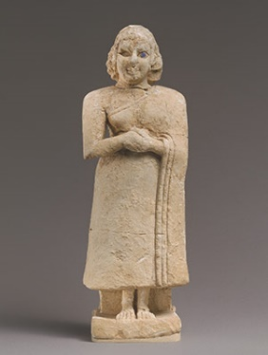 | In such a centralized government structure, positions included scribes, who specialized in writing and accounting.  There was a hierarchy of roles, with landowners and other elite positions such as priests and scribes near the top. Lower down came traders/merchants, artisans, and of course the majority of the people, peasants who farmed and owed forced labour to the state.  Life for women was very much centred around family through roles as mothers and daughters. However, women might have extended some of their domestic tasks into outside of the home jobs such as selling the beer they had made.  Image: Ram in thicket, photograph taken in the British Museum. This 16-inch high statue of a goat looking for food was found in the Royal Cemetery of Ur. It dates to 2600 BCE and shows the fine work done for kings.  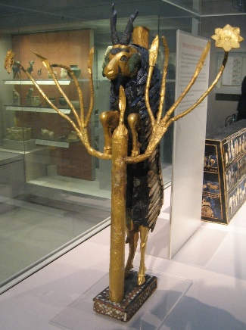  By <a href="https://en.wikipedia.org/wiki/User:Jack1956" class="extiw" title="en:User:Jack1956">Jack1956</a> at the <a href="https://en.wikipedia.org/wiki/" class="extiw" title="w:">English language Wikipedia</a>, <a href="http://creativecommons.org/licenses/by-sa/3.0/" title="Creative Commons Attribution-Share Alike 3.0">CC BY-SA 3.0</a>, <a href="https://commons.wikimedia.org/w/index.php?curid=3584798">Link</a> | Cuneiform script evolved from pictograms (drawings representing objects) around 2500 BCE. It was written on clay tablets with reed wedge-shaped styluses. At first writing was thought to be used for accounting purposes but over time it became useful for other more abstract things such as literature. People who specialized in writing were known as scribes and they were amongst the elite that received education.  For people alive today, one of the best things about Mesopotamians recording things is that we know of their many advancements: math, the calendar, irrigation, the seeder plough, the wheel, and many more.  Image: stylus or stone tablet  Reed stylus and cuneiform tablet  British Museum, Mesopotamia, Writing,  N.d.,  http://www.mesopotamia.co.uk/writing/explore/images/reed.gif | Ziggurats were platform- based temples with a stairway running up the length of the platforms leading to a temple at the top. The Ziggurat at Ur was built in the 2000s BCE  Image: Ziggurat of Ur  By Hardnfast, CC BY 3.0, https://commons.wikimedia.org/w/index.php?curid=3544015  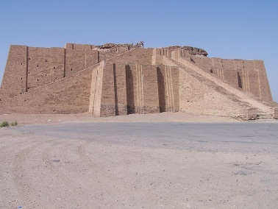 | As time passed, palaces overtook temples as the most important governing institutions. They organized many facets of life, including grain distribution and long-distance trade.  A large bureaucracy of government officials took care of many tasks, most important of which was making rules for the maintenance of the canals that fed the farm lands. Regulators, a technology combining dams and gates, prevented individual farmers from using too much water.  Early Sumerian city states also had a law code. You will learn more about the later Babylonian law code in an upcoming lesson.

Egypt
 | State religion | Specialization and stratification | Writing | Monumental architecture | Centralized Gov’t
Egypt | Religion was at the centre of Egyptian life. The religion was polytheistic, with many hundreds of gods and goddesses, both local and national, minor and major. By the New Kingdom, Amen Re had risen to the most prominent position as king of the Gods.  There was also a concept called maat, the harmony of the universe. Maat also represented the idea of justice. It guided Egyptians’ sense of morality.  Death, burial and getting to the afterlife were crucial parts of Egyptian religion (and thus life). There were many rituals that had to be attended to in order to reach the afterlife –eternal life. Egyptians believed that the soul had to come back to a body. Therefore, the most well known of the Egyptian death rituals was mummification, preservation of the body through a 70-day process (for those who could afford it). There were also elaborate funerals, inclusion of objects in the tomb, and spells and prayers said by priests.  Here is an interview with Egyptologist Salima Ikram in which she discusses mummies.  http://www.pbs.org/wgbh/nova/ancient/afterlife-ancient-egypt.html  Image:  In this scene the pharaoh on the left holds lotus flowers. They are of spiritual significance as they represent the idea of rebirth.  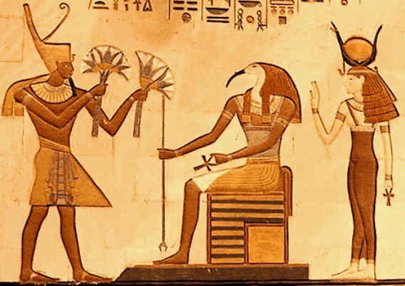  Land of Pyramids, Lotus Symbol, 2015, http://www.landofpyramids.org/lotus-symbol.htm | To have such a well functioning society over so many thousands of years, the Egyptians developed a number of specialized roles. These came to overlap with the attribution of status attached to each role.  Scholars believe that Egyptian society was very hierarchical, with a person’s status largely determined by his or her birth. Though there were some changes over the thousands of years of Egypt’s history, the social hierarchy looked generally like the following:  Certainly the Pharaoh and his /her family and aristocrats, or nobles, would have been at the top.  Scribes were near the top because of the education required. Other educated classes included accountants and doctors. Scribes were government officials and often priests as well.  Craftsmen and artisans occupied the next rung down. However, this didn’t mean they had a bad life. Evidence has been found of the towns where workers who built the Great Pyramid and the rock-cut tombs at the Valley of the Kings lived. Both show that they were well fed. Though their work was difficult, they were treated well by the state.  Soldiers gained higher status in the New Kingdom as Egypt expanded territorially.  Some scholars believe that household servants were above the ordinary farmers.  Ordinary farmers made up the most numerous class. The land they farmed was often owned by the temples or the pharaoh to whom they owed a tax in kind (usually grain).  Slaves occupied the lowest level of the hierarchy. However, there weren’t that many of them.  Women occupied an interesting position in Egyptian society, possibly unique in the ancient world in that they had equal legal rights and relatively strong rights overall, despite their mainstay being “mistress of the house.” While the society was male-dominated, especially in the political sense (though there were a small number of female pharaohs), women could hold many jobs, could own property, and get a divorce. What was most expected of women was to produce and take care of children as the family was the most important unit of social life.  Image:  Farmers harvesting rich fields in the afterlife. From a Theban tomb, 1295–1213 B.C..  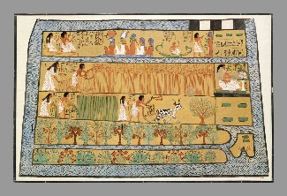  Metropolitan Museum of Art, Heilbrunn Timeline of Art History, Sennedjem and Iineferti in the Fields of Iaru, N.d., http://www.metmuseum.org/toah/works-of-art/30.4.2/ | The Egyptian system of writing was called hieroglyphics and was originally picture-based. Eventually it gained a phonetic/alphabetic aspect. It was very formal and used for religious purposes, thus they called it “divine word”.  The patron God of writing was Thoth, the God of wisdom. Traditionally writing’s origins have been dated to about 3200 BCE, though newer research has found evidence from further back when hieroglyphics were just starting to be used.  Those who specialized in writing were called scribes. They had to learn over 700 signs. Eventually easier cursive forms were invented, called hieratic and demotic, so that scribes could get more done faster (like we have printing and writing).  In a famous Egyptian poem, a scribe writes a “Satire of the Trades” to highlight the negative aspects of other professions in comparison to his own: “Look, no scribe will ever be lacking in food  or the things of the House of the King, may he live, prosper and be well!”  http://www.ucl.ac.uk/museums-static/digitalegypt/literature/satiretransl.html  Image:  This chart demonstrates the evolution of hieroglyphics over time, starting on the left.  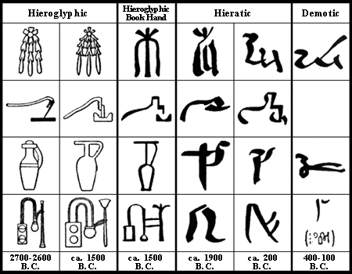  Canadian Museum of History, Mysteries of Egypt, Hieroglyphs, N.d., http://www.historymuseum.ca/cmc/exhibitions/civil/egypt/egcw02e.shtml  Taken from: G. Steindorff and K. Seele, When Egypt Ruled the East, Chicago: 1942, p.122  A section of papyrus containing hieratic writing. It was found in Thebes, Egypt and has been dated to 1190-1075 BC.  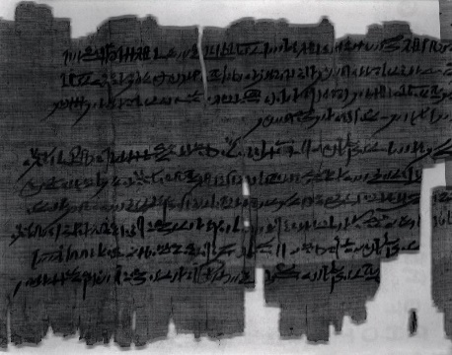  University of Pennsylvania Museum of Archaeology and Anthropology, Manuscript, 2017, https://www.penn.museum/collections/object/197405  Papyrus, the plant out of which Egyptians made a paper-like substance, was a commonly used symbol in hieroglyphics.  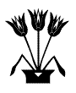  Canadian Museum of History, Egypt Royal Symbols, N.d., http://www.historymuseum.ca/cmc/exhibitions/civil/egypt/egcgov5e.shtml | Most of Egyptian architecture (that has been preserved) relates to religion and/or the pharaoh, such as temples, tombs, and palaces.  Egyptians were probably the first in the world to use stone columns to support buildings and roofs.  Image:  Here is an open papyrus style column.  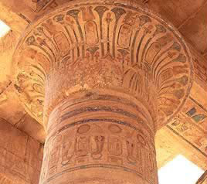  Jimmy Dunn, Egypt: The Columns of Ancient Egypt, Tour Egypt, 1996-2017, http://www.touregypt.net/featurestories/columns.htm  While many people would be familiar with the pyramids at Giza, built during the Old Kingdom (the pyramid age), many might not be familiar with the incredible skill taken to carve out of rock the royal tombs in Valley of the Kings. In a foreboding location outside of the city of Thebes, the deep tombs were hidden deep underground, the deepest being Seti I’s at more than 120 metres. It was 137 metres long. The tombs are made up of decorated rooms, chambers, annexes, and stairways. Seti I’s tomb is also known as one of the most finely decorated with its intricate religious scenes.  Image: the location of the Valley of the Kings.  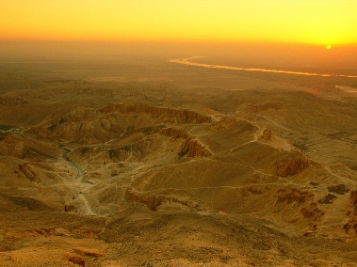  National Geographic, Reference, Valley of the Kings, N.d., http://www.nationalgeographic.com/archaeology-and-history/archaeology/valley-of-the-kings/  Image:  The Theban Mapping Project surveys and maps the Valley of the Kings and Thebes. Below is a map of all the known tombs in the Valley of the Kings.  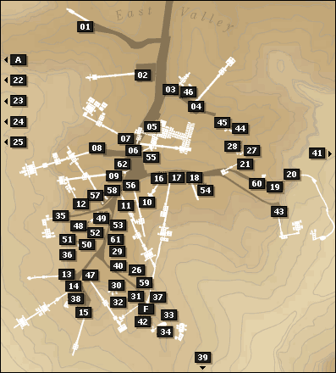  Theban Mapping Project, Sites in the Valley of the Kings, 1997-2010, http://www.nationalgeographic.com/archaeology-and-history/archaeology/valley-of-the-kings/  Located near the valley is one of the most beautiful examples of Egyptian architecture, the mortuary temple of Hatshepsut (a female pharaoh), Deir el Bahri. It is carved directly into the cliffs. It was built by the architect Senenmut.  Image:  Hatshepsut’s temple, Deir el Bahri  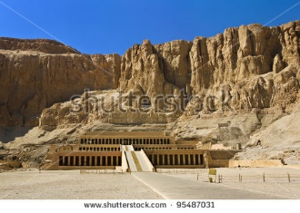  https://www.shutterstock.com/image-photo/egypt-luxor-deir-elbahari-or-elbahri-95487031?src=4cl8dakidRTBiTO5ZBMgkw-1-4 | Once upper and lower Egypt were unified around 3150 BCE by king Narmer, the first dynasty began. For the most part, with some exceptions, there was a central government that helped to keep Egypt organized and stable after that.  While the pharaoh was the most powerful figure (owing to status as either a living god or a representative of a god on earth), he/she was assisted by viziers (the highest administrators), high priests, and overseers.  Viziers were very powerful officials. The following quote lists a vizier’s responsibility of appointing many other officials:  “It is he who despatches to cut trees as stated in the Domain of the King  It is he who despatches district councillors to make outlet channels in the entire land  It is he who despatches mayors and governors of domains at ploughing and harvest  It is he who appoints overseers of enquiry in a bureau of the Domain of the King  It is he who appoints the hearer of mayors and governors of domains  who have gone out in his name to Upper and Lower Egypt.”  University College London, Administration in Ancient Egypt, 2002,  http://www.ucl.ac.uk/museums-static/digitalegypt//administration/dutiesviziertrans.html  Overseers looked after many different aspects of running the state, often relating to land, rivers, fields, and storage of grain (usually barley or emmer wheat) since there was no money in ancient Egypt. The grain that was paid to the state as a tax was often stored at temples.  Some of the best proof of the extents to which the government got involved in large building projects and the care of the workers can be found at Deir El Medina. Deir El Medina was the village where the workers who built the Valley of the Kings lived in the 19th and 20th dynasties. Recent evidence suggests that the state provided subsidized health care for the workers there.  https://archaeologynewsnetwork.blogspot.ca/2014/11/ancient-human-remains-at-deir-el-medina.html#TmcLQUEzm6p9hfPE.97  Workers village, Deir el Medina. This is where the workers, who were skilled craftsmen, lived who built the Valley of the Kings. Their needs were attended to by the government.  Wiki Commons, Deir El Medina, 2009, https://commons.wikimedia.org/wiki/Category:Deir_el-Medina#/media/File:SFEC_2009_POT-0001.JPG  